S. AMANZHOLOV EAST KAZAKHSTAN UNIVERSITY

Department of Chemistry

Subject: "Nanotechnologies and nanomaterials" (instruments, research methods)

Lecture No. 1: «Fourier-transform infrared (FTIR) spectroscopy»

Lecturer: Kuanyshbekov Tilek Kuanyshbekuly, PhD

Oskemen 2024

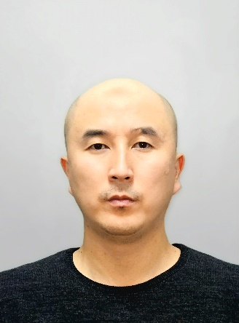 | LECTURER: PhD, Associate Professor  Kuanyshbekov Tilek Kuanyshbekuly  Lecture No. 1: «Fourier-transform infrared (FTIR) spectroscopy»  Plan:  - Fourier-transform infrared (FTIR) spectroscopy  - FTIR analysis of BAC-GO and G-GO  - Comparative FTIR spectra of the starting materials and the obtained GO  - Functional groups of G-GO and BAC-GO according to UV and FTIR spectra  - 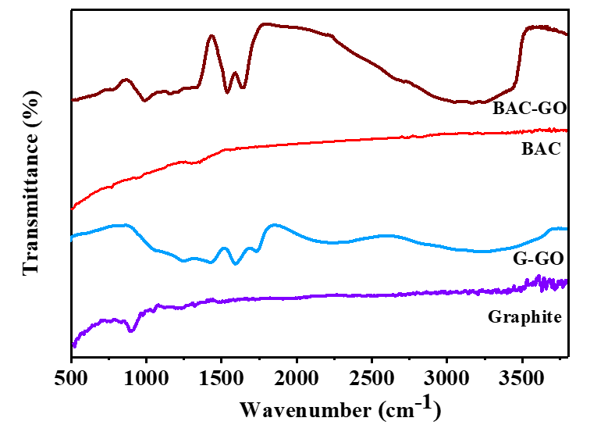

Fourier-transform infrared (FTIR) spectroscopy

FTIR analysis of BAC-GO and G-GO were performed on an FT-801 FTIR spectrometer (Simex, Russian), with a resolution of 1 cm⁻¹ at a range of 450-4700 cm⁻¹, in accordance with the standard method and using an accessory to measure attenuated total reflection (ATR) and specular-diffuse reflection (SDR), at a temperature of 25±1⁰C.

FTIR spectroscopy

Figure 1 shows the comparative FTIR spectra of the starting materials and the obtained GO. Weak signals of C-O-H and C=O bonds were observed in the spectra of BAC and GO at wave numbers 980 cm⁻¹ and 1417 cm⁻¹ [1]. This further clarifies the accuracy of the numerical values of oxygen groups (0.2 mg-eq/g) in BAC and graphite molecules in Table 1. This further clarifies the accuracy of the numerical values of oxygen groups (0.2 mg-eq/g) in BAC and graphite molecules in Table 1. And, according to the obtained spectra of BAC-GO and G-GO, the absorption region at 3300 cm⁻¹ and 1420 cm⁻¹ is due to O-H, 1723 cm⁻¹ long vibration of C=O bonds in carbonyl group and carboxyl groups, long-term vibrations and deformation peaks of C=C bonds of the aromatic ring at 1585 cm⁻¹, absorption at 1249 cm⁻¹ is attributed to long-range vibration of C–O epoxy functional groups, 1054 cm⁻¹ was found to be characteristic of long-range vibrations of C–O alkoxy bonds [2-6]. In the course of strong oxidation, we can see that intense absorption peaks of oxygenated hydroxyl, epoxy, carboxyl, carbonyl groups connected with carbon atoms appear. From this, we can see that the increase in the numerical values of the bound oxygen groups in Table 2 by 65 times in BAC-GO and 75 times in G-GO was clearly observed in the FTIR spectrum. Similar research results were obtained in studies [3, 4, 7, 8].

Fig. 1 FTIR spectra

Based on this, the FTIR spectra data confirm that the BAC derived from renewable plant biomass and the GO synthesized from it are of high quality and are similar to the GO obtained from synthetic graphite. The synthesis efficiency (yield) of GO from synthetic graphite is 10.4%, and that of GO from BAC is 11.6%, nearly 1,2% higher than the yield of GO from synthetic graphite. In this regard, based on the above data, in comparison with synthetic graphite, BAC is the most efficient and economical material for the synthesis of BAC-GO.

Table 1 Functional groups of G-GO and BAC-GO according to UV and FTIR spectra

Samples | Functional groups
Samples | UV spectra,  λ, wavelength (nm) |  | FTIR spectra,  wavenumber (cm⁻¹)
Samples | 228 | 233 | 980 | 1417 | 1054 | 1249 | 1585 | 1723 | 1420 | 3300
G-GO | presence of π-π* bond of aromatic ring in GO molecule and C=O bonds in epoxy, carbonyl groups |  | C-O-H and C=O bonds |  | C–O alkoxy bonds | C–O epoxy functional groups | C=C bonds of the aromatic ring | C=O bonds in carbonyl group and carboxyl groups | O-H
BAC-GO

Questions
- Fourier-transform infrared (FTIR) spectroscopy
- FTIR analysis of BAC-GO and G-GO
- Comparative FTIR spectra of the starting materials and the obtained GO
- Functional groups of G-GO and BAC-GO according to UV and FTIR spectra

REFERENCES
- Savitskyi, D.P.; Makarov, A.S.; Goncharuk, V.V. Preparation of a colloidal graphene oxide solution from natural coal. J. Rep. Natl. Acad. Sci. Ukr. 2016, 6, 87–94.
- Loeh, M.O.; Badaczewski, F.; Faber, K.; Hintner, S.; Bertino, M.F.; Mueller, P.; Metz, J.; Smarsly, B.M. Analysis of thermally induced changes in the structure of coal tar pitches by an advanced evaluation method of X-ray scattering data. J. Carbon 2016, 109, 823–835.
- Atkins, C.A.; Lindemann, G.W.; Targett, M. Methods for Producing Graphene from Coal. U.S. Patent US2019/0194022A1, 27 June 2019.
- Kishibayeva, K.K.; Tokpayev, R.R.; Atchabarov, A.A.; Efremov, S.A.; Voropaeva, N.L.; Fernández-Sanjurjo, M.J.; Nechipurenko, S.V.; Nauryzbayev, M.K.; Tassibekov, S.K.; Karpachev, V.V. Activated Carbons of Varied Nature in Recovery of Gold. Russ. J. Appl. Chem. 2016, 89, 381−387.
- Fiolek, B.W.; Macquarrie, S.L.; Omari, K.W. Generation of high quality birch-based activated carbons for adsorption of heavy metals and pah from water. WO2015066816A1, 14 May 2015.
- Seyedzadeh, A.; Mwafy, A.; Ahmed, W.K.; Kamala Pandurangan, K.; Hilal-Alnaqbi, A. Activating Carbon Fibers and Date Pits for Use in Liver Toxin Adsorption. In Poisoning-From Specific Toxic Agents to Novel Rapid and Simplified Techniques for Analysis [Internet]; Malangu, N., Ed.; IntechOpen: London, UK, 2017. https://doi.org/10.5772/intechopen.7189. Available online: https://www.intechopen.com/chapters/57993 (accessed on 17 January 2023).
- Shinke, K.; Ando, K.; Koyama, T.; Takai, T.; Nakaji, S.; Ogino, T. Properties of various carbon nanomaterial surfaces in bilirubin adsorption. J. Colloids Surf. B Biointerfaces 2010, 77, 18–21.
- Chang, S.-K.; Zainal, Z. Activated Carbon for Supercapacitors. J. Synth. Technol. Appl. Carbon Nanomater. 2019, 309–334. https://doi.org/10.1016/B978-0-12-815757-2.00012-7

