S. AMANZHOLOV EAST KAZAKHSTAN UNIVERSITY

Department of Chemistry

Subject: "Nanotechnologies and nanomaterials" (instruments, research methods)

Lecture No. 2: «Introducing the Winner 2005 particle size analyzer»

Lecturer: Kuanyshbekov Tilek Kuanyshbekuly, PhD

Oskemen 2024

 | LECTURER: PhD, Associate Professor  Kuanyshbekov Tilek Kuanyshbekuly  Lecture No. 2: «Introducing the Winner 2005 particle size analyzer»  Plan:  - The particle sizes of B-GO and G-GO  - The particle sizes and functional oxygen-containing groups in the BAC-GO and G-GO  - Total number of oxygen-containing groups in carbon materials  - 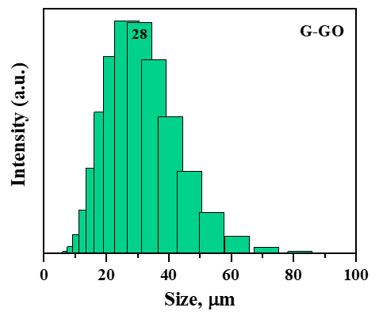

The particle sizes of B-GO and G-GO

A 1 wt% aqueous suspension of BAC-GO and G-GO were subjected to 30 kHz for 10 min using an ultrasonic disperser, U-sonic UZTA-0.15/22-0 (Alena, Russian). The average particle size was determined via dynamic light scattering (DLS) using a Zetasizer NanoZS 90 (Malvern, UK).

The particle sizes and functional oxygen-containing groups in the BAC-GO and G-GO

Figure 1 shows the average particle sizes in the obtained BAC-GO and G-GO aqueous suspensions. The average particle size of BAC-GO was 22.7±2 μm, and G-GO was 28±2 μm. The size of GO obtained from BAC was found to be about 5 μm smaller than GO obtained from graphite.

Fig. 1 The particle sizes

In Table 1, comparing the raw material and obtained GO, we see that the difference in numerical values is large. It turned out that in the initial BAC, the content of oxygen-containing groups was 0.3%, after strong oxidation, the obtained BAC-GO increased by 13% and increased by 65 times, and in Graphite and synthesized G-GO increased by 75 times, from 0.2% to 15%.
It was found that the amount of bound oxygen groups (oxygen-containing groups) in the go molecule obtained from this BAC is less than 10 mg-eq/g compared to go obtained from graphite with an ordered crystal structure that intensively affects the attraction of oxygen atoms. In the study [1], the amount of oxygen-containing groups in the GO molecule obtained by surface modification of coal was 6.6%, which was 16.5 times lower than that of the initial raw material. Moreover, the result obtained in this study is 2 times higher than the result of study [1].

Table 1 Total number of oxygen-containing groups in carbon materials

Samples | Total number of oxygen-containing groups, mg-eq/g
BAC | 0.2±0.01
Graphite | 0.2±0.01
BAC-GO | 13±0.2
G-GO | 15±0.2

Questions
- The particle sizes of B-GO and G-GO
- The particle sizes and functional oxygen-containing groups in the BAC-GO and G-GO
- Total number of oxygen-containing groups in carbon materials

REFERENCES

- Marinin, S.D.; Afrikyan, G.T. Production of carbon sorbents for metal recovery from metal salt solutions. Min. Inf. Anal. Bull. 2020, 4, 33.

