S. AMANZHOLOV EAST KAZAKHSTAN UNIVERSITY

Department of Chemistry

Subject: "Nanotechnologies and nanomaterials" (instruments, research methods)
Lecture No. 7: «Study of the electrical properties of GO films using the traditional four-probe method. Determination of surface and specific resistivities»

Lecturer: Kuanyshbekov Tilek Kuanyshbekuly, PhD

Oskemen 2024

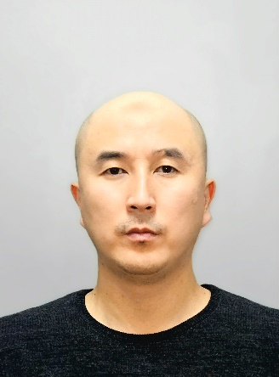 | LECTURER: PhD, Associate Professor  Kuanyshbekov Tilek Kuanyshbekuly  Lecture No. 7: «Study of the electrical properties of OG films using the traditional four-probe method. Determination of surface and specific resistivities»  Plan:  - - Electrical characteristic of the G-GO and BAC-GO  - - Electrical Characterization of the GO and GO/CMC membrane  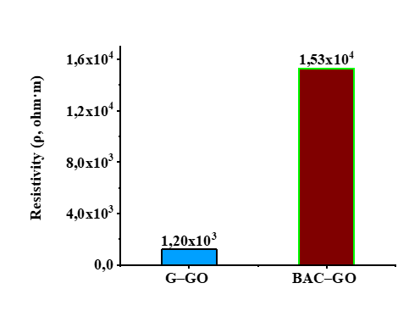

Electrical Characterization
The electrical properties of GO and RGO films were investigated by four-point probes method. Electrical measurements were made using the traditional four-probe method, with current measured on a Keithley 6485 (Tektronix, Inc. U.S.A.) and voltage applied with a Tektronix PWS2326.

Electrical characteristic of the G-GO and BAC-GO
The electrical characteristics of the G-GO and BAC-GO samples were measured using the Keithley picoammeter (Model 6485) by four-point probes. The resistivity results showed the following values: ρ (G-GO) = 1.2x10³ and ρ (BAC-GO) = 1.53x10⁴ (Fig. 1). According to the obtained resistivity values, there is a difference between G–GO and BAC–GO, that for the BAC–GO sample, ρ has become an order of magnitude greater than for G–GO. The high value of BAC–GO resistivity is due to the fact that BAC crystals by their nature have a random porous rod-like structure of the aliphatic character of saturated carbon bonds (Fig. 8 (a, c)) [1-18], respectively, the conductivity of the electric current is lower than that of G-GO. Graphite crystals mainly have flocculent, scaly or lamellar forms of aromatic nature of the ordered structure [1, 1-18] (Fig. 7 (b, d)), which allows good current conductivity, respectively, shows a lower value of resistivity than in BAC. In addition, the high value of BAC resistivity is presumably influenced by the location of functional oxygen-containing groups, along the periphery and inside the tunnel rod-like porous form of BAC (Fig. 8 (a, c)) [1, 1-18], as well as the presence defective surface (Fig. 4) (Table 1) [54-66]. That is in good agreement with the results of UV, XPS, IR, Raman, XRD, SEM, SEM, EDX (Fig. 1-9) and determination of the level of oxygen-containing groups (Table 2).
Fig. 1 Electrical characteristics

Electrical Characterization of the GO and GO/CMC membrane
The electrical characterization of the GO and GO/CMC membrane was carried out using a Keithley Picoammeter (Model 6485) using the four-point probe method. The resistivity of the GO/CMC membrane increased from 1.51×10⁶ to 1.26×10⁷Ohm×m compared to the initial GO with an increasing amount of CMC (0.03 g; 0.06 g; 0.15 g) (Figure 2(0)–(3)).

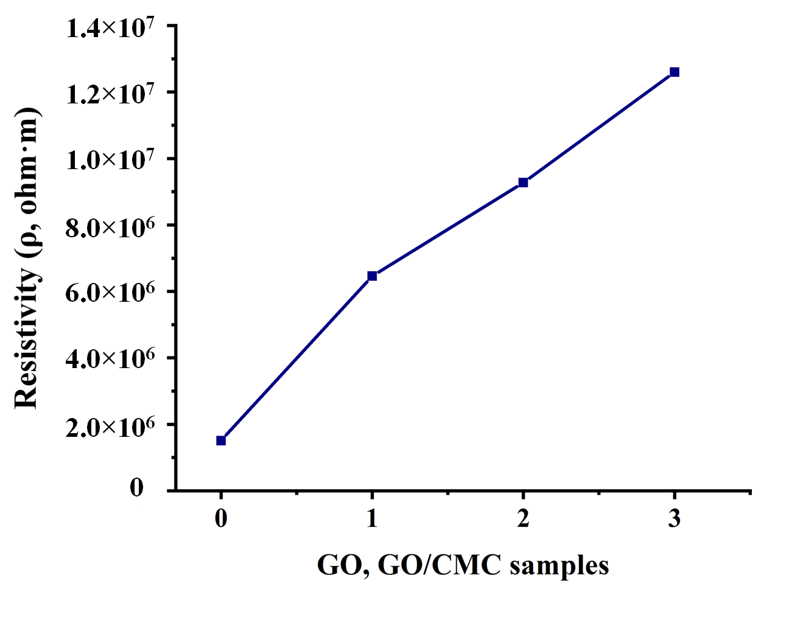
Figure 2. Electrical characterization of GO and GO/CMC samples: (0) initial GO; (1) GO/CMC 0.03 g; (2) GO/CMC 0.06 g; (3) GO/CMC 0.15 g.

The value of the resistivity of the initial GO was equal to 1.51×10⁶, and for the GO/CMC sample (0.03 g), it showed the following value: 6.46×10⁶ (Figure 9(1)). On the following GO samples of added CMC solid masses (0.06 g; 0.15 g) there was an increase from 9.27 ×10⁶ to 1.26×10⁷(Figure 2(2),(3)).
In general, according to the obtained results of the specific resistance of the GO with added CMC particles (0.03 g; 0.06 g; 0.15 g), an increase in the resistivity was observed compared to the initial sample. According to the research, an increase in the permittivityof a composite with GO is associated with interfacial polarization that occurs at the CMC–GO interface [3,4].
Moreover, the increase in the dielectric constant was affected by the presence of polar functional groups of GO, such as –OH, –CHO, –CO, and –COOH, providing good adhesion and corresponding to local electrical contacts that can lead to strong interfacial polarization. In the case of a pure GO sample, this polarization can be due to the immiscible phase of the polymer matrix. Presumably, spatial polarization due to trap states leads to the accumulation of charge carriers and to an increase in the value of the permittivity [3,5].

Questions
- Electrical characteristic of the G-GO and BAC-GO
- Electrical Characterization of the GO and GO/CMC membrane

REFERENCES
- Lee, S.-Y.; Mahajan, R.L. A facile method for coal to graphene oxide and its application to a biosensor. J. Carbon 2021, 181, 408e420.
- Savitskyi, D.P.; Makarov, A.S.; Goncharuk, V.V. Preparation of a colloidal graphene oxide solution from natural coal. J. Rep. Natl. Acad. Sci. Ukr. 2016, 6, 87–94.
- Loeh, M.O.; Badaczewski, F.; Faber, K.; Hintner, S.; Bertino, M.F.; Mueller, P.; Metz, J.; Smarsly, B.M. Analysis of thermally induced changes in the structure of coal tar pitches by an advanced evaluation method of X-ray scattering data. J. Carbon 2016, 109, 823–835.
- Popova, A.N. Crystallographic Analysis of Graphite by X-Ray Diffraction. Coke Chem. 2017, 60, 361–365.
- Kishibayeva, K.K.; Tokpayev, R.R.; Atchabarov, A.A.; Efremov, S.A.; Voropaeva, N.L.; Fernández-Sanjurjo, M.J.; Nechipurenko, S.V.; Nauryzbayev, M.K.; Tassibekov, S.K.; Karpachev, V.V. Activated Carbons of Varied Nature in Recovery of Gold. Russ. J. Appl. Chem. 2016, 89, 381−387.
- Larraza, I.; Ugarte, L.; Fayanas, A.; Gabilondo, N.; Arbelaiz, A.; Corcuera, M.A.; Eceiza, A. Influence of Process Parameters in Graphene Oxide Obtention on the Properties of Mechanically Strong Alginate Nanocomposites. J. Mater. 2020, 13, 1081. https://doi.org/10.3390/ma13051081.
- Fuku, X.; Dyosiba, X.; Iftikhar, F.J. Green prepared nanomaterials from various biodegradable wastes and their application in energy. J. Nano-Struct. Nano-Objects 2023, 35, 100997 https://doi.org/10.1016/j.nanoso.2023.100997.
- Nandi, D.; Parameswaranpillai, J.; Siengchin, S. Synthesis of three-dimensional graphene architectures from chicken feather and its unusual dimensional crossover in electronic conductivity. J. Nano-Struct. Nano-Objects 2021, 25, 100665 https://doi.org/10.1016/j.nanoso.2020.100665.
- Saha, J.K.; Dutta, A. A Review of Graphene: Material Synthesis from Biomass Sources. J. Waste Biomass Valorization 2022, 13, 1385–1429 https://doi.org/10.1007/s12649-021-01577-w.
- Marinin, S.D.; Afrikyan, G.T. Production of carbon sorbents for metal recovery from metal salt solutions. Min. Inf. Anal. Bull. 2020, 4, 33.
- Chafidz, A.; Astuti, W.; Augustia, V.; Novira, D.T.; Rofiah, N. Removal of methyl violet dye via adsorption using activated carbon prepared from Randu sawdust (Ceiba pentandra). IOP Conf. Ser. Earth Environ. Sci. 2018, 167, 012013.
- Kuanyshbekov, T.; Guseinov, N.; Tolepov, Z.; Kurbanova, B.; Tulegenova, M.; Akatan, K.; Kantay, N.; Zhasasynov, E. Thermally Reduced Graphene Oxide Membranes From Local Kazakhstan Graphite “Ognevsky”. ChemistrySelect 2023, 8, e202301746. https://doi.org/10.1002/slct.202301746.
- Qi, C.; Yang, L.; Xu, H.; He, S.; Men, Y. Natural polysaccharides-modified graphene oxide for adsorption of organic dyes from aqueous solutions. J. Colloid. Interface Sci. 2017, 486, 84–96.
- Tang, G.; Jiang, Z.G.; Li, X.; Zhang, H.B.; Dasari, A.; Yu, Z.Z. Three dimensional graphene aerogels and their electrically conductive composites. Carbon 2014, 77, 592–599.
- Manoj, B.; Kunjomana, A.G. Study of Stacking Structure of Amorphous Carbon by X-ray Diffraction Technique. Int. J. Electrochem. Sci. 2012, 7, 3127.
- Manoj, B. Synthesis and Characterization of Porous, Mixed Phase, Wrinkled, Few Layer Graphene Like Nanocarbon from Charcoal. Russ. J. Phys. Chem. A 2015, 89, 2438–2442.
- Lu, L.; Sahajwalla, V.; Kong, C.; Harris, D. Quantitative X-ray diffraction analysis and its application to various coals. Carbon 2001, 39, 1821–1833.
- Siburian, R.; Sihotang, H.; Lumban Raja, S.; Supeno, M.; Simanjuntak, C. New Route to Synthesize of Graphene Nano Sheets. Orient. J. Chem. 2018, 34, 182–187.

