S. AMANZHOLOV EAST KAZAKHSTAN UNIVERSITY

Department of Chemistry

Subject: "Nanotechnologies and nanomaterials" (instruments, research methods)

Lecture No. 8: «Neutralization of synthesized graphene oxide suspension using a centrifuge»

Lecturer: Kuanyshbekov Tilek Kuanyshbekuly, PhD

Oskemen 2024


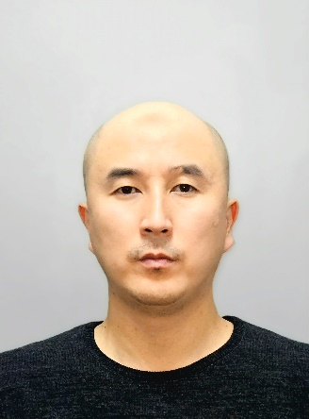 | LECTURER: PhD, Associate Professor  Kuanyshbekov Tilek Kuanyshbekuly  Lecture No. 8: «Neutralization of synthesized graphene oxide suspension using a centrifuge»  Plan:  - Preparation of GO suspension  - Exfoliation of graphene oxide (GO)  - Neutralization of GO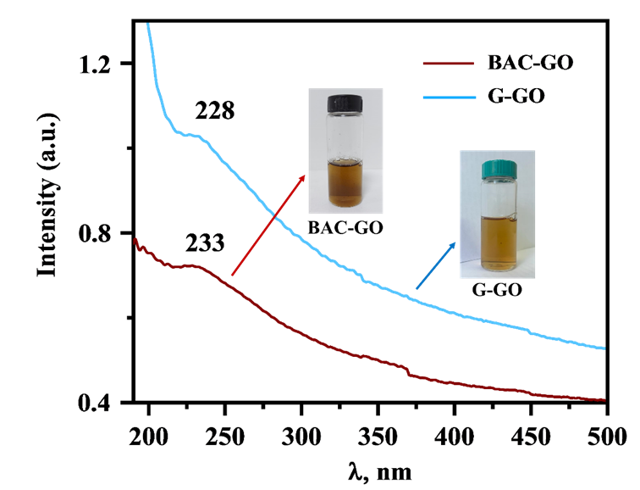

Exfoliation of graphene oxide (GO)

In the last stage of GO synthesis, important step is the exfoliation of multilayer graphene oxide sheets into few-layer graphene sheets. As a result of oxidizing graphite with strong oxidizers by the Hummers method, graphene oxide has a large number of oxygen-containing functional groups on both sides and edges of the graphite sheet, which helps to increase the distance between the layers. The process of exfoliation of graphene oxide is carried out using centrifugation and ultrasonic treatment, as a result of which GO is exfoliated into multilayer, even single-layer sheets. The GO suspension was treated with a centrifuge at a rotation speed of 5000 rpm, then processed by ultrasound at a frequency of 45 kHz (UZTA-0.15 / 22-0, Russia) at a temperature of 25 °C for 60 minutes (Figure 1) [1-3].

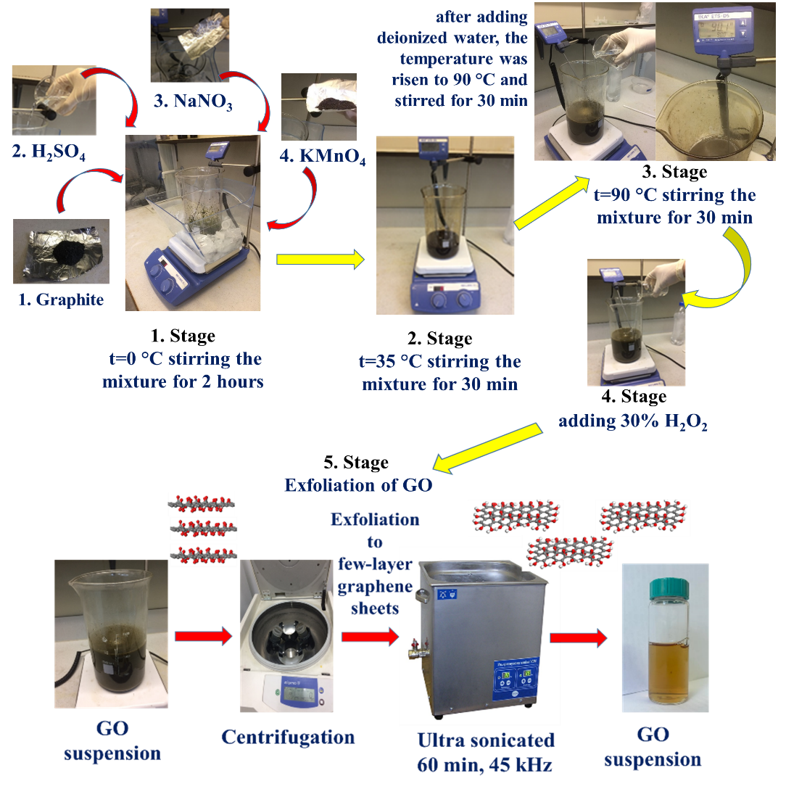

Figure 1. Stage of synthesis GO suspension.

UV-Vis Analysis of BAC–GO and G–GO
Figure 2 shows the relative UV spectrum of BAC- and graphite-derived GO. In the spectrum of BAC–GO, an absorption band was observed at a wavelength of 228 nm, and for G–GO, a wavelength of 233 nm was observed. This indicates the presence of a π-π* bond of the aromatic ring in the GO molecule and C=O bonds in the epoxy; carbonyl groups formed after strong oxidation [3,4] (Table 1). The obtained results are in good agreement with other studies [5–7] in which absorption was found in the 220–240 nm region.
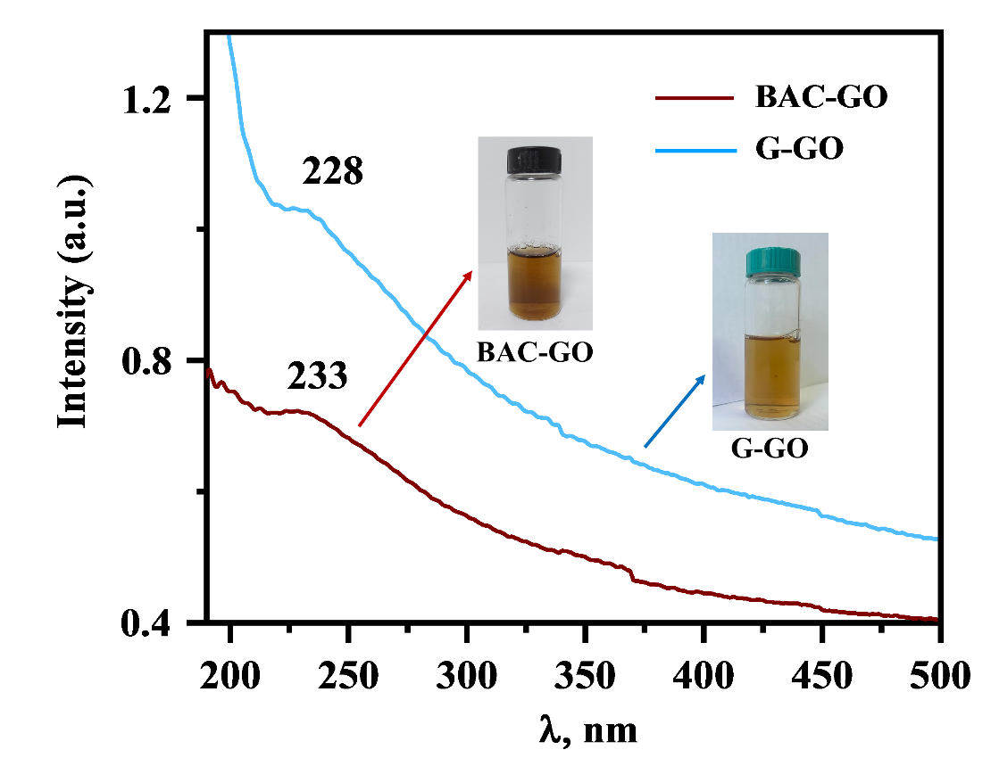
Figure 2. UV spectra of G–GO and BAC–GO suspension.

According to the obtained UV spectra, it is found that GO from graphite and BAC are similar, with only a noticeable difference in their intensities.

Questions
- Preparation of GO suspension
- Exfoliation of graphene oxide (GO)
- Preparation of GO

REFERENCES
- Du J. and Cheng H.M.: The Fabrication, Properties, and Uses of Graphene/Polymer Composites. J. Macromolecular chemistry and physics 213,(10-11) (2012) 1060–1077. https://doi.org/10.1002/macp.201200029
- Iijima, S., and Ichihashi, T. Single-shell carbon nanotubes of 1-nm diameter. J. Nature 363, 603–605 (1993). doi: 10.1038/363603A0
- Bethune, D.S., Kiang, C.H., Devries, M.S., Gorman, G., Savoy, R., Vazquez, J., and Beyers, R.: Cobalt-catalysed growth of carbon nanotubes with single-atomic-layer walls. J. Nature 363, 605–607 (1993). DOI:10.1038/363605a0
- Singh, V., Joung, D., Zhai, L., Das, S., Khondaker, S.I., and Seal, S.: Graphene based materials: past, present and future. J. Progress in Materials Science 56(8), 1178–1271 (2011). https://doi.org/10.1016/j.pmatsci.2011.03.003
- Stankovich, S., Dikin, D.A., Dommett, G.H.B., et al.: Graphene-based composite materials. J. Nature 442(7100), 282–286 (2006). doi: 10.1038/nature04969
- Stoller, M.D., Park, S., Zhu, Y., et al.: Graphene-based ultracapacitors. J. Nano Lett. 8(10), 3498–3502 (2008). DOI: 10.1021/nl802558y
- Novoselov, K.S., Geim, A.K., Morozov, S.V., Jiang, D., Zhang, Y., Dubonos, S.V., Grigorieva, I.V., and Firsov, A.A.: Electric field effect in atomically thin carbon films. J. Science 306, 666–669 (2004). DOI: 10.1126/science.1102896
- Kuanyshbekov, T., Sagdollin, Z., Zhasasynov, E., Akatan, K., Kurbanova, B., Guseinov, N., Tolepov, Z., Kantay, N., Beisebekov, M. Composite Membrane Based on Graphene Oxide and Carboxymethylcellulose from Local Kazakh Raw Materials for Possible Applications in Electronic Devices. J. Compos. Sci. 7, 342 (2023). https:// doi.org/10.3390/jcs7080342

