S. AMANZHOLOV EAST KAZAKHSTAN UNIVERSITY

Department of Chemistry

Subject: Nanotechnologies and Nanomaterials

Lecture No. 9: «Becoming acquainted with the device for studying the sensitivity of OG membranes to moisture.»

Lecturer: Kuanyshbekov Tilek Kuanyshbekuly, PhD

Oskemen 2024

 | LECTURER: PhD, Associate Professor  Kuanyshbekov Tilek Kuanyshbekuly  Lecture No. 9: «Becoming acquainted with the device for studying the sensitivity of OG membranes to moisture»  Plan:  - Introduction  - Important role of Humidity sensor  - The basic units of humidity measurement  - Creation of a Humidity Sensor  - Electrophysical Characteristics of the Humidity Sensor Based on G-GO and BAC-GO  - 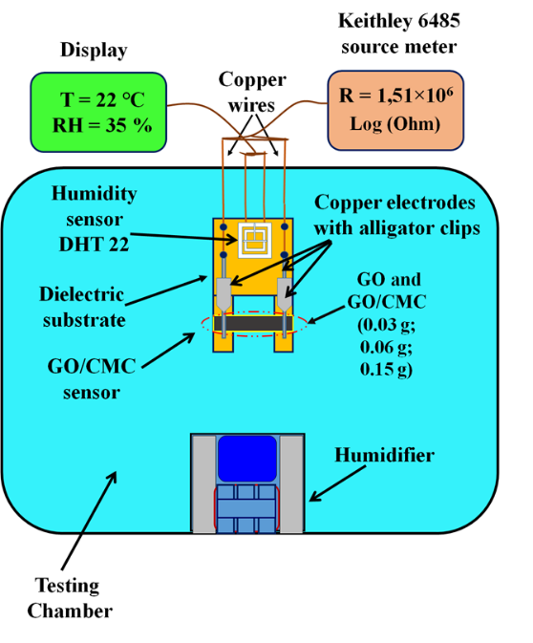

Creation of a Humidity Sensor Based on GO and GO/CMC
The design of the humidity sensor is shown in Figure 1.The GO and GO/CMC (0.03 g; 0.06 g; 0.15 g) membranes were mounted on a dielectric substrate and connected with opposite ends of copper wire (0.15 mm in diameter) as electrodes to the samples. These electrodes were attached with stable fixtures to ensure good electrical contact. Four legs of the dielectric substrate were installed. As can be seen fromFigure 3, the sensor substrate had the following dimensions: 10.5 × 5.7 cm; the thickness of the membranes was about 20 microns; the length was 3.5 cm; and the width was 1 cm. The surface of the GO and GO/CMC membranes was open on both sides, making it sensitive to the relative humidity of the environment. As can be seen from the diagram in Figure 1, a humidity sensor based on GO and GO/CMC (0.03 g; 0.06 g; 0.15 g) and an exemplary DHT 22 sensor on the Arduino platform were mounted together on a dielectric substrate and placed together in the test chamber (Figure 2) that was used to control the humidity.The DHT 22 sensor is designed to measure humidity levels in the range from 0 to 100% and the measurement accuracy is in the range of2–5%.
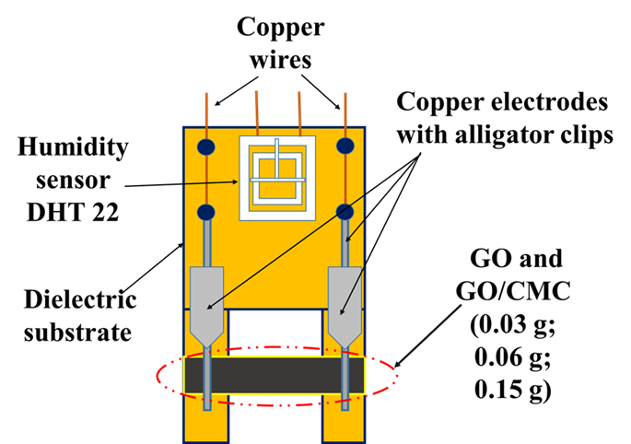
Figure 1. Structure of the humidity sensor.
A schematic representation of the installation for investigating the sensitivity of the sensor to humidity is shown in Figure 4. The humidity sensor test chamber has a main box and a humidity controller from 1% to 99% with a temperature sensor. A Keithley Picoammeter (Picoammeter 6485× Model) was used to measure the electrophysical characteristics of the humidity sensor. The Keithley 6485 meter was attached to the copper electrodes with alligator clips. The error bars were limited by an instrument error of no more than 0.5%.
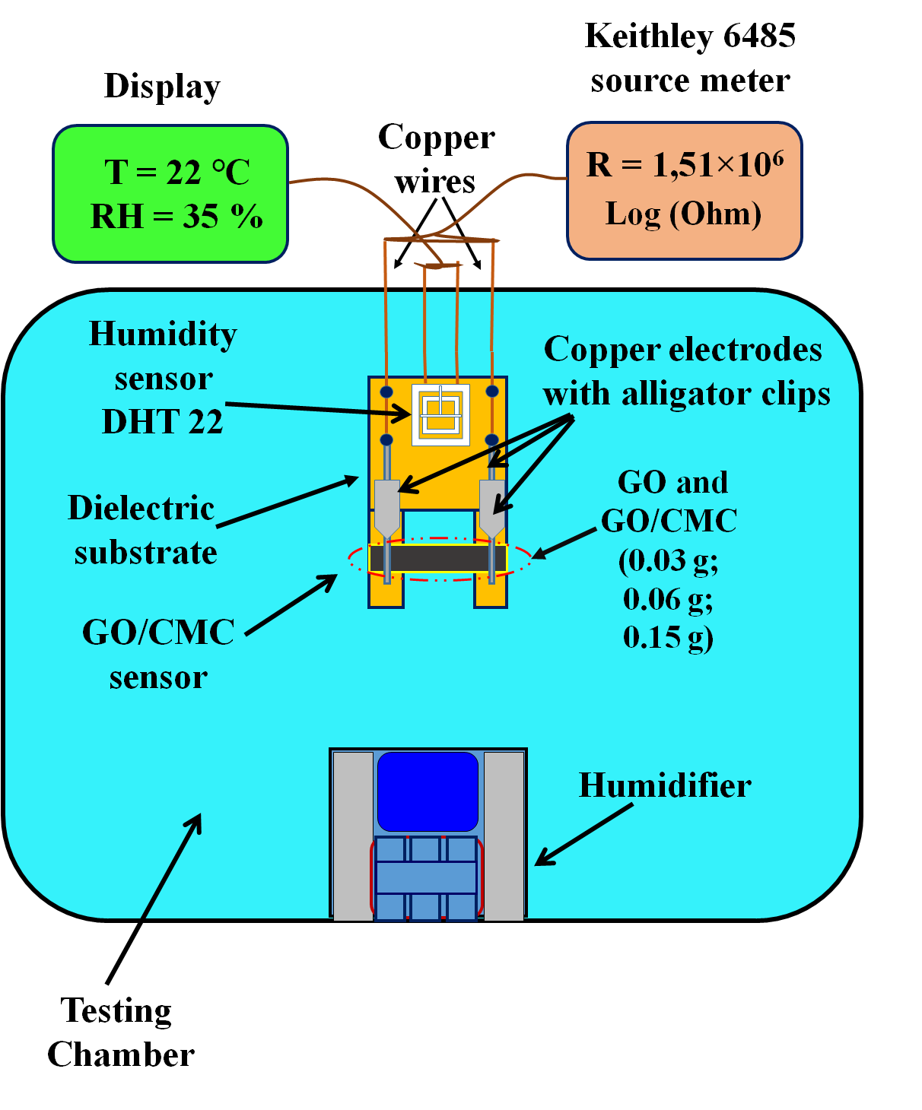
Figure 2. Schematic view of the installation.

Electrophysical Characteristics of the Humidity Sensor Based on BAC–GO and G–GO
The electrical parameters of the humidity sensor based on the BAC–GO and G–GO samples were studied as a function of humidity to determine the performance of the device. The response and recovery of the humidity sensor were tested using a Keithley (Model 6485) meter attached to copper electrodes with alligator clips. The results of the sensor response and recovery tests as a function of time are shown in Figure 3. The response and recovery time of the humidity sensor was tested in a sealed chamber with a controlled humidity level in the range from 10% to 75% (RH) with an interval of 5% (RH) for 135 sec (Figure 15). The results of this study showed that with an increase in the relative humidity, the electrical resistance of the humidity sensor decreased.
Figure 3. Dynamics of response and recovery of (1) BAC–GO and (2) G–GO.
For the G–GO sample, with an increase in humidity from 10% to 75% (RH), the electrical resistance decreased by three orders of magnitude from 1.8 × 10⁶ to 1.5 × 10⁵ Log (R, Ohm), and in the BAC–GO sample, the electrical resistance decreased—(from 2.5 × 10⁶ up to 2.5 × 10⁵) Log (R, Ohm). Accordingly, in the dynamics of recovery, with a decrease in humidity from 75% to 10%, the electrical resistance for G–GO and BAC–GO samples increased in the following order: G–GO—(from 1.5 × 10⁵ to 5 × 10⁶); BAC–GO—(from 2.5 × 10⁵ to 7.6 × 10⁶) Log (R, Ohm). In general, during the response of the sensor, the process of reducing the electrical resistance with increasing humidity is due to the fact that a large number of water molecules are adsorbed on the surface of BAC–GO and G–GO, which significantly increases its conductivity. Accordingly, during the dynamics of recovery, adsorbed water molecules are removed, which leads to an increase in resistance. Thus, according to the results of the dynamics of response and recovery of the humidity sensor, a decrease and increase in the electrical resistance values is observed in the entire range of relative humidity, which confirms the sensitivity of BAC–GO and G–GO membranes to humidity.

Questions
            - Important role of creation and application of a humidity sensor
            - Basic units of humidity measurement are relative humidity and absolute humidity and based on these measurement parameters
            - Creation of a Humidity Sensor Based on G-GO and BAC-GO
            - Electrophysical Characteristics of the Humidity Sensor Based on G-GO and BAC-GO

References
            - Farahani H., Wagiran R. and Hamidon M.N.. Review Humidity Sensors Principle, Mechanism, and Fabrication Technologies // A Comprehensive Review Sensors. – 2014. – Vol. 14. – Р.7881 – 7939;
            - Chia Y.L. and Gwo B.L. Humidity Sensors: A Review // SENSOR LETTERS. – 2005. – Vol. 3. – Р. 1 – 14.
            - Zhang, H.; Zhai, D.; He, Y. Graphene oxide/polyacrylamide/carboxymethylcellulose sodium nanocomposite hydrogel with enhanced mechanical strength: Preparation, characterization and the swelling behavior. J. RSC Adv.2014, 4, 44600–44609.
            - Lim, D.J.; Marks, N.A.; Rowles, M.R. Universal Scherrer equation for graphene fragments. Carbon2020, 162, 475–480. https://doi.org/10.1016/j.carbon.2020.02.064.
            - Hen, J.; Li, H.; Zhang, L.; Du, C.; Fang, T.; Hu, J. Direct Reduction of Graphene Oxide/Nanofbrillated Cellulose Composite Film and its Electrical Conductivity Research. J. Sci. Rep.2020, 10, 124.
            - Zhao, M.; Zhang, S.; Fang, G.; Huang, C.; Wu, T. Directionally-GrownCarboxymethyl Cellulose/Reduced Graphene Oxide Aerogel with Excellent Structure Stability and Adsorption Capacity. J. Polym. 2020, 12, 2219.
            - Ciolacu, D.E.; Suflet, D.M. Cellulose-Based Hydrogels for Medical/Pharmaceutical Applications in Biomass as Renewable Raw Material to Obtain Bioproducts of High-Tech Value; Elsevier: Amsterdam, The Netherlands, 2018
            - Mariano, M.; El Kissi, N.; Dufresne, A. Cellulose nanocrystals and related nanocomposites: Review of some properties and challenges. J. Polym.Sci.Part B Polym.Phys. 2014, 52, 791–806.
            - He, S.; Wang, G.S.; Lu, C.; Luo, X.; Wen, B.; Guo, L.; Cao, M.S. Enhanced wave absorption of nanocomposites based on the syn-thesized complex symmetrical CuS nanostructure and poly (vinylidene fluoride). J. Mater Chem. A2013, 1, 4685–4692.
            - Lim, W.H.; Yap, Y.K.; Chong, W.Y.; Ahmad, H. All-Optical Graphene Oxide Humidity Sensors. Sensors 2014, 14, 24329–24337. https://doi.org/10.3390/s141224329.
            - Ghosh, S.; Ghosh, R.; Guha, P.K.; Bhattacharyya, T.K. Humidity Sensor Based on High Proton Conductivity of Graphene Oxide. IEEE Trans. Nanotechnol. 2015, 14, 931–937. https://doi.org/10.1109/TNANO.2015.2465859.
            - Hernández-Rivera, D.; Rodríguez-Roldán, G.; Mora-Martínez, R.; Suaste-Gómez, E. A Capacitive Humidity Sensor Based on an Electrospun PVDF/Graphene Membrane. Sensors2017, 17, 1009. https://doi.org/10.3390/s17051009.
            - Anderson, J.H.; Parks, G.A. Electrical conductivity of silica gel in the presence of adsorbed water. J. Phys. Chem.1968, 72, 3662–3668. https://doi.org/10.1021/j100856a051.

