S. AMANZHOLOV EAST KAZAKHSTAN UNIVERSITY

Department of Chemistry

Subject: "Nanotechnologies and nanomaterials" (instruments, research methods)

Lecture No. 11: «Ultraviolet–visible spectroscopy (UV-vis) analysis of B-GO and G-GO»

Lecturer: Kuanyshbekov Tilek Kuanyshbekuly, PhD

Oskemen 2024


 | LECTURER: PhD, Associate Professor  Kuanyshbekov Tilek Kuanyshbekuly  Lecture No. 11: «Ultraviolet–visible spectroscopy (UV-vis) analysis of B-GO and G-GO»  Plan:  - Ultraviolet–visible spectroscopy  - Ultraviolet–visible spectroscopy (UV-vis) analysis of B-GO and G-GO  - UV-vis analysis of BAC-GO and G-GO 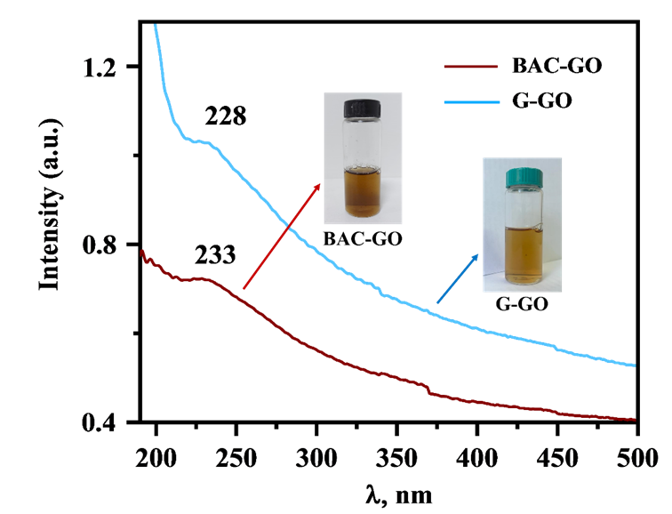

Ultraviolet–visible spectroscopy (UV-vis) analysis of B-GO and G-GO

The optical absorption spectrum of the birch activated carbon-graphene oxide (BAC–GO) and graphite-graphene oxide (G-GO) aqueous solutions obtained were recorded on a spectrophotometer (PE-5400UV, Russian) with a scanning speed of 240 nm/min and a wavelength of 190-1000 nm. A 10 mm thick quartz cuvette was used.

UV-vis analysis of BAC-GO and G-GO

Figure 1 shows the relative UV spectrum of BAC and graphite-derived GO. In the spectrum of BAC-GO, absorption was recorded at a wavelength of 228 nm, and G-GO at a wavelength of 233 nm. This indicates the presence of π-π* bond of aromatic ring in GO molecule and C=O bonds in epoxy, carbonyl groups formed after strong oxidation [1-8]. According to the obtained UV spectra, it is found that GO obtained from graphite and BAC are similar, the difference is only noticeable in their intensities.

Fig. 1 UV spectra

Questions
- Ultraviolet–visible spectroscopy
- Ultraviolet–visible spectroscopy (UV-vis) analysis of B-GO and G-GO
- UV-vis analysis of BAC-GO and G-GO

REFERENCES
- Du J. and Cheng H.M.: The Fabrication, Properties, and Uses of Graphene/Polymer Composites. J. Macromolecular chemistry and physics 213,(10-11) (2012) 1060–1077. https://doi.org/10.1002/macp.201200029
- Iijima, S., and Ichihashi, T. Single-shell carbon nanotubes of 1-nm diameter. J. Nature 363, 603–605 (1993). doi: 10.1038/363603A0
- Bethune, D.S., Kiang, C.H., Devries, M.S., Gorman, G., Savoy, R., Vazquez, J., and Beyers, R.: Cobalt-catalysed growth of carbon nanotubes with single-atomic-layer walls. J. Nature 363, 605–607 (1993). DOI:10.1038/363605a0
- Singh, V., Joung, D., Zhai, L., Das, S., Khondaker, S.I., and Seal, S.: Graphene based materials: past, present and future. J. Progress in Materials Science 56(8), 1178–1271 (2011). https://doi.org/10.1016/j.pmatsci.2011.03.003
- Stankovich, S., Dikin, D.A., Dommett, G.H.B., et al.: Graphene-based composite materials. J. Nature 442(7100), 282–286 (2006). doi: 10.1038/nature04969
- Stoller, M.D., Park, S., Zhu, Y., et al.: Graphene-based ultracapacitors. J. Nano Lett. 8(10), 3498–3502 (2008). DOI: 10.1021/nl802558y
- Novoselov, K.S., Geim, A.K., Morozov, S.V., Jiang, D., Zhang, Y., Dubonos, S.V., Grigorieva, I.V., and Firsov, A.A.: Electric field effect in atomically thin carbon films. J. Science 306, 666–669 (2004). DOI: 10.1126/science.1102896
- Kuanyshbekov, T., Sagdollin, Z., Zhasasynov, E., Akatan, K., Kurbanova, B., Guseinov, N., Tolepov, Z., Kantay, N., Beisebekov, M. Composite Membrane Based on Graphene Oxide and Carboxymethylcellulose from Local Kazakh Raw Materials for Possible Applications in Electronic Devices. J. Compos. Sci. 7, 342 (2023). https:// doi.org/10.3390/jcs7080342

