S. AMANZHOLOV EAST KAZAKHSTAN UNIVERSITY

Department of Chemistry

Subject: "Nanotechnologies and nanomaterials" (instruments, research methods)

Lecture No. 12: «Optical microscopy of GO»

Lecturer: Kuanyshbekov Tilek Kuanyshbekuly, PhD

Oskemen 2024


 | LECTURER: PhD, Associate Professor  Kuanyshbekov Tilek Kuanyshbekuly  Lecture No. 12: «Optical microscopy of GO»  Plan:  - Optical microscopy analysis of GO  - Optical properties of GO and RGO films  - FFLGN in different forms 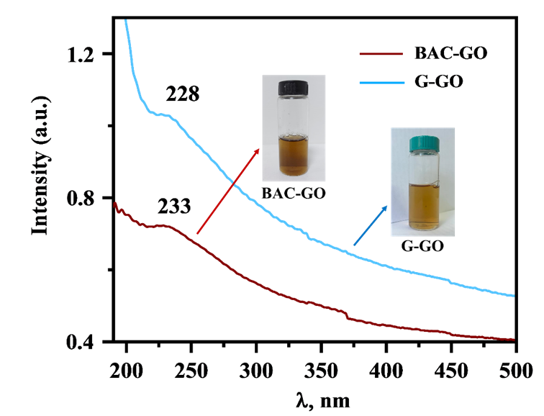

Optical microscopy analysis of GO
The surface morphologies of GO and RGO were analyzed using an optical microscope (Leica DM 6000 M), which allows to investigate solid and liquid; transparent, translucent and opaque objects with a resolution of up to 200 nm (x/y).
Optical properties of GO and RGO films
Optical images of the initial and RGO samples in the air at temperatures of RT, 80 °C, 120 °C, 160 °C, 200 °C, 240 °C, 280 °C were investigated. At these temperatures, the RGO samples appeared almost identical to each other. Additionally, there were no distinctive differences observed in the average sizes of the surface flakes in the initial GO samples. Fig. 1 shows typical optical images of the initial and reduced (280 °C) GO samples.

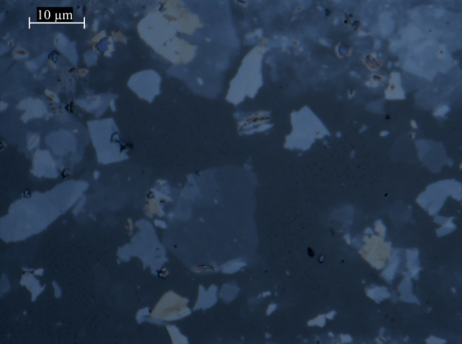 | 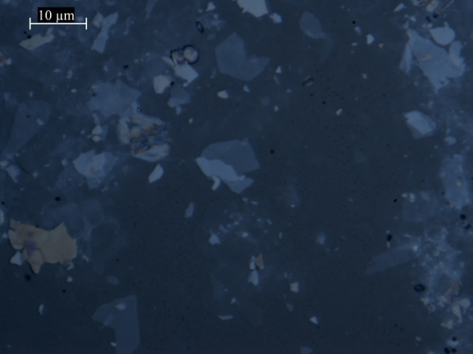
- Profile 1 | - Profile 2
Initial GO at RT
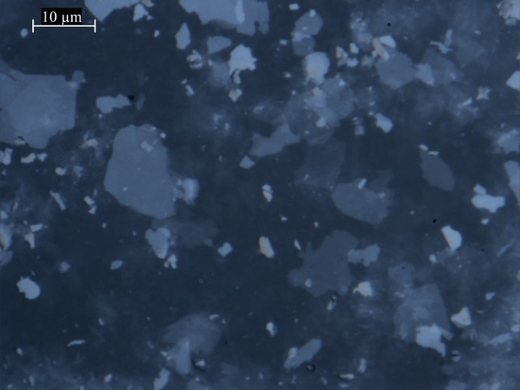 | 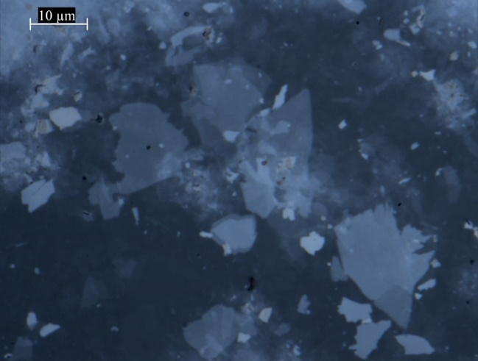
- Profile 1 | - Profile 2
RGO 280 °С
Fig. 1 Optical images of GO films

It can be seen from image 2 (a, b) that the FFLGN flakes are in solution and in dry form (Figure 2 (b)), where the FFLGN sheets are placed on the surface of the substrate.

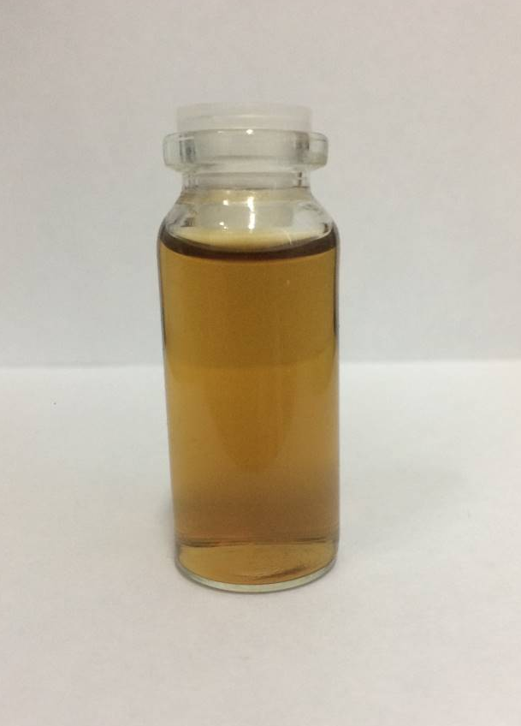  a) liquid solution FFLGN with concentration of 0.1 mg/ml | 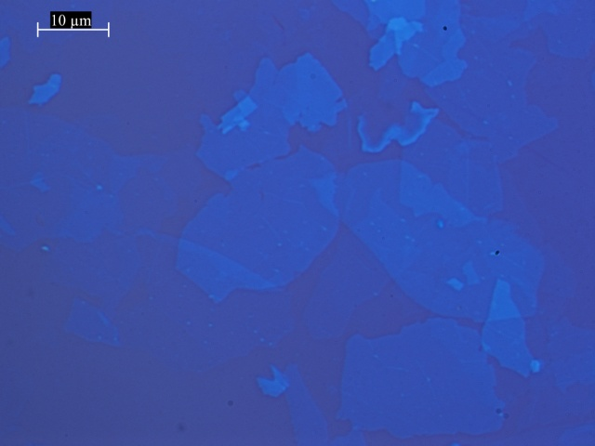  b) optical image of FFLGN on Si/SiO₂ substrate

Figure 2 – FFLGN in different forms

According to Figure 2 (a), FFLGN exfoliated into single-layer sheets of a 2D form, which is surrounded by water and alcohol molecule, also which negatively charged sheets of FFLGN promote the formation of a double layer FFLGN/water interface. In Figure 2 (b), FFLGN sheets placed on the substrate are one side in contact with the substrate, and the other side, that is, the surface with the atmosphere of air, but in any case water molecules are strongly physical sorbed on both sides of the FFLGN sheets even if they are on the surface substrates [1-8].

Questions
- Optical microscopy analysis of GO
- Optical properties of GO and RGO films
- FFLGN in different forms
REFERENCES
- Du J. and Cheng H.M.: The Fabrication, Properties, and Uses of Graphene/Polymer Composites. J. Macromolecular chemistry and physics 213,(10-11) (2012) 1060–1077. https://doi.org/10.1002/macp.201200029
- Iijima, S., and Ichihashi, T. Single-shell carbon nanotubes of 1-nm diameter. J. Nature 363, 603–605 (1993). doi: 10.1038/363603A0
- Bethune, D.S., Kiang, C.H., Devries, M.S., Gorman, G., Savoy, R., Vazquez, J., and Beyers, R.: Cobalt-catalysed growth of carbon nanotubes with single-atomic-layer walls. J. Nature 363, 605–607 (1993). DOI:10.1038/363605a0
- Singh, V., Joung, D., Zhai, L., Das, S., Khondaker, S.I., and Seal, S.: Graphene based materials: past, present and future. J. Progress in Materials Science 56(8), 1178–1271 (2011). https://doi.org/10.1016/j.pmatsci.2011.03.003
- Stankovich, S., Dikin, D.A., Dommett, G.H.B., et al.: Graphene-based composite materials. J. Nature 442(7100), 282–286 (2006). doi: 10.1038/nature04969
- Stoller, M.D., Park, S., Zhu, Y., et al.: Graphene-based ultracapacitors. J. Nano Lett. 8(10), 3498–3502 (2008). DOI: 10.1021/nl802558y
- Novoselov, K.S., Geim, A.K., Morozov, S.V., Jiang, D., Zhang, Y., Dubonos, S.V., Grigorieva, I.V., and Firsov, A.A.: Electric field effect in atomically thin carbon films. J. Science 306, 666–669 (2004). DOI: 10.1126/science.1102896
- Kuanyshbekov, T., Sagdollin, Z., Zhasasynov, E., Akatan, K., Kurbanova, B., Guseinov, N., Tolepov, Z., Kantay, N., Beisebekov, M. Composite Membrane Based on Graphene Oxide and Carboxymethylcellulose from Local Kazakh Raw Materials for Possible Applications in Electronic Devices. J. Compos. Sci. 7, 342 (2023). https:// doi.org/10.3390/jcs7080342

