S. AMANZHOLOV EAST KAZAKHSTAN UNIVERSITY

Department of Chemistry

Subject: "Nanotechnologies and nanomaterials" (instruments, research methods)

Lecture No. 13: «Synthesis of graphene oxide using the Hammers method»

Lecturer: Kuanyshbekov Tilek Kuanyshbekuly, PhD

Oskemen 2024


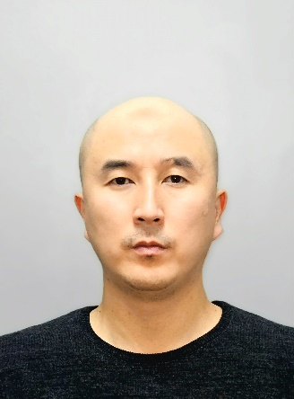 | LECTURER: PhD, Associate Professor  Kuanyshbekov Tilek Kuanyshbekuly  Lecture No. 13: «Synthesis of graphene oxide using the Hammers method»  Plan:  - Vacuum filtration  - Vacuum filtration methods  - The synthesis of GO membrane using vacuum filtration  - 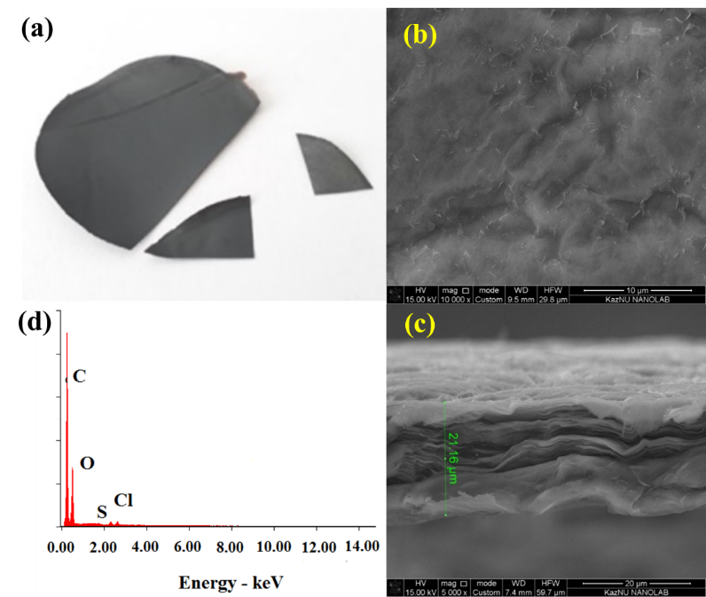

Preparation of GO membrane

In order to obtain the GO membrane, the following methods are used: filtration (vacuum, pressure filtration); casting-plating (spinning casting-plating, drop casting, two-piece coating); layer-by-layer assembly; evaporation; alignment method which is related to the shift and hybrid method [1].
From all the above methods in our experimental work, we chose vacuum filtration because of its availability, low labor intensity, nano-sized control over the membrane thickness and the possibility of high-scale production of GO membranes. GO membranes using vacuum filtration were first obtained in work [2], in which GO monolayers were connected almost in parallel. Also in this work, it is stated that during the preparation process, the physical and chemical properties of GO monolayers do not change [3, 4].
The synthesis of GO membrane using vacuum filtration consists of following main steps: the selection of the appropriate concentration of GO solution; GO membrane is deposited by passing GO solution through a porous film, then after the completion of the filtration, the obtained GO membrane is dried [3, 5]. The result is a uniform dispersible membrane with a relatively flat surface due to the fluidity of water in the solution filtration process. The thickness of obtained film depends on the concentration.
In order to prepare GO membrane, we used the vacuum filtration method. In order to do that, 200 mLsuspension of GO (C= 1.5 mg/mL) was filtered through a porous alumina membrane filter. The GO membrane was left to dry at 25±2°C for 48 h and then separated from the filter (Figure 2).

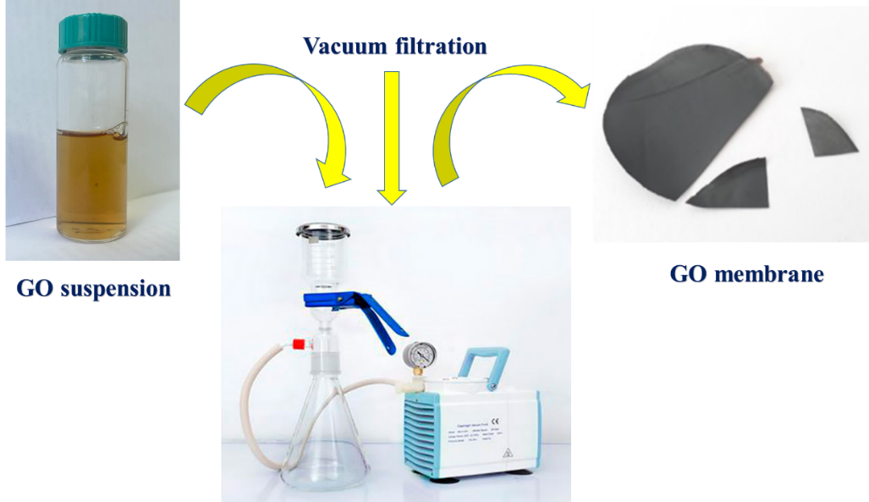

Figure 2. Preparation of GO membrane.
Surface morphology and cross section GO membrane

The SEM images of GO (a) in Fig. 2 (b –surface, c –cross section) clearly show that GO has a two-dimensional sheet-like structure. From the images (Fig. 2 (b, c)) of SEM, it can be seen that the films are stacked one above the other, and there are wrinkled areas on the GO membrane surface. According to Fig. 2 (c), the SEM image of the cross-section clearly shows that the GO membrane is layered and has a highly ordered lamellar structure. The film thickness is about 20 μm. GO membrane has a relatively flat surface, a large area, flexible and mechanically strong (Fig. 2) [3, 4]. The EDX analysis in Fig. 2 (a) shows that GO membrane contains: C – 69.02 at.%, O – 30.04 at.%, S – 1.39 at. %, Cl – 0.77 at.%

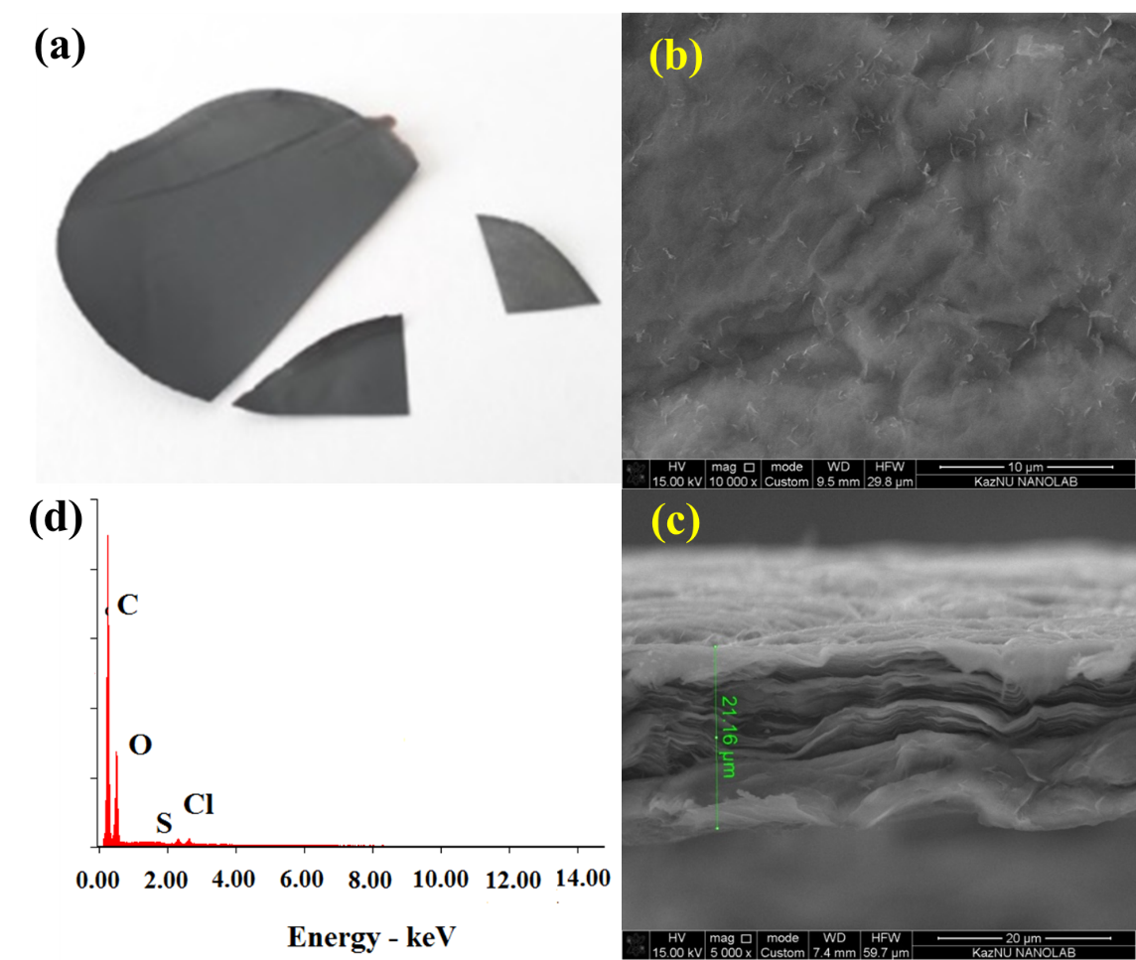

Fig. 2 Surface morphology and cross section and EDX GO membrane: a) GO membrane; b) Surface of GO membrane; c) Cross-section of GO membrane; d) EDX analysis of GO membrane.

Questions
- Vacuum filtration
- Vacuum filtration methods
- The synthesis of GO membrane using vacuum filtration

REFERENCES
- Kuanyshbekov, T., Sagdollin, Z., Zhasasynov, E., Akatan, K., Kurbanova, B., Guseinov, N., Tolepov, Z., Kantay, N., Beisebekov, M. Composite Membrane Based on Graphene Oxide and Carboxymethylcellulose from Local Kazakh Raw Materials for Possible Applications in Electronic Devices. J. Compos. Sci. 7, 342 (2023). https:// doi.org/10.3390/jcs7080342 .
- Kuanyshbekov, T.K., Akаtаn, K., Kabdrakhmanova, S.K., Nemkaeva, R., Aitzhanov, M., Imasheva, A., Kаirаtuly, E.: Synthesis of Graphene Oxide from Graphite by the Hummers Method. J. Oxidation Communications 44(2), 356–365 (2021)
- Jinxia, Ma., Dan P. and Xinfa, D.: Recent Developments of Graphene Oxide Based Membranes: A Review. J. Membranes 7(52), 29 (2017). doi: 10.3390/membranes7030052
- Piner, R.D., Ruoff, R.S., Stankovich, S., Zimney, E.J., Evmenenko, G., Dikin, D.A., Dommett, G.H.B.; Nguyen S.T.: Preparation and characterization of graphene oxide paper. J. Nature 448(7152), 457–460 (2014). DOI: 10.1038/nature06016.

