S. AMANZHOLOV EAST KAZAKHSTAN UNIVERSITY

Department of Chemistry

Subject: "Nanotechnologies and nanomaterials" (instruments, research methods)

Lecture No. 17: «Familiarization with the device for determining hardness by the suction method»

Lecturer: Kuanyshbekov Tilek Kuanyshbekuly, PhD

Oskemen 2024


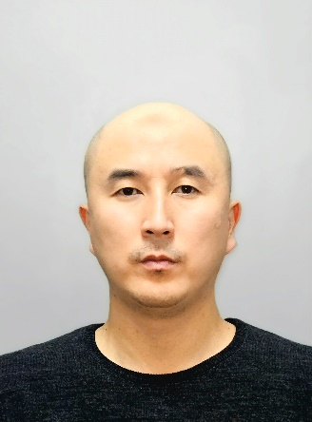 | LECTURER: PhD, Associate Professor  Kuanyshbekov Tilek Kuanyshbekuly  Lecture No. 17: «Familiarization with the device for determining hardness by the suction method»  Plan:  - Mechanical Characterization  - The mechanical characteristics of the GO and GO/CMC membranes  - 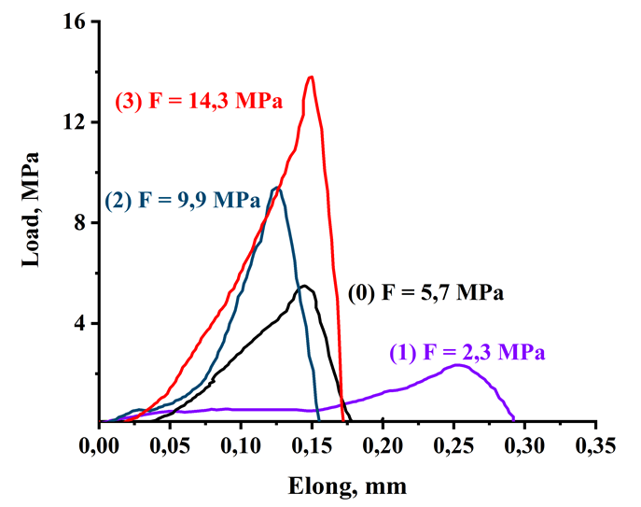

Mechanical Characterization
The mechanical characteristics of the GO and GO/CMC membranes were studied using a tensile testing machine (Tensile testing machine WDW5× kN - Time Group Inc., China) with a measured load range of 0.01–5kN and a loading speed range of 0.0005–500 mm/min. Data registration was performed automatically using a computer with a special program. During the testing of the samples under a load of 0.01 kN, the movement speed was 2 mm/min. The samples were tested until the maximum tensile force was reached or before the sample became deformed.
Mechanical Characterization
One important point of the study is the mechanical testing of the GO/CMC composites, which highlights the importance of the properties of the obtained composite membranes. Figure 1(0)–(3) show a graph of the applied force and relative elongation after stretching GO and GO with CMC (0.03 g, 0.06 g, and 0.15 g) at room temperature on WDW-5E. The obtained results regarding the mechanical properties of the GO and GO/CMC composites showed that with an increase in the added solid mass of CMC (0.03 g; 0.06 g; 0.15 g) in the GO, the mechanical tensile strength increases from 2.3 MPa to 14.3 MPa and the Young’s modulus from 2.3 MPa to 143 MPa (Figure 1(0)–(3)).
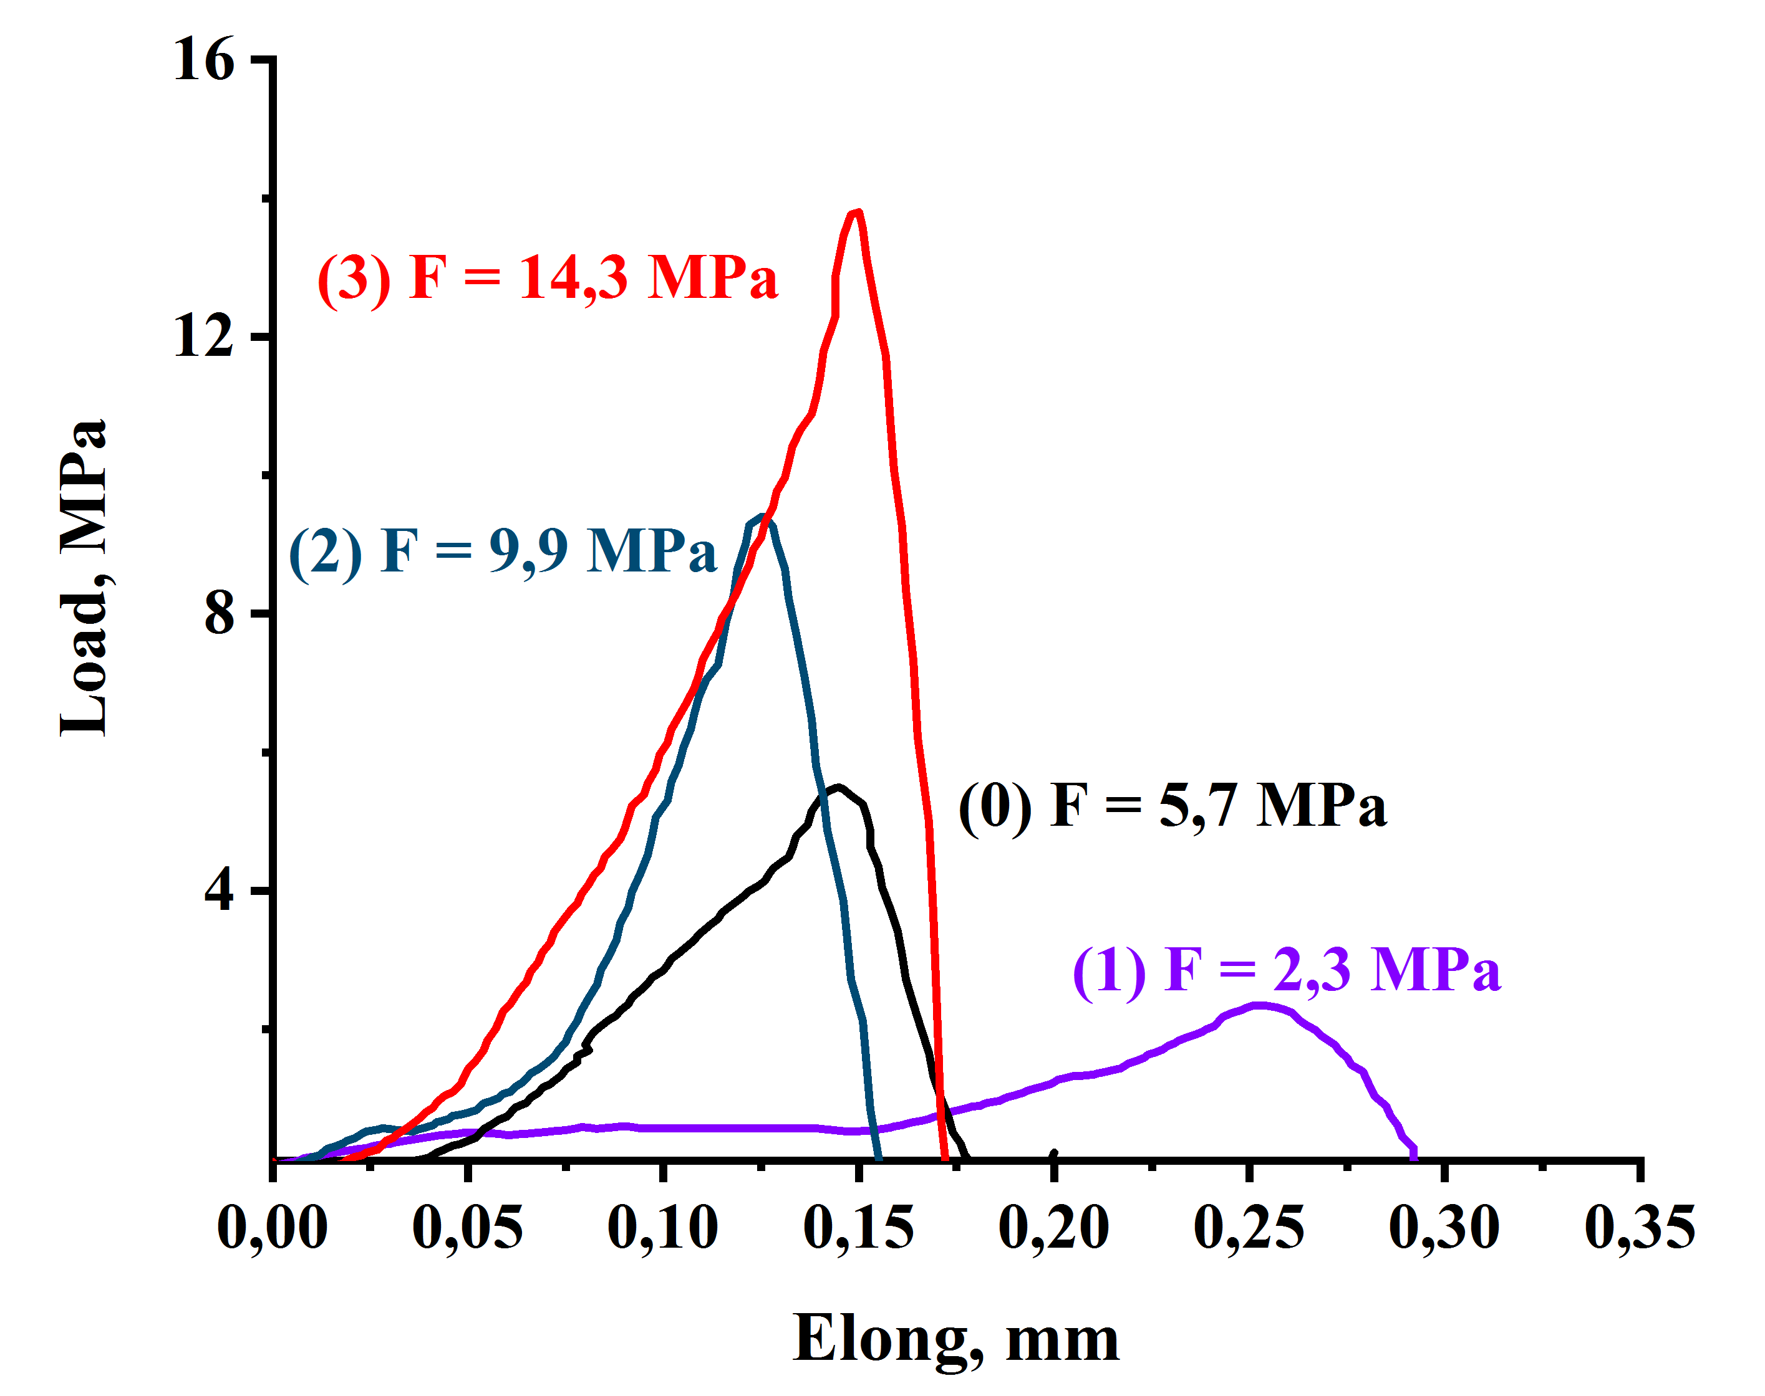
Figure 1. Mechanical tensile strengthof GO and GO/CMC samples: (0) initial GO; (1) GO/CMC 0.03 g; (2) GO/CMC 0.06 g; (3) GO/CMC 0.15 g.
According to the obtained results, the tensile strength of the initial GO was 5.7 MPa andthe Young’s modulus was 57 MPa. After adding 0.03 g of CMC to the GO, the strength limit was 2.3 MPa and the Young’s modulus was 9.2 MPa. Then, after adding 0.06 g of CMC to the GO, the ultimate strength was 9.9 MPa and the Young’s modulus was 66 MPa. Further, after adding 0.15 g of CMC to the GO, the strength limit was 14.3 MPa and the Young’s modulus was 143 MPa. Based on the results of this research, it can be seen that adding a small amount of CMC to the GO decreases the strength limit and Young’s modulus, and increasing the amount of CMC significantly increases the strength limit and Young’s modulus. In our opinion, presumably, the addition of CMC in a small amount can increase the porosity in the layer of graphene oxide film, and when the amount of CMC is further increased, it fills the pores between the GO lattices and forms a connection between the GO and CMC, leading to an increase in the Young’s modulus at the strength limit. Also, an increase in mechanical strength with an increase in the added mass of CMC particles in GO according to the Young modulus values of the GO/CMC composite membranes is explained by the presence of a large number of carboxymethyl groups in the CMC and various functional oxygen-containing groups in the GO, as well as the presence of hydrogen bonds between GO and CMC [1–4] and the ether bond –C=O, which is confirmed by the FTIR spectra. Therefore, the results regarding the mechanical testing of GO/CMC composite membranes are in good agreement with the data fromthe SEM, FTIR, XRD, and electrical characterization analyses.
Questions
- Mechanical Characterization
- The mechanical characteristics of the GO and GO/CMC membranes

References
- Hen, J.; Li, H.; Zhang, L.; Du, C.; Fang, T.; Hu, J. Direct Reduction of Graphene Oxide/Nanofbrillated Cellulose Composite Film and its Electrical Conductivity Research. J. Sci. Rep.2020, 10, 124.
- Zhao, M.; Zhang, S.; Fang, G.; Huang, C.; Wu, T. Directionally-GrownCarboxymethyl Cellulose/Reduced Graphene Oxide Aerogel with Excellent Structure Stability and Adsorption Capacity. J. Polym. 2020, 12, 2219.
- Ciolacu, D.E.; Suflet, D.M. Cellulose-Based Hydrogels for Medical/Pharmaceutical Applications in Biomass as Renewable Raw Material to Obtain Bioproducts of High-Tech Value; Elsevier: Amsterdam, The Netherlands, 2018.
- Yu, H.; Hong, H.-J.; Kim, S.M.; Ko, H.C.; Jeong, H.S. Mechanically enhanced graphene oxide/carboxymethyl cellulose nanofibril composite fiber as a scalable adsorbent for heavy metal removal. Carbohydr. Polym.2020, 240, 116348. https://doi.org/10.1016/j.carbpol.2020.116348.

