S. AMANZHOLOV EAST KAZAKHSTAN UNIVERSITY

Department of Chemistry

Subject: "Nanotechnologies and nanomaterials" (instruments, research methods)

Lecture No. 18: «Measuring the masses of reagents used in synthesis»

Lecturer: Kuanyshbekov Tilek Kuanyshbekuly, PhD

Oskemen 2024


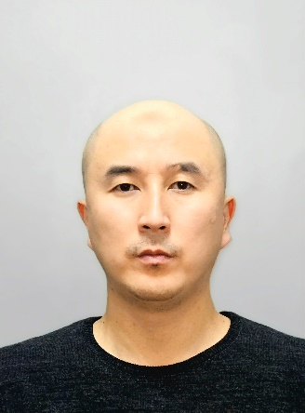 | LECTURER: PhD, Associate Professor  Kuanyshbekov Tilek Kuanyshbekuly  Lecture No. 18: «Measuring the masses of reagents used in synthesis»  Plan:  - Preparation of GO suspension  - Exfoliation of graphene oxide (GO)  - Preparation of GO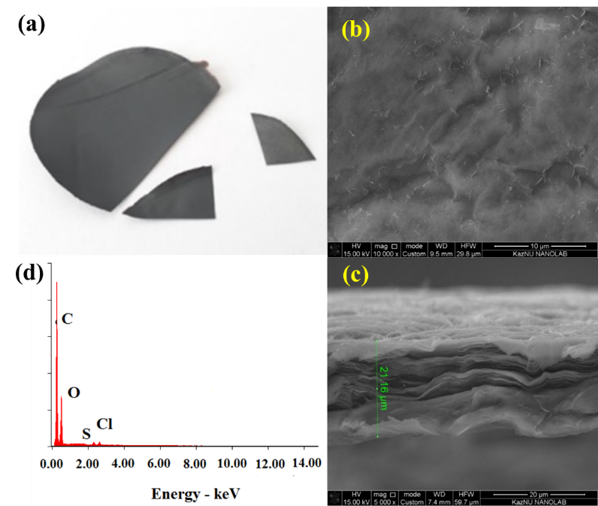

Materials
In this study,the following materials were used:potassium permanganate (KMnO₄, 99%), sodium nitrate (NaNO₃, 99%), hydrochloric acid (HCl, 35%), graphite obtained from theOgnevsk ore field (Ognevka mine) located in the Ulan district, East Kazakhstan region, hydrogen peroxide (H₂O₂, 31%), glacial acetic acid (CH₃COOH, ≥85%), ethanol (C₂H₅OH, 96%), sulfuric acid (H₂SO₄, 98%), sodium hydroxide NaOH, ≥99%), trichloroacetic acid (Cl₃CHCOOH, 99%) obtained from Alita LLP (Kazakhstan), and deionized water. All other reagents were of analytical grade and were used without additional purification.

Preparation of GO suspension
Graphene oxide was synthesized by two stages [1-8]: oxidation of graphite and exfoliation of graphite oxide, which is shown in Fig. 1, 2. The GO was prepared by the modified Hammers method using pure natural graphite. First, 23 ml of concentrated H₂SO₄ were added to a 250 mL ice flask at 0°C, which was filled with 1 g of graphite, after 0.5 g of sodium nitrate was added. Then, while stirring the mixture with a mechanical stirrer, 3 g of solid potassium permanganate was gradually added in the temperature below 20 °C for 2 h. After raising the temperature of the mixture to 35 °C, it was maintained for 30 min at this temperature, then, deionised water was added, after the temperature rose to 90°C and stirred for 30 min. Finally, 30% hydrogen peroxide was added until the color of the mixture changed to bright yellow and gas evolution ceased. Then the product was filtered and washed several times in 5% hydrochloric acid solution to remove metal ions, after washed with deionised water to remove acids. GO was synthesized according to our previous works [2, 3]. The GО synthesis process is presented below in a specific sequence (Fig. 1).

Exfoliation of graphene oxide (GO)

In the last stage of GO synthesis, important step is the exfoliation of multilayer graphene oxide sheets into few-layer graphene sheets. As a result of oxidizing graphite with strong oxidizers by the Hummers method, graphene oxide has a large number of oxygen-containing functional groups on both sides and edges of the graphite sheet, which helps to increase the distance between the layers. The process of exfoliation of graphene oxide is carried out using centrifugation and ultrasonic treatment, as a result of which GO is exfoliated into multilayer, even single-layer sheets. The GO suspension was treated with a centrifuge at a rotation speed of 5000 rpm, then processed by ultrasound at a frequency of 45 kHz (UZTA-0.15 / 22-0, Russia) at a temperature of 25 °C for 60 minutes (Fig. 1) [3].

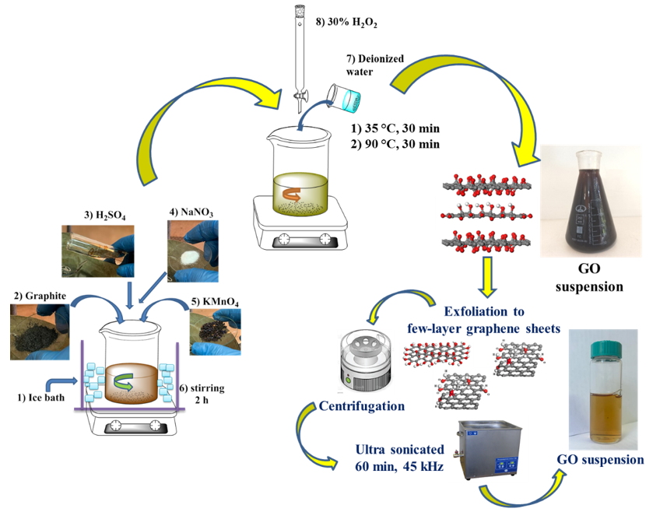

Fig. 1 Stage of synthesis GO suspension

Preparation of GO
Graphene oxide was synthesized by two stages [4, 6-8]: oxidation of graphite and exfoliation of graphite oxide, which is shown in Figure 1, 2. The GO was prepared by the modified Hammers method using pure natural graphite. First, 23 ml of concentrated H₂SO₄ were added to a 250 mL ice flask at 0°C, which was filled with 1 g of graphite, after 0.5 g of sodium nitrate was added. Then, while stirring the mixture with a mechanical stirrer, 3 g of solid potassium permanganate was gradually added in the temperature below 20 °C for 2 h. After raising the temperature of the mixture to 35 °C, it was maintained for 30 min at this temperature, then, deionised water was added, after the temperature rose to 90°C and stirred for 30 min. Finally, 30% hydrogen peroxide was added until the color of the mixture changed to bright yellow and gas evolution ceased. Then the product was filtered and washed several times in 5% hydrochloric acid solution to remove metal ions, after washed with deionised water to remove acids. GO was synthesized according to our previous works [5, 7]. The GО synthesis process is presented below in a specific sequence (Figure 2).
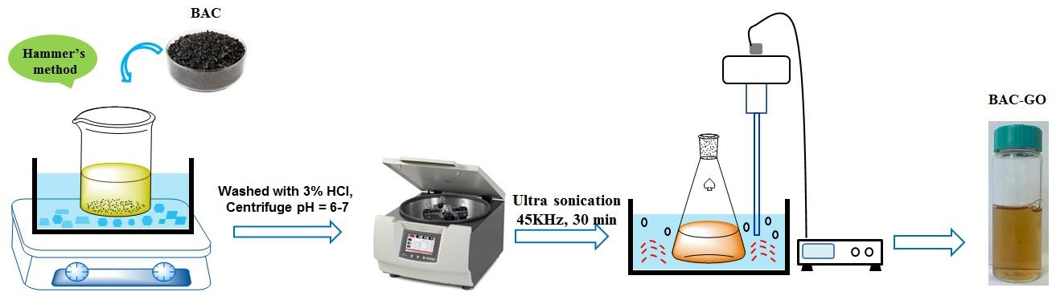

Fig. 2 Scheme representing the preparation of GO

Questions
- Preparation of GO suspension
- Exfoliation of graphene oxide (GO)
- Preparation of GO

REFERENCES
- Du J. and Cheng H.M.: The Fabrication, Properties, and Uses of Graphene/Polymer Composites. J. Macromolecular chemistry and physics 213,(10-11) (2012) 1060–1077. https://doi.org/10.1002/macp.201200029
- Iijima, S., and Ichihashi, T. Single-shell carbon nanotubes of 1-nm diameter. J. Nature 363, 603–605 (1993). doi: 10.1038/363603A0
- Bethune, D.S., Kiang, C.H., Devries, M.S., Gorman, G., Savoy, R., Vazquez, J., and Beyers, R.: Cobalt-catalysed growth of carbon nanotubes with single-atomic-layer walls. J. Nature 363, 605–607 (1993). DOI:10.1038/363605a0
- Singh, V., Joung, D., Zhai, L., Das, S., Khondaker, S.I., and Seal, S.: Graphene based materials: past, present and future. J. Progress in Materials Science 56(8), 1178–1271 (2011). https://doi.org/10.1016/j.pmatsci.2011.03.003
- Stankovich, S., Dikin, D.A., Dommett, G.H.B., et al.: Graphene-based composite materials. J. Nature 442(7100), 282–286 (2006). doi: 10.1038/nature04969
- Stoller, M.D., Park, S., Zhu, Y., et al.: Graphene-based ultracapacitors. J. Nano Lett. 8(10), 3498–3502 (2008). DOI: 10.1021/nl802558y
- Novoselov, K.S., Geim, A.K., Morozov, S.V., Jiang, D., Zhang, Y., Dubonos, S.V., Grigorieva, I.V., and Firsov, A.A.: Electric field effect in atomically thin carbon films. J. Science 306, 666–669 (2004). DOI: 10.1126/science.1102896
- Kuanyshbekov, T., Sagdollin, Z., Zhasasynov, E., Akatan, K., Kurbanova, B., Guseinov, N., Tolepov, Z., Kantay, N., Beisebekov, M. Composite Membrane Based on Graphene Oxide and Carboxymethylcellulose from Local Kazakh Raw Materials for Possible Applications in Electronic Devices. J. Compos. Sci. 7, 342 (2023). https:// doi.org/10.3390/jcs7080342

