S. AMANZHOLOV EAST KAZAKHSTAN UNIVERSITY

Department of Chemistry

Subject: Nanotechnologies and Nanomaterials

Lecture No. 1: «Characterization of FFLGN by Raman spectroscopy»

Lecturer: Kuanyshbekov Tilek Kuanyshbekuly, PhD

Oskemen 2024

 | LECTURER: PhD, Associate Professor  Kuanyshbekov Tilek Kuanyshbekuly  Lecture No. 1: «Characterization of FFLGN by Raman spectroscopy»  Plan:  - Introduction  - Characterization of FFLGN by Raman spectroscopy  - Raman spectra  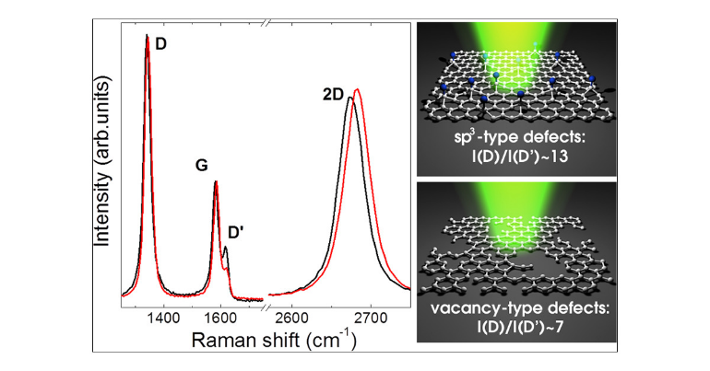

- Introduction
Raman spectroscopy is a fundamental method for studying characteristics of carbon nanostructures, the transverse size of crystals, the density of defects, and the quality of the graphene layer and is used to describe the quality of graphene in manufacturing processes since it is not destructive [1–24]. Basically, the Raman spectra of carbon and carbon nanomaterials are characterized by two main peaks, designated as G and D peaks near 1589 and 1351 cm⁻¹. The G peak originates from stretching of sp² bonded carbon, while the D peak is due to the breathing mode of the C6 hexagonal ring, typically observed in disordered sp²-bonded carbon. In the case of graphite and few-layered graphene nanostructures, the Raman spectra present three main peaks, D, G, and a 2D peak. The 2D peak around 2730 cm⁻¹ represents the second order of the D band; however, unlike the D band, the 2D peak does not require the presence of defects to be observed in graphitic materials. Increase in FWHM and a decrease in intensity of the 2D peak indicate the high level of disorder in sp² graphitic structures.
- Characterization of FFLGN by Raman spectroscopy
The Raman spectra of FFLGN, like graphene, have G and D bands, the first order of scattering of the E_{2g} phonon of sp² carbon atoms, G, the band is reflected around 1580 cm⁻¹, and also occurs due to stretching the C–C bond in the basal plane, which is characteristic of all sp² hybridized carbon materials, and the D band appears in zone of 1200–1400 cm^{–1} and indicates a certain amount of disorder, defect (disorder) or edges in the carbon structure [6, 7].
D and G bands have certain differences compared to graphite and graphene. In FFLGN, the D band is wider and more intense, while the G band is suppressed [8, 9] and significantly broadened and sometimes slightly mixed to higher frequencies [10, 11]. This shift may be due to the doping effects [11], with the result that doping will affect the mixing of the G band [12, 13].
D, G, and 2D Raman scattering bands are the basis for characterizing the reduced FFLGN and determining the density of defects. In work [18] it is given that with increasing degree of functionalization, wide D, G, and 2D bands are expected, also in this paper, it is considered that the degree of functionalization cannot be determined by Raman spectroscopy.
Another issue in the Raman spectroscopy of FFLGN and reduced FFLGN is the change in spectra after reduction. The D-band in FFLGN is mainly due to chemical functionalization and the expanded quantity of sp³ C atoms, also structural defects inside the carbon skeleton. Functional groups are removed by reducing from π surfaces and from structural defects, such as vacancies or rebuilt carbon structures (five-membered or seven-membered rings) dominate [18].
As described above, the D band in graphene can be caused by structural defects or functional additions, as in FFLGN. Thus, by removing and adding functional groups, carbon integrity can be studied.
To determine the relative content of defects in the sp² carbon lattice, the most convenient measure is the ratio between the intensities I_{D}/I_{G}. The I_{D}/I_{G} ratio in FFLGN is more than graphene or graphite, where the D-band is often indistinguishable from the background and the I_{D}/I_{G} is of the order of 0.01. To use this ratio to quantify disorder, it is important to consider two defect modes [17]. Since the disorder in the graphene lattice begins to increase with a low-density defect, the I_{D}/I_{G} ratio also increases at first. With a further increase in the density of defects, ultimately lead to the loss of the carbon lattice, the I_{D}/I_{G} ratio begins to decrease due to nonlinear damping of all the peaks of Raman scattering when the material begins to turn into amorphous carbon [17].
In the low-density density mode, I_{D}/I_{G} can be approximated by an empirical formula linking the relation to the distance between two adjacent defects, L_{a}:

I_{D}/I_{G} = С (λ)/L_{a}²

where λ is the excitation wavelength of Raman scattering and C (λ) is an empirical parameter: C (λ) = 102 nm² for the excitation wavelength λ = 514 nm [17]. For FFLGN, L_{a} determines the size of graphite regions (domains) surrounded by oxygen-containing functional groups. For edge defects, another formula (2), the Tuinstra-Koenig ratio [14], is more appropriate:

I_{D}/I_{G} = С (λ)/L_{a}

Here, C (λ) = (2.4 × 10-10 nm⁻³)×λ⁴ [15], and λ is the wavelength of the excitation of Raman scattering. How unlike low defect density, in the high-density-defect mode, the I_{D}/I_{G} ratio depends directly on the size of the graphite cluster [16, 17]:

I_{D}/I_{G} = С (λ)/L_{a}

Here C '(514 nm) = 0.55 nm⁻² [16, 17]. As a result, the ratio between the intensities of the Raman scattering bands can serve as an estimate of the defect density in FFLGN, as well as the L_{a} value of graphite sp² hybridized carbon clusters surrounded by sp³ hybridized functionalized sites.
In consideration of this I_{D}/I_{G} dependence on the density of oxygen-containing functional groups, we expect significant changes in the Raman spectra depending on the oxidation. This was observed in experiments on oxidative etching on single and layered graphite substrates [18]: I_{D}/I_{G} increased with oxidation, which indicates a decrease in the size of graphite carbon zones.
Due to significant oxidation, at a certain time a number of defects in the graphite structure can reach an enriched point at which, due to the degradation of six-membered rings, the intensity D of the Raman band begins to decrease. At such high defect densities, the I_{D}/I_{G} ratio decreases with decreasing size of the graphite cluster according to (3).
The combination of I_{D}/I_{G} dependencies on the size of sp²-hybridized zones with low and high defect density modes provides a suitable theoretical explanation for the observed behavior and allows us to estimate that the size of the graphite zones of L_{a} decreases to ~ 1 nm during oxidation. As well as in other works on the sizes of the sp² zones in FFLGN thin films and bulk FFLGN samples obtained by the Hammers method reaches up to 2.5–6 nm [19, 21].
In the reverse process, of the reduction FFLGN, the I_{D}/I_{G} ratio changes differently for different experiments with different reduction procedures. Some studies on the chemical reduction of FFLGN showed no difference in I_{D}/I_{G} [19, 20], implying that although the oxygen-containing groups were removed by reduction and the places of defects left by these groups were not cured. Other studies show a decrease in the I_{D}/I_{G} ratio, which indicates the elimination of defects through reduction [21–23], and there are works in which an increase in the I_{D}/I_{G} ratio [14–16] is considered.
This may result from an increase in the number of disorders in the system and an increase in the intensity of the D band due to the random nucleation of small sp² zones. A no monotonic trend in the I_{D}/I_{G} ratio was also observed for experiments with gradual chemical reduction: with the first intensity ratio, D/G was reduced and then increased [17]. This is due to the growth of the sp² zones during the initial reduction leading to a decrease in the I_{D}/I_{G} ratio, followed by the random formation of smaller sp² zones within the sp³ clusters, which increased the lattice disorder and the I_{D}/I_{G} ratio [16, 18-22].
Thus, the characterization changes of the Raman spectra of FFLGN before and after thermal reduction play an important role in the analysis and identifying certain structural characteristics of the samples.
- Raman spectra
Figure 1 shows the Raman results of our graphite, G–GO, BAC, and BAC–GO samples, and, according to the shown spectra, there are distinctive features in the peak positions and shapes of the G, D, and 2D peaks, and the relative intensity (which are normalized from 0 to 1) of these peaks also varies significantly. According to the Raman spectra in graphite, G–GO, BAC, and BAC–GO samples, there is a G peak due to in-plane stretching between sp² carbon atoms and a D band recognized as a disordered band due to structural defects, edge effects and dangling sp2 carbon bonds that break the symmetry.
For the initial graphite, the positions of the D and G peaks are in the center of 1360 cm⁻¹ and 1582 cm⁻¹; the 2D peak is at 2747 cm⁻¹ (Table 2, Figure 6). After its oxidation via the Hummers’ method, an increase in the intensities of the D peak (from 0.36 to 0.88) and a position shift (from 1360 to 1357 cm⁻¹) are observed, and the G peak is broadened. However, the intensity remains almost unchanged; however, a shift in the position of the G band towards higher wave numbers (from 1582 to 1589 cm⁻¹) is more noticeable in G–GO than in the graphite sample. The increase in the intensities of the D peak is explained by the introduction of oxygen functional groups into the graphite chain [11,19–21]. Accordingly, the number of defects on the carbon surfaces increases, which contributes to a greater increase in the I_{D}/I_{G} of the G–GO sample by almost 2.5 times (from 0.36 to 0.88) compared to that of graphite (Table 2, Figure 6). A change in position of the G band towards higher wave numbers during graphite amorphization indicates the presence of double bonds that resonate with higher wave numbers, which confirms the successful oxidation of graphite via the Hummers’ method [1-24]. The shift of the G band from 1582 to 1589 in the G–GO sample, as well as the change in the intensity ratios of the D and G bands (I_{D}/I_{G}) from 0.36 to 0.88, approximately agrees with the data obtained in [2-24], where they vary in the range from 1575 to 1595 cm⁻¹.
Table 1. Functional groups of G–GO and BAC–GO according to UV and FTIR spectra.
Samples | Functional Groups
Samples | UV Spectra,  λ, Wavelength (nm) |  | FTIR Spectra,  Wavenumber (cm⁻¹)
Samples | 228 | 233 | 980 | 1054 | 1249 | 1585 | 1723 | 1420 | 3300
G–GO | presence of π-π* bond of aromatic ring in GO molecule and C=O bonds in epoxy and carbonyl groups |  | C-O-H and C=O bonds | C–O alkoxy bonds | C–O epoxy functional groups | C=C bonds of the aromatic ring | C=O bonds in carbonyl group and carboxyl groups | O-H
BAC–GO

The same distinctive changes in the shape and position of the Raman peaks are observed between the initial BAC and BAC–GO samples. The D peak of the initial BAC is located at 1360 cm⁻¹ with intensity (I_{D} = 1) and the G peak is at 1595 cm⁻¹ (I_{G} = 0.8). For BAC–GO, these peaks are centered at 1354 cm⁻¹ (I_{D} = 1) and 1598 (I_{G} = 0.7) cm⁻¹, respectively (Figure 4). After BAC oxidation, a noticeable difference is observed in the positions and intensities of the D and G peaks, with the D band shifting to lower wave numbers (from 1360 to 1354 cm⁻¹). The slight increase in the intensity of the D peak compared to the initial BAC is due to the introduction of oxygen functional groups, primarily located at the edges, or within the pores of the tunnel-shaped BAC–GO honeycomb structure (Figure 6) [1-24]. The G peak shows low intensity relative to the D peak in both the initial BAC and BAC–GO, which is explained by the fact that BAC inherently has a higher disordered structure than graphite and G–GO [84–91]. Compared to BAC, there is a shift of the G band in the BAC–GO sample towards higher wave numbers. This is due to the increase in disorder in the graphitic structure and a rise in additional defect modes, leading to the widening of this band during BAC amorphization, which agrees with the G–GO data and confirms the successful oxidation of BAC via the Hummers’ method [11,13,24,41,59,69–81,85–88]. In addition, the successful modification of BAC is indicated by the increase in the intensity ratio of the D and G bands (I_{D}/I_{G}) from 1.23 to 1.38, approximately 1.12-times higher compared to the initial BAC. This result is consistent with other studies [11,69–81], which observe D and G peak shifts in the region from 1345 to 1357, and from 1585 to 1604, respectively, with I_{D}/I_{G} ratios ranging from 1.00 to 2.21.
The most significant results of Raman scattering are the determination of the crystal size of the initial samples of graphite from BAC before and after their oxidation via the Hummers’ method, according to the following Tuinstra Koenig relation [105]:
L_{a} (nm)= (2.4 × 10⁻¹⁰) × λ⁴ (I_{D}/I_{G})⁻¹ | (3)
where λ if the laser wavelength (nm), and I_{G} and I_{D} are intensities of the G and D peaks, respectively.
According to Table 2, a change in the crystal size is observed; compared with the initial samples of graphite and BAC, after their oxidation using the Hummers’ method, the L_{a} values of graphite and G–GO samples decreased by almost 2.4 times from 33.09 nm to 13.69 nm, and in BAC, BAC–GO decreased by 1.13 times from 9.8 to 8.67. The decrease in the crystal size of G–GO depends on the structure and shape of the initial material. Since graphite crystals are mainly flaky, scaly, or lamellar, respectively, after Hummers’ method, 3D bulk graphite is able to split into multilayer and even single-layer graphene sheets, which in turn affects the size reduction [11,7–23]. Compared to G–GO, the BAC–GO sample showed the smallest decrease in values, since the initial BAC is a highly developed porous rod-like structure, which affected the insignificant change in the crystal size. The L_{a} values of the graphite, G–GO, BAC, and BAC–GO are approximately similar to the data in [11,9–24], where they vary in the range from about 18 nm to 120 nm.
In general, according to the obtained results of Raman spectroscopy (Table 2, Figure 6), in the comparison of G–GO and BAC–GO, depending on the initial samples of graphite and BAC, changes are clearly observed in the positions, intensities, and shapes of the peaks, which in turn is in good agreement with the known literature data [11,69–81]. Moreover, a good correlation between UV, XPS, IR, Raman, XRD, SEM, EDX (Figures 4–11, and determination of the level of oxygen-containing groups (Table 3), respectively, confirms the successful oxidation of graphite and BAC using the Hummers’ method. The most important point in the successful synthesis of G–GO and BAC–GO is the measurement of the intensity ratio of the D and G bands (I_{D}/I_{G}) and the determination of the level of functional oxygen-containing groups (Table 3). The incorporation of oxygen functional groups in the G–GO was more than 2.4 times greater than the initial graphite. Similar changes were observed in the ratio of the intensities of the D and G bands (I_{D}/I_{G}) of the BAC and BAC–GO samples, which increased by almost 1.13 times from that of the initial BAC, respectively, which is in good agreement with the determination of the level of oxygen-containing groups (Table 3). A distinctive difference is that the level of oxygen-containing groups and the I_{D}/I_{G} ratio of the BAC–GO sample turned out to be lower than those of G–GO, since in G–GO, the functional oxygen-containing groups were attached to the basal plane and along the edges [11,57–69]. While in BAC–GO, due to a structural feature, these groups are located at the edges, or they may have penetrated into the pores of the tunnel-shaped, rod-shaped common honeycomb structure of BAC–GO [11,69–81,97–104]. According to the known literature Raman spectra data [43–45], the D peaks were detected in the region of 1300–1400 cm⁻¹, and G peaks were detected from 1500 to 1600 cm⁻¹, coinciding well with our results and confirming the successful preparation of G–GO and BAC–GO.
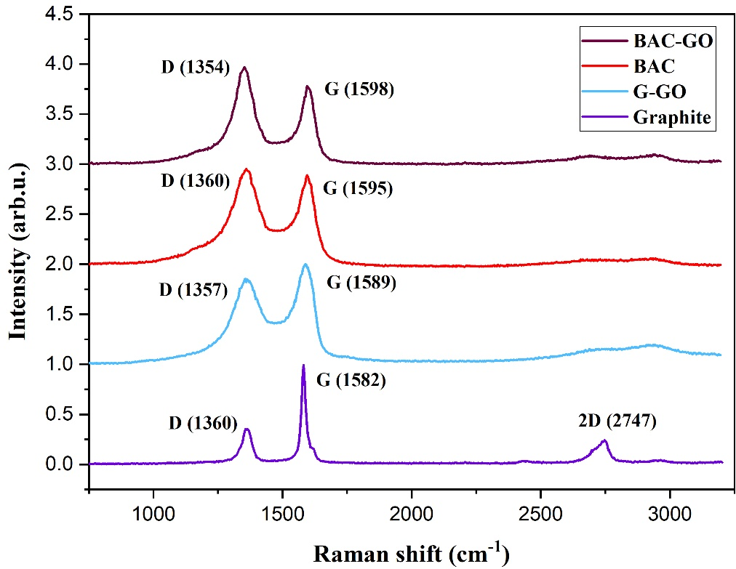
Figure 1. Raman spectra of graphite, G–GO, BAC, and BAC–GO.
Table 2. Ratios of the D and G bands (I_{D}/I_{G}) and crystal sizes of samples.
Samples | 2D | D-Band  Position (cm⁻¹) | G-Band  Position (cm⁻¹) | I_{D} (arb.u.) | I_{G} (arb.u.) | L_{a} (nm) | I_{D}/I_{G}
G | 2747 | 1360 | 1582 | 0.3642 | 1 | 33.09 | 0.3642
G–GO | Broad peak 2600–2800 | 1357 | 1589 | 0.8813 | 1 | 13.69 | 0.88
BAC | Broad peak 2600–2800 | 1360 | 1595 | 1 | 0.8148 | 9.8 | 1.23
BAC–GO | Broad peak 2600–2800 | 1354 | 1598 | 1 | 0.7158 | 8.67 | 1.39

Questions
            - Raman spectroscopy
            - Main peaks of Raman spectra
            - Characterization of FFLGN by Raman spectroscopy
            - Raman spectra

References
- Zuñiga, J.; Akashi, L.; Pinheiro, T.; Rivera, M.; Barreto, L.; Albertin, K.F.; Champi, A. Synthesis of lysozyme-reduced graphene oxide films for biosensor applications. J. Diam. Relat. Mater. 2020, 126, 109093. [Google Scholar] [CrossRef]
- Larraza, I.; Ugarte, L.; Fayanas, A.; Gabilondo, N.; Arbelaiz, A.; Corcuera, M.A.; Eceiza, A. Influence of Process Parameters in Graphene Oxide Obtention on the Properties of Mechanically Strong Alginate Nanocomposites. J. Mater. 2020, 13, 1081. [Google Scholar] [CrossRef] [PubMed]
- Kaniyoor, A.; Ramaprabhu, S. A Raman spectroscopic investigation of graphite oxide derived grapheme. J. AIP Adv. 2012, 2, 032183. [Google Scholar] [CrossRef]
- Ferrari, A.C. Raman spectroscopy of graphene and graphite: Disorder, electron–phonon coupling, doping and nonadiabatic effects. J. Solid State Commun. 2007, 143, 47–57. [Google Scholar] [CrossRef]
- Cançado, L.G.; Pimenta, M.A.; Neves, B.R.A.; Medeiros-Ribeiro, G.; Enoki, T.; Jorio, A. Anisotropy of the Raman Spectra of Nanographite Ribbons. J. Phys. Rev. Lett. 2004, 93, 047403. [Google Scholar] [CrossRef] [PubMed]
- Nemanich, R.J.; Solin, S.A. First- and second-order Raman scattering from finite-size crystals of graphite. J. Phys. Rev. B 1979, 20, 392–401. [Google Scholar] [CrossRef]
- Roscher, S.; Hoffmann, R.; Ambacher, O. Determination of the graphene-graphite ratio of graphene powder by Raman 2D band symmetry analysis. J. Anal. Methods 2019, 11, 1224–1228. [Google Scholar] [CrossRef]
- Frank, O.; Mohr, M.; Maultzsch, J.; Thomsen, C.; Riaz, I.; Jalil, R.; Galiotis, C. Raman 2D-Band Splitting in Graphene: Theory and Experiment. J. ACS Nano 2011, 5, 2231–2239. [Google Scholar] [CrossRef]
- Mohr, M.; Maultzsch, J.; Thomsen, C. Splitting of the Raman 2D Band of Graphene Subjected to Strain. J. Phys. Rev. B 2010, 82, 201409. [Google Scholar] [CrossRef]
- Scardaci, V.; Compagnini, G. Raman Spectroscopy Investigationof Graphene Oxide Reduction by Laser Scribing. J. Carbon Res. 2021, 7, 48. [Google Scholar] [CrossRef]
- López-Díaz, D.; Delgado-Notario, J.A.; Clericò, V.; Diez, E.; Merchán, M.D.; Velázquez, M.M. Towards Understanding the Raman Spectrum of Graphene Oxide: The Effect of the Chemical Composition. J. Coat. 2020, 10, 524. [Google Scholar] [CrossRef]
- Kudin, K.N.; Ozbas, B.; Schniepp, H.C.; Prud’homme, R.K.; Aksay, I.A.; Car, R. Raman Spectra of Graphite Oxide and Functionalized Graphene Sheets. J. Nano Lett. 2008, 8, 36–41. [Google Scholar] [CrossRef] [PubMed]
- Sadilov, I.; Petukhov, D.; Brotsman, V.; Chumakova, A.; Eliseev, A.; Eliseev, A. Light Response and Switching Behavior of Graphene Oxide Membranes Modified with Azobenzene Compounds. J. Membr. 2022, 12, 1131. [Google Scholar] [CrossRef] [PubMed]
- Dennison, J.R.; Greg Swain, M.H. Raman Spectroscopy of Carbon Materials. J. Spectrosc. 1996, 11, 38–45. [Google Scholar]
- Wang, Y.; Alsmeyer, D.C.; McCreery, R.L. Raman Spectroscopy of Carbon Materials: Structural Basis of Observed Spectra. J. Chem. Mater. 1990, 2, 557–563. [Google Scholar] [CrossRef]
- Carvalho, A.; Costa, M.C.F.; Marangoni, V.S.; Ng, P.R.; Nguyen, T.L.H.; Castro Neto, A.H. The Degree of Oxidation of Graphene Oxide. J. Nanomater. 2021, 11, 560. [Google Scholar] [CrossRef]
- Aliyev, E.; Filiz, V.; Khan, M.M.; Lee, Y.J.; Abetz, C.; Abetz, V. Structural Characterization of Graphene Oxide: Surface Functional Groups and Fractionated Oxidative Debris. J. Nanomater. 2019, 9, 1180. [Google Scholar] [CrossRef]
- Abolhassani, M.; Griggs, C.S.; Gurtowski, L.A.; Mattei-Sosa, J.A.; Nevins, M.; Medina, V.F.; Greenlee, L.F. Scalable Chitosan-Graphene Oxide Membranes: The Effect of GO Size on Properties and Cross-Flow Filtration Performance. J. ACS Omega 2017, 2, 8751–8759. [Google Scholar] [CrossRef]
- Qian, L.; Wang, H.; Yang, J.; Chen, X.; Chang, X.; Nan, Y.; Liu, T. Amino Acid Cross-Linked Graphene Oxide Membranes for Metal Ions Permeation, Insertion and Antibacterial Properties. J. Membr. 2020, 10, 296. [Google Scholar] [CrossRef]
- Xia, S.; Ni, M.; Zhu, T.; Zhao, Y.; Li, N. Ultrathin graphene oxide nanosheet membranes with various d-spacing assembled using the pressure-assisted filtration method for removing natural organic matter. J. Desalination 2015, 371, 78–87. [Google Scholar] [CrossRef]
- Ma, F.; Li, Z.; Zhao, H.; Geng, Y.; Zhou, W.; Li, Q.; Zhang, L. Potential application of graphene oxide membranes for removal of Cs(I) and Sr(II) from high level-liquid waste. J. Sep. Purif. Technol. 2017, 188, 523–529. [Google Scholar] [CrossRef]
- Yorgun, S.; Yıldız, D. Preparation and characterization of activated carbons from Paulownia wood by chemical activation with H₃PO₄. J. Taiwan Inst. Chem. Eng. 2015, 53, 122–131. [Google Scholar] [CrossRef]
- Syafiuddin, A.; Salmiati, S.; Hadibarata, T.; Salim, M.R.; Kueh, A.B.H.; Suhartono, S. Removal of Silver Nanoparticles from Water Environment: Experimental, Mathematical Formulation, and Cost Analysis. J. Water Air Soil Pollut. 2019, 230, 102. [Google Scholar] [CrossRef]
- Cychosz, K.A.; Guillet-Nicolas, R.; Garcia-Martinez, J.; Thommes, M. Recent advances characterization of hierarchically structured nanoporous materials. J. Chem. Soc. Rev. 2017, 46, 389–414. [Google Scholar] [CrossRef] [PubMed]

