S. AMANZHOLOV EAST KAZAKHSTAN UNIVERSITY

Department of Chemistry

Subject: Nanotechnologies and Nanomaterials

Lecture No. 3: «Reduction of FFLGN»

Lecturer: Kuanyshbekov Tilek Kuanyshbekuly, PhD

Oskemen 2024


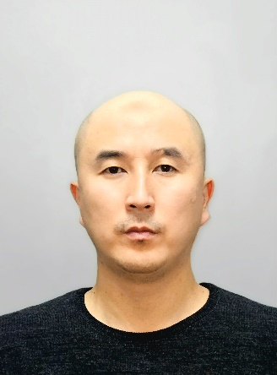 | LECTURER: PhD, Associate Professor  Kuanyshbekov Tilek Kuanyshbekuly  Lecture No. 3: «Reduction of FFLGN»  Plan:  - Introduction  - Properties of pure graphene and reduced FFLGN Functionalization of graphene  - Heat treatment  - Electrochemical reduction of FFLGN  - Process of temperature reduction of FFLGN  - Preparation of GO  - Exfoliation of graphene oxide (GO)  - Preparation of GO membrane  - Thermal reduction of GO membranes  - 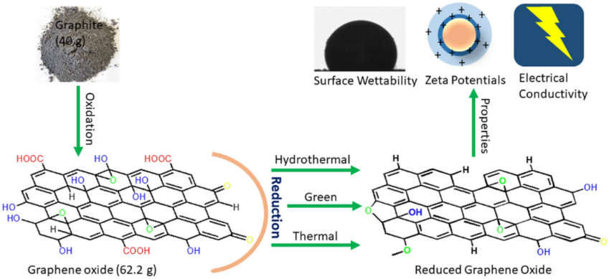

3. Reduction of FFLGN
The most attractive feature of FFLGN is the thermal reduction of graphene-like sheets, as a result of which oxygen-containing functional groups are removed, whereupon it’s electrical, optical and other properties change. Also, a reduced sheet of FFLGN is usually considered as one of the types of chemically produced graphene and has a number of other names such as functionalized graphene, chemical modified graphene, chemically transformed graphene, or reduced graphene [71].
Currently, the properties of pure graphene and reduced FFLGN are close. Therefore, the reduction of FFLGN is one of the actual processes that allows obtaining graphene-like materials in large quantities and their application is important in science and technology. In this regard, to obtain graphene in large quantities the following methods of the reduction process are used: chemical, thermal and electrochemical. As mentioned above, the use of these methods leads to obtaining FFLGN which electrical, thermal, mechanical properties are close to graphene [85].
Various chemical reagents are used in chemical reduction process, but one of the most common is hydrazine monohydrate, which is a good chemical reagent for the reduction of FFLGN [86]. The process of reducing FFLGN with hydrazine and its derivatives such as hydrazine and dimethyl hydrazine hydrate is the addition to the aqueous dispersion of FFLGN [87].
FFLGN can be reduced by heat treatment and this process is called reduction using thermal annealing [88]. Thermal annealing is usually carried out by thermal radiation. Some non-standard heating means such as microwave irradiation [89] and photo irradiation [90] for thermal reduction are used as an alternative. Also, the main advantage of microwave irradiation compared with conventional methods of heating is to heat the substance evenly and quickly [89]. In addition to the above methods, thermal reduction in a flow tube in various atmospheres (argon, vacuum, hydrogen, hydrogen/argon) is currently widely used [91]. Another method that shows a reduction of FFLGN relies on the electrochemical removal of the oxygen-containing functional groups [85].
Electrochemical reduction of FFLGN sheets or films is performed in an electrochemical cell using an aqueous buffer solution at room temperature. Reduction, as a rule, does not require a special chemical and is mainly due to the electronic exchange between FFLGN and electrodes [92, 93].
One of the important points in the process of temperature reduction of FFLGN is temperature zones at which functional oxygen-containing groups are removed in a hydrogen stream in a flow tube under the influence of various temperatures. The process of temperature reduction of FFLGN to 2000 °C has 6 important temperature zones: 140-180 °С, 180-600 °С, 600-800 °С, 800-1000 °С, and 1000-2000 °С. At a temperature of 130 °C, due to the mild evaporation of intercalated Н₂О molecules, a continuous intensive compression of GO crystals occurs. In the range of 140-180 °C, due to the rapid evaporation of intercalated Н₂О molecules, GO crystals are partially exfoliated. In the range of 180-600 °C, the intermediate layers for all types of graphene and GO are contracted with the removal of the basic carboxyl groups. Within 600-800 °C, the residual carboxyl and partially hydroxyl groups are removed as gases. Within the range, of 800-1000 °C, residual hydroxyl and partially epoxy groups are removed. In the range, of 1000-2000 °C, a decrease in the number of defects is observed [94, 95].
Thus, the difference in FFLGN and reduced FFLGN is that FFLGN is highly oxygenated, with the presence of many oxygen-containing functional groups that are smaller in reduced FFLGN. These oxygen-containing functional groups, such as epoxy, hydroxyl, carbonyl and carboxyl groups on its main plane [83] can be removed in the process of chemical and thermal reduction, as a result of which the physicochemical properties of reduced FFLGN are changing, and can also find wide application in science and technology. The experimental part of the synthesis and the study of the optical and electrical properties of FFLGN films, and also changing the structure of the FFLGN membrane after thermal reduction are given in section 3.2, and application as a humidity sensor based on the FFLGN membrane is discussed in section 3.2.8 of this work.

Preparation of GO
Graphene oxide was synthesized by two stages [26-31]: oxidation of graphite and exfoliation of graphite oxide, which is shown in Fig. 1, 2. The GO was prepared by the modified Hammers method using pure natural graphite. First, 23 ml of concentrated H₂SO₄ were added to a 250 mL ice flask at 0°C, which was filled with 1 g of graphite, after 0.5 g of sodium nitrate was added. Then, while stirring the mixture with a mechanical stirrer, 3 g of solid potassium permanganate was gradually added in the temperature below 20 °C for 2 h. After raising the temperature of the mixture to 35 °C, it was maintained for 30 min at this temperature, then, deionised water was added, after the temperature rose to 90°C and stirred for 30 min. Finally, 30% hydrogen peroxide was added until the color of the mixture changed to bright yellow and gas evolution ceased. Then the product was filtered and washed several times in 5% hydrochloric acid solution to remove metal ions, after washed with deionised water to remove acids. GO was synthesized according to our previous works [32, 33]. The GО synthesis process is presented below in a specific sequence (Fig. 1).

Exfoliation of graphene oxide (GO)
In the last stage of GO synthesis, important step is the exfoliation of multilayer graphene oxide sheets into few-layer graphene sheets. As a result of oxidizing graphite with strong oxidizers by the Hummers method, graphene oxide has a large number of oxygen-containing functional groups on both sides and edges of the graphite sheet, which helps to increase the distance between the layers. The process of exfoliation of graphene oxide is carried out using centrifugation and ultrasonic treatment, as a result of which GO is exfoliated into multilayer, even single-layer sheets. The GO suspension was treated with a centrifuge at a rotation speed of 5000 rpm, then processed by ultrasound at a frequency of 45 kHz (UZTA-0.15 / 22-0, Russia) at a temperature of 25 °C for 60 minutes (Fig. 1) [33].
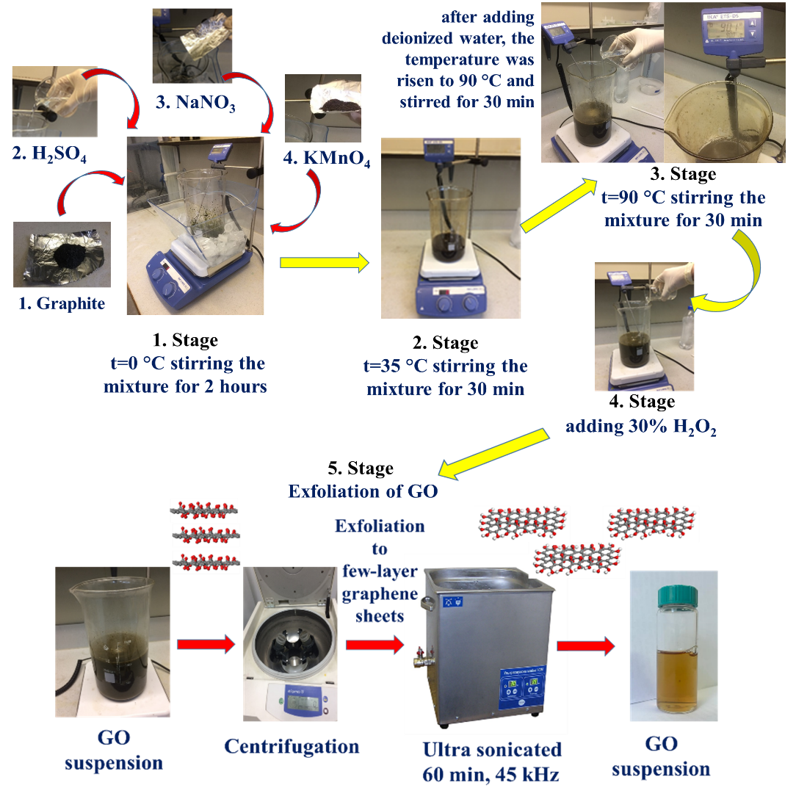

Fig. 1 Stage of synthesis GO suspension

Preparation of GO membrane
In order to obtain the GO membrane, the following methods are used: filtration (vacuum, pressure filtration); casting-plating (spinning casting-plating, drop casting, two-piece coating); layer-by-layer assembly; evaporation; alignment method which is related to the shift and hybrid method [34].
From all the above methods in our experimental work, we chose vacuum filtration because of its availability, low labor intensity, nano-sized control over the membrane thickness and the possibility of high-scale production of GO membranes. GO membranes using vacuum filtration were first obtained in work [35], in which GO monolayers were connected almost in parallel. Also in this work, it is stated that during the preparation process, the physical and chemical properties of GO monolayers do not change [34, 35].
The synthesis of GO membrane using vacuum filtration consists of following main steps: the selection of the appropriate concentration of GO solution; GO membrane is deposited by passing GO solution through a porous film, then after the completion of the filtration, the obtained GO membrane is dried [34, 36]. The result is a uniform dispersible membrane with a relatively flat surface due to the fluidity of water in the solution filtration process. The thickness of obtained film depends on the concentration.
In order to prepare GO membrane, we used the vacuum filtration method. In order to do that, 200 mLsuspension of GO (C= 1.5 mg/mL) was filtered through a porous alumina membrane filter. The GO membrane was left to dry at 252C for 48 h and then separated from the filter (Fig. 2).

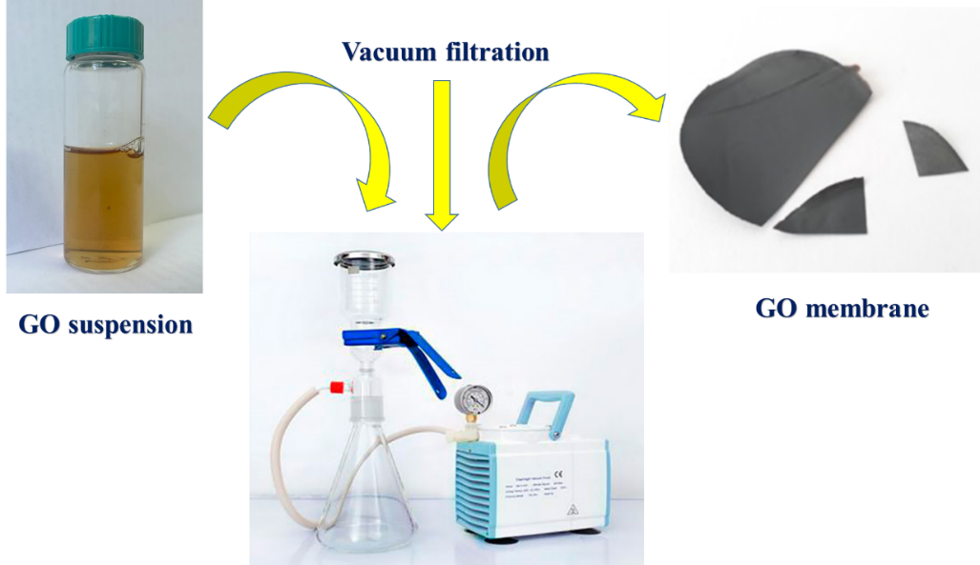

Fig. 2 Preparation of GO membrane.

Thermal reduction of GO membranes
Thermal reduction of GO membranes was carried out using a chemical vapor deposition (CVD) furnace (Nabertherm, Germany), the maximum temperature of which reached up to 1100 °C. In a typical experiment, a GO sample was taken in a ceramic boat and placed inside a CVD quartz tube. The quartz tube was sealed at both the ends with end couplings having provision for allowing gas. The furnace was purged with H₂ for 15 min at 300 sccm (hydrogen flow) to remove O₂. After purging, the flow of H₂ turned on to 100 sccm and the furnace was heated to the required temperature at a rate of 40 °C per minute. The total duration of the GO thermal reduction process was 30 min. for each sample at the following temperatures: 150 °C; 300 °C; 500 °C; 900 °C in a H₂ atmosphere. After 2 hours, the furnace was switched off and the tube was left to cool slowly to room temperature (Fig. 3).

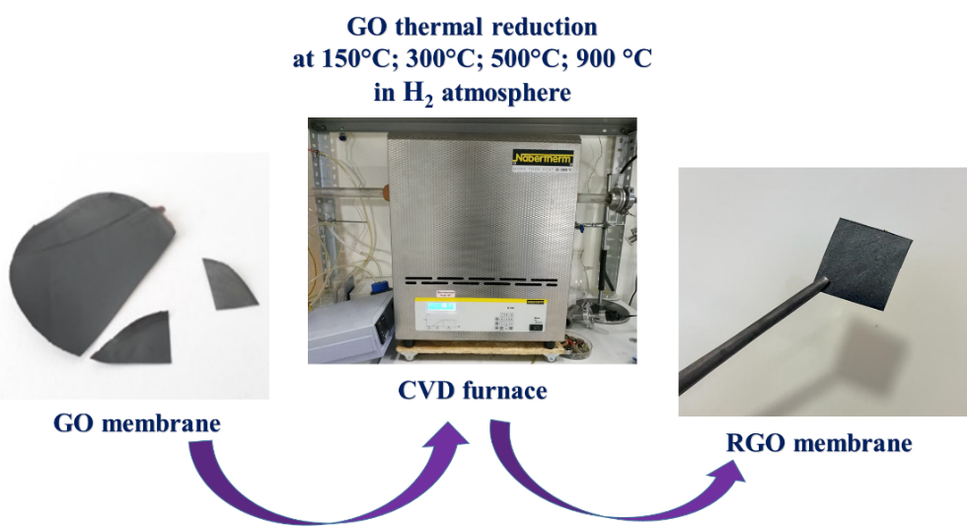

Fig. 3 Thermal reduction of GO membranes

SEM of GO and RGO membranes
The SEM images of GO in Fig. 4 ((a), (surface, cross section)) clearly show that GO has a two-dimensional sheet-like structure. From the images Fig. 7 (a) of SEM, it can be seen that the films are stacked one above the other, and there are wrinkled areas on the GO membrane surface. According to Fig. 7 (a) cross section, the SEM image of the cross-section clearly shows that the GO membrane is layered and has a highly ordered lamellar structure. The film thickness is about 20 μm.
GO membrane has a relatively flat surface, a large area, flexible and mechanically strong (Fig. 4) [28, 29]. In Fig. 7 ((b, c, d, and e), (surface, cross section)) are shown images of GO samples reduced at temperatures of 150 °C, 300 °C, 500 °C, 900 °C which were investigated on SEM. The surfaces of RGO membranes at different temperatures do not differ much between themselves; with an increasing in the temperature of reduction their thickness was decreased by ~37 % (from 22 to 14 μm), which is explained by removal of oxygen-containing functional groups. A slight increase in thickness RGO 150 °C (Fig. 4 (b – cross section, 22,90 μm)) compared to the initial GO (Fig. 4 (a – cross section, 21,16 μm)), is explained by the penetration of the heat flux into the interplanar distance, as a result of which the membrane swells due to the initial temperature effects. Then, in subsequent RGO samples, under the influence of temperature, the dimensions of the thickness and interplanar spacing of the membranes decreased [21-24, 28,29, 39-41]. As the temperature increases and as the release of water and functional groups, the specific surface of the RGO increases.

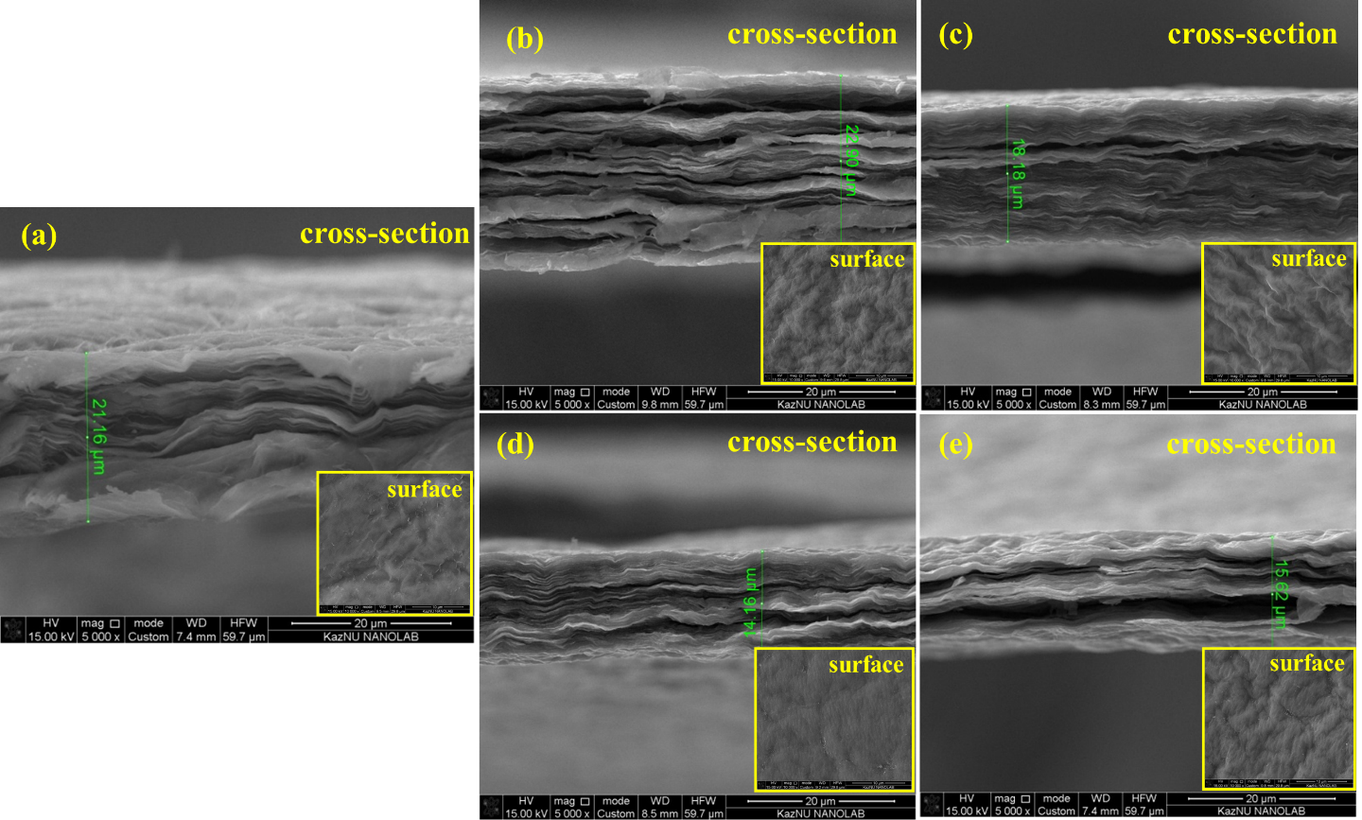
Fig. 4 SEM images of: a) initial GO; b) RGO 150 °C; c) RGO 300 °C; d) RGO 500 °C; e) RGO 900 °C

Thus, based on the obtained images, it can be concluded that RGO have a developed layered structure, in turn, can be considered as promising materials in the manufacture of electronic devices, electrical sources, in particular, lithium-ion batteries.

Raman spectroscopy of GO and RGO membranes
One of the most important research methods for characterizing the structures of the GO and RGO samples is Raman spectroscopy. The GO obtained was studied using Raman spectroscopy equipment, which is intended to study the characteristics of carbon nanostructures, as well as to describe the quality of graphene.
The ratio D/G indicates a large number of defects in the crystal lattice, and this ratio also increases during chemical reduction. The Fig. 5 (a, b, c) shows the Raman spectra of GO and RGO. According to Fig. 5 (a), the D band is located in the region of 1350 cm⁻¹, the G-band is in the region of 1587 cm⁻¹, and the ratio of these bands corresponds to 0.85.
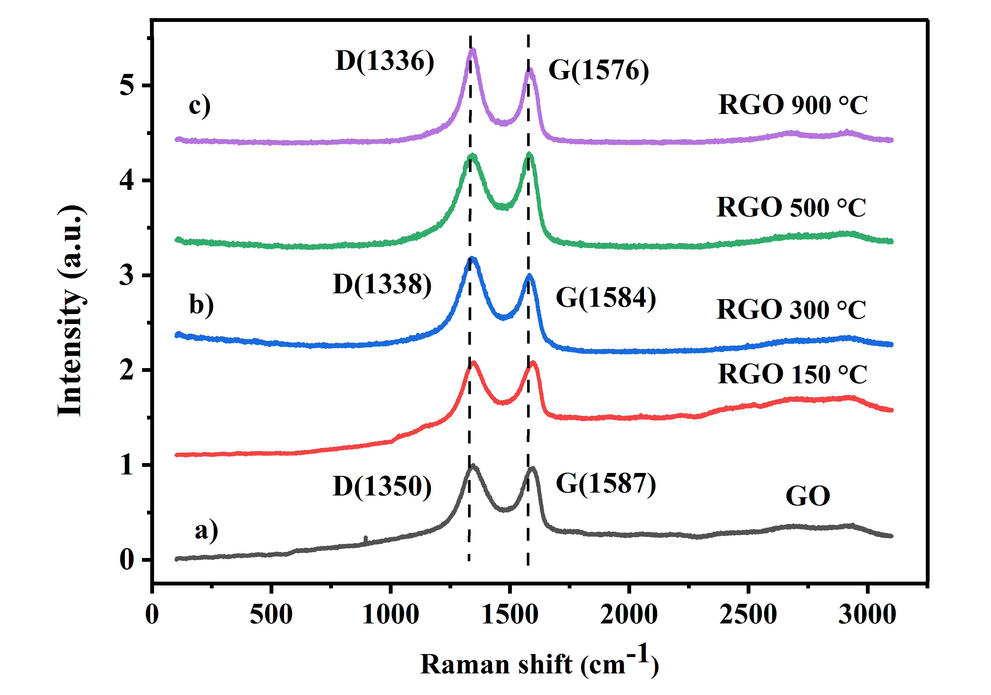

Fig. 5 Raman of GO and RGO samples

GO samples were studied, as well as RGO, which were exposed to reduction at different temperatures in a hydrogen atmosphere. The reduction of GO was carried out at temperatures of 150 °C, 300 °C, 500 °C and 900 °C. Samples after reduction were investigated by using Raman spectroscopy, which is shown in Fig. 8 (a, b, c). According to the table, when the annealing temperature is changed the intensity of the G and D bands changes, the intensity of the G band decreases from 1587 to 1576 with an increase in the reduction temperature from initial GO to 900 °C, and this changes are observed at the intensity of the D band, which also decreases. Table 1 shows the values ​​of the bands G and D. These changes in band intensities and changes in the ratio of bands mean that the removal of oxygen-containing functional groups with the thermal treatment of GO [21-24, 39-41].

Table 1
Intensity G and D bands of the GO and RGO samples at temperatures: initial, 300 °C, 900 °C
Samples, °C | G – band (cm⁻¹) | D – band (cm⁻¹)
GO | 1587 | 1350
Reduced GO 300°C | 1584 | 1338
Reduced GO 900°C | 1576 | 1336

Thus, Raman spectroscopy of GO and RGO can provide important information about the state of the grating disorder, the size of the sp² carbon regions and electronic doping from chemical additives during the oxidation, reduction or functionalization process. According to the obtained results, it was revealed that the thermal treatment of the GO membrane at different temperatures affects the intensity change and the ratio of the bands of the Raman spectroscopy, which is explained by removal of oxygen-containing functional groups.

Questions
- Most attractive feature of FFLGN
- Properties of pure graphene and reduced FFLGN
- Preparation of GO
- Exfoliation of graphene oxide (GO)
- Chemical reduction process
- Electrochemical reduction of FFLGN
- Process of temperature reduction of FFLGN

References
- 71 Eda G, Chhowalla M. Chemically derived graphene oxide: towards large-area thin-ﬁlm electronics and optoelectronics // Adv Mater. – 2010. – Vol. 22, № 22. – P. 2392 – 2415.
- 85 Dreyer D.R, Park S, Bielawski C.W., Ruoff R.S. The chemistry of graphene oxide // Chem Soc Rev. – 2010. – Vol. 39, № 1. – P. 228-40. doi: 10.1039/b917103g.
- 86 Stankovich S., Dikin D.A., Piner R.D., Kohlhaas K.A., Kleinhammes A., Jia Y., Wu Y., Nguyen S.T. and Ruoff R.S. Synthesis of graphene-based nanosheets via chemical reduction of exfoliated graphite oxide // Carbon. – 2007. – Vol. 45, № 7. – P. 1558 – 1565.
- 87 Stankovich S, Dikin D.A, Dommett G.H.B, Kohlhaas K.M, Zimney E.J, Stach E.A, et al. Graphene-based composite materials // Nature. – 2006. – Vol. 442, № 7100. – P. 282 – 286.
- 88 Schniepp H.C, Li J-L, McAllister M.J, Sai H, Herrera-Alonso M, Adamson D.H, et al. Functionalized single graphene sheets derived from splitting graphite oxide // J Phys Chem B. – 2006. – Vol. 110, № 17. – P. 8535 – 8539.
- 89 Zhu Y, Murali S, Stoller M.D, Velamakanni A, Piner R.D, Ruoff R.S. Microwave assisted exfoliation and reduction of graphite oxide for ultracapacitors // Carbon. – 2010. – Vol. 48, № 7. – P. 2118 – 2122.
- 90 Zhang Y, Guo L, Wei S, He Y, Xia H, Chen Q, et al. Direct imprinting of microcircuits on graphene oxides ﬁlm by femtosecond laser reduction // Nanotoday. – 2010. – Vol. 5, № 1. – P. 15 – 20.
- 91 Kaniyoor A, Baby T.T, Arockiadoss T, Rajalakshmi N, Ramaprabhu S. Wrinkled graphenes: A study on the effects of synthesis parameters on exfoliation-reduction of graphite oxide // J Phys Chem C. – 2011. – Vol. 115. – P. 17660 – 17669.
- 92 Zhou M, Wang Y, Zhai Y, Zhai J, Ren W, Wang F, et al. Controlled synthesis of large-area and patterned electrochemically reduced graphene oxide ﬁlms // Chem Euro J. – 2009. – Vol. 15, № 25. – P. 6116 – 6120.
- 93 Ramesha G.K, Sampath S. Electrochemical reduction of oriented graphene oxide ﬁlms: an in situ raman spectro electrochemical study // J Phys Chem C. – 2009. – Vol. 113, № 19. – P. 7985 – 7989.
- 94 Seung H.H. Chapter 5 Thermal Reduction of Graphene Oxide. Physics and Applications of Graphene - Experiments, 2011. – P.73 – 90.
- 95 Sundaram R.S, Gomez-Navarro C, Balasubramanian K, Burghard M, Kern K. Electrochemical modification of graphene // Adv Mater. – 2008. – Vol. 20. – P. 3050 – 3053.
- 96 Tuinstra F. and Koenig J.. Raman spectrum of graphite // Journal of Chemistry Physics. – 1970. – Vol. 53. – Р. 1126 – 1130.

