S. AMANZHOLOV EAST KAZAKHSTAN UNIVERSITY

Department of Chemistry

Subject: Nanotechnologies and Nanomaterials

Lecture No. 4: «Application of FFLGN membrane as a humidity sensor and comparison of its performance»

Lecturer: Kuanyshbekov Tilek Kuanyshbekuly, PhD

Oskemen 2024

 | LECTURER: PhD, Associate Professor  Kuanyshbekov Tilek Kuanyshbekuly  Lecture No. 4: «Application of FFLGN membrane as a humidity sensor and comparison of its performance»  Plan:  - Introduction  - Characteristics of humidity sensors  - Creation a humidity sensor based on an FFLGN membrane and studying its electrophysical characteristics  - Testing the humidity sensor for the stability of the capacitance  - Dependence of capacity on humidity  - The recovery and response time of the sensor  - 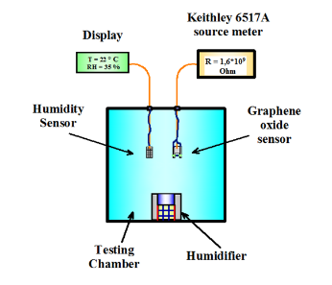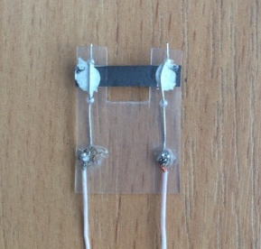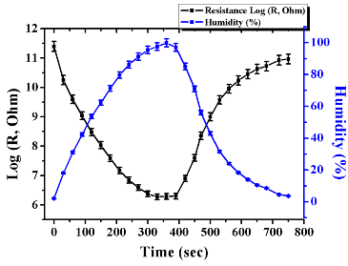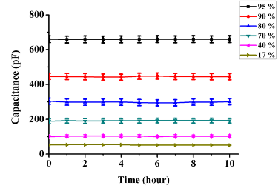

4. Application of FFLGN membrane as a humidity sensor and comparison of its performance
This section provides an overview of the application of a humidity sensor based on graphene, graphene oxide, FFLGN membrane, and other carbon materials, in turn, these materials are durable and have high thermal conductivity, as well as excellent adsorption characteristics [1], therefore they are important practical application as a humidity sensor.
The membrane based on FFLGN, GO, compared with other carbon materials, contains functional groups such as hydroxyl, carbonyl, and carboxyl on their basal plane and this makes it hydrophilic; therefore, sensors based on such materials are moisture-sensitive [2].
Therefore, according to the above-listed properties, FFLGN is currently an important material for creating humidity sensors with high sensitivity, which is necessary for such fields of engineering and science as medicine, textile industry, agriculture, biological products, scientific and technical centers, food industry and other industries [3].
To create humidity sensors, the most important electrophysical characteristics are: faster response and short recovery time; stability of work at various levels of humidity and in aggressive environments; a wide range of moisture detection, as well as the most important are the ease of manufacture technologies, low cost, which are necessary to satisfy consumers.
To achieve the above listed characteristics over the years, much attention has been paid to the creation of various types of sensors with high sensitivity based on such materials as: metal oxide nanowires; ceramic nanomaterials; silicon; semiconductor nanoparticles, etc., but despite this the creation of sensors with the above-listed characteristics remains an unsolved task to this day [4].
In this regard, as the initial material, we choose the FFLGN membrane, which is one of the potential materials to satisfy the above characteristics, and the choice of a suitable material is considered the most important factor in creating a sensitive sensor.
Due to the physicomechanical and important electronic properties of graphene and graphene-like materials, there has been more research and many studies have been done on the creation and use it as sensors for determining various gases and humidity.
The use of graphene in sensors for the determination of various gases was first demonstrated in [5], then its related structures such as FLG, GO have become more investigated and used to create nanoscale sensors [6].
Humidity sensors using graphene structures were created for the determination of NO₂, NH₃, and CO₂ gases, which were demonstrated on the basis of the following materials and principles of operation of thermally reduced graphene; epitaxial graphene; carbon nanotubes and graphene; coarse-grained GO thin film; FLG, microscale capacitive humidity sensor based on GO film; high proton conductivity GO; capacitive humidity sensor based on the Electro-spun PVDF/Graphene Membrane [7, 8-11].
We made a comparison of the performance of humidity sensors based on FFLGN with similar types of humidity sensors [12, 13-17] according to the following characteristics: dynamics of response and recovery, humidity detection range (Table 1). According to the table 1, compared to the sensors listed below, our device [4] has an advantage in response and recovery time, which has the same time of 360 s, as well as a wide range of humidity from 5-100%, and its electrophysical characteristics presented in section 3.2.8.
Of all the sensors listed, the longest response and recovery time (1200 s) in [17], besides this, the long recovery time (2300 s) is shown in [18], and in the same work the smallest response time, which is (50 s). Compared with our sensor [19], a wide range of humidity detection (0-100%) is shown in [20] and a narrow range (20-36%) in [21], the disadvantages of these devices are long response and recovery times.

Table 1 – Characteristics of humidity sensors

№ | Name of works | Sensor type | Material used | Humidity Detection Range (%) | Response time  (sec) | Recovery time  (sec)
1 | 2 | 3 | 4 | 5 | 6 | 7
1 | A Capacitive Humidity Sensor Based on an Electrospun PVDF/Graphene [16]. | capacitive | Electrospun PVDF/Graphene | 50-90 | 1000-1400 | 15-230
2 | Gas Sensors Based on Graphene [19] | conduct metric sensor | Scotch tape graphene | 5-75 | 1200 | 1000-1200
3 | Polyimide-Based Capacitive Humidity Sensor [20] | capacitive | Polyimide | 5-85 | 400-600 | 400
4 | NO₂ and humidity sensing characteristics of few-layer graphene [21] | impedance | Few-layer graphene | 4-84 | 300 | Several hours

Table continuation 1
1 | 2 | 3 | 4 | 5 | 6 | 7
5 | Resistive graphene humidity sensors with rapid and direct electrical readout [22] | resistive | Graphene | 0-25 | 130-150 | 70-100
7 | Graphene-based CO₂ sensing and it's cross sensitivity with humidity [23] | impedance | Graphene | 1-67 | 50 | 2300
8 | Room-Temperature Humidity Sensing Using Graphene Oxide Thin Films [24]. | impedance | GO | 30-60 | 100 | 2200
9 | A Capacitive humidity sensor based on ordered macroporous silicon with thin film surface coating [23] | capacitive | macroporous  silicon with a Ta₂O₅ thin film coating | 0-100 | 1200 | 1200
10 | Humidity sensor based on FFLGN membrane [26] | impedance | FFLGN membrane | 5-100 | 360 | 360

Thus, graphene and its related structures, based on the above-listed works, as well as due to physicomechanical properties, have found potential practical applications as humidity sensors and today considered as promising materials in electronics and technology, in particular, for the creation of sensitive elements. In this regard, we created a humidity sensor based on the FFLGN membrane and determined its electrophysical characteristics, which are discussed in the section 3.2.8. In comparison with different sensors, the sensor presented by us is a potential device for a commercially available product that has such advantages as a wide range of humidity, faster response, and recovery, low cost, does not require high technology and is resistant to aggressive media [20-24].

Creation a humidity sensor based on an FFLGN membrane and studying its electrophysical characteristics
In this section, we present the results of the humidity sensor research on the stability of the capacitance reading and electrical resistance under different levels of constant humidity as a function of time, also, the dependence of capacitance and the dependence of the electrical resistance on humidity. The FFLGN membrane sensor was tested under fixed humidity conditions in a wide range at room temperature for 10 hours [24-26].
The most important process in the creation of a sensor is a synthesis of initial material. In our condition, FFLGN membrane was used as initial material. To obtain this membrane, FFLGN was originally synthesized using the modified Hummers method, the synthesis of this material and its characteristics are discussed in Section 3.2.1 in Figure 28. After the synthesis of FFLGN, the FFLGN membrane was obtained from its liquid solution using vacuum filtration, the details of the preparation are indicated in section 3.2.3 in Figure 35. The characteristics of the obtained initial material FFLGN and the membrane FFLGN were investigated using SEM, Raman spectroscopy, XRD, optical microscopy, TGA results are discussed in subsections 3.2.1, 3.2.4-3.2.7 in Figures 30 (a), 38, 40 (a), 41, 42 (a), 43 (а). The obtaining results confirm with the properties of FFLGN and these results correspond with known literature data.
The design of the humidity sensor is shown in Figure 1, where the FFLGN membrane was mounted on a dielectric substrate and connected at opposite ends with copper wire (0.15 mm in diameter) as electrodes with an FFLGN sample. These electrodes were covered with conductive silver paint contacts and left to dry overnight to ensure good electrical contact [21, 22].

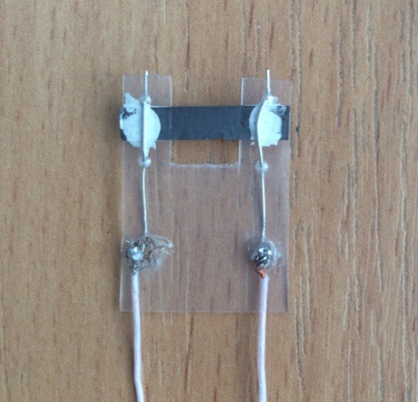

Figure 1 – Structure of the humidity sensor
The substrate of the sensor has following dimensions: 2.5*1.8 cm, the FFLGN membrane thickness is about 20 μm, as shown in Figure 1 (b), the length is 2.5 cm, and width is 0.5 cm. The surface of the FFLGN membrane is open on both sides, which allows to react sensitively to the relative humidity of the environment.
As can be seen from the schematic in Figure 1, a humidity sensor based on FFLGN and an exemplary DHT 22 sensor by the Arduino platform are placed together in the testing chamber, which was used to control the humidity and DHT 22 sensor has the following technical characteristics: calculated to measure the level of humidity in the range from 0 to 100 % and the measurement accuracy is in the range of 2-5 %. Schematic representation of installation for investigating the sensitivity of the sensor to humidity shows in Figure 2.

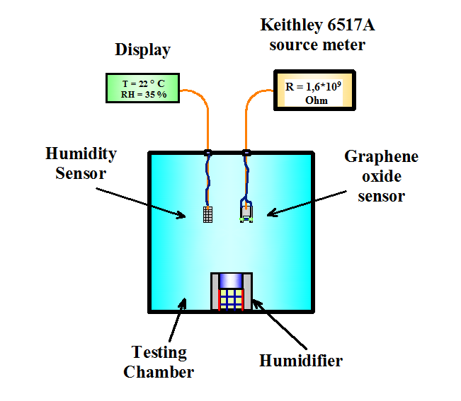

Figure 2 – Schematic view of the installation

The electro-physical parameters were studied as a function of humidity to determine the operating characteristics of the device. The stability of the electrical capacitance was monitored using the Keithley 6517A meter attached to the copper electrodes with alligator clips. The results of testing the sensor for the stability of the electrical capacitance under various levels of constant humidity, depending on the time are shown in Fig. 2. It can be seen from the results that the deviation of the electrical capacitance values of the structure for a long time does not exceed 2 %

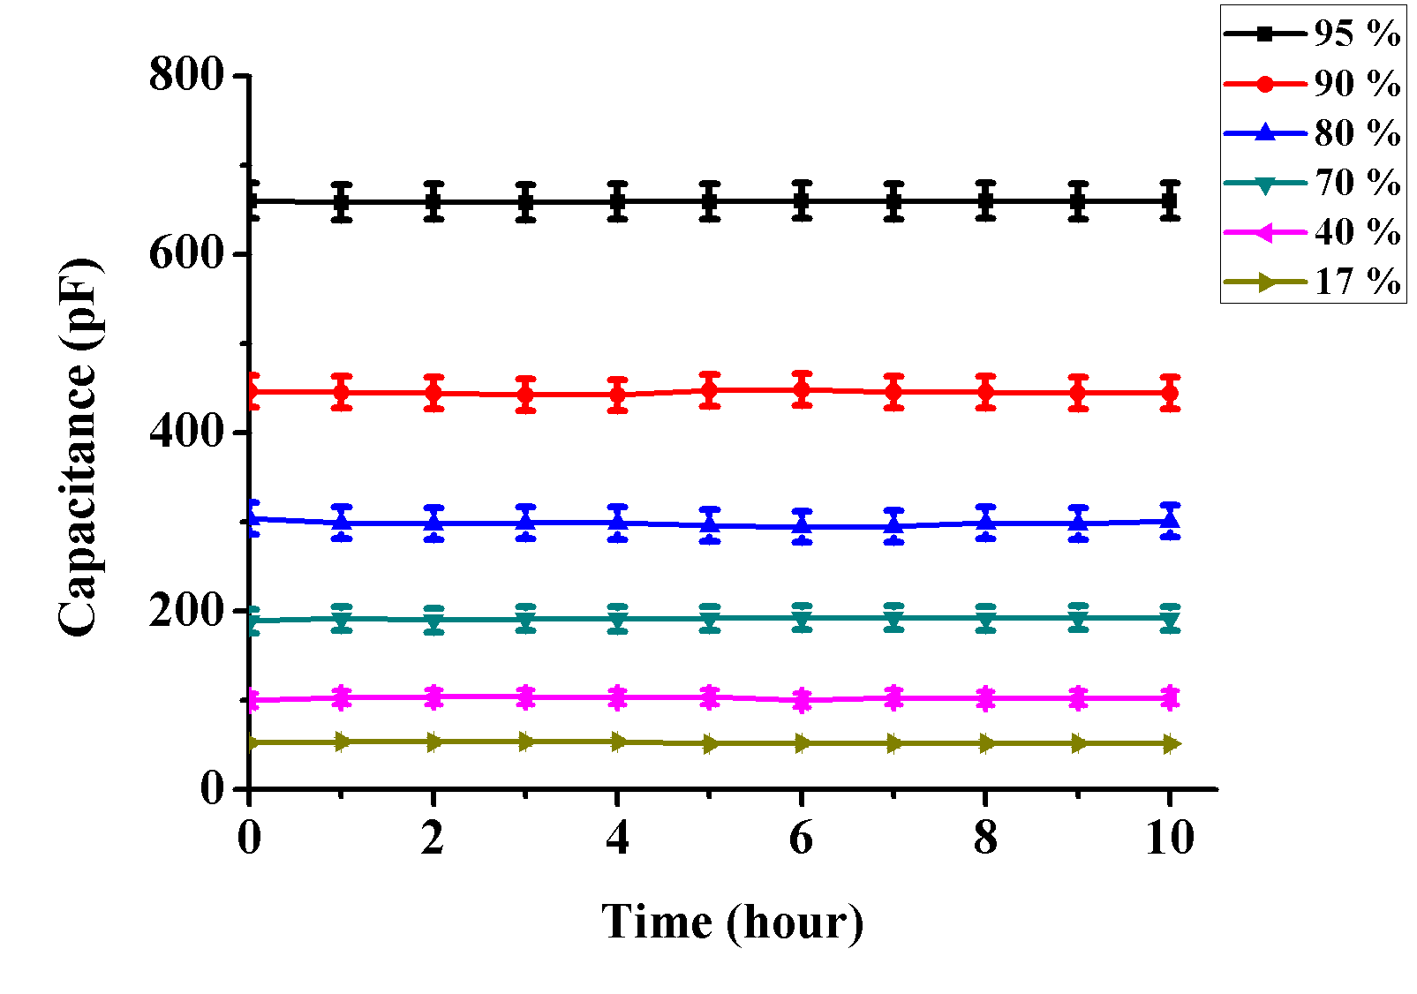
Figure 2 – Testing the humidity sensor for the stability of the capacitance reading under various levels of constant humidity as a function of time

The humidity sensor was kept in the sealed chamber with humidity levels controlled at 5 %, 25 %, 50 %, 75 %, 100 % for 10 hours. The results of testing the sensor for the stability of the electrical resistance under various levels of constant humidity, depending on the time are shown in Figure 3. It can be seen from the results that the deviation of the electrical resistance values of the structure for a long time does not exceed 2 %.
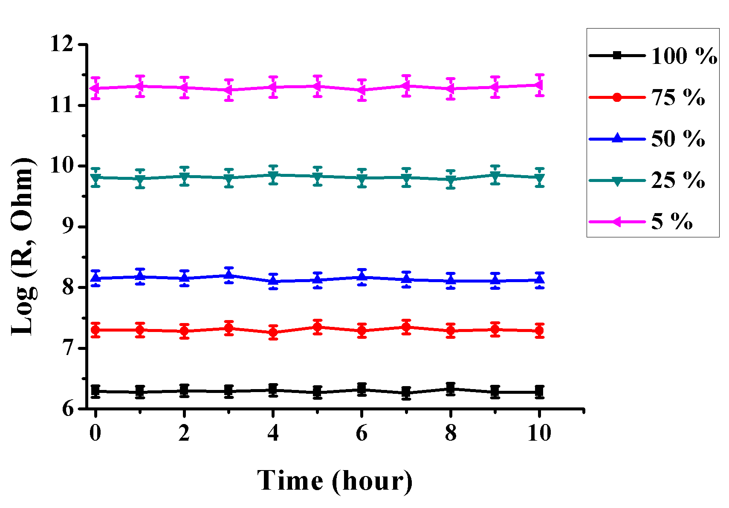

Figure 3 – Testing the humidity sensor on the stability of the electrical resistance readings under different humidity levels

Figure 4 shows the dependence of capacity on humidity. This figure shows that as the humidity level increases, the capacity of the sensor increases. Significant changes in capacity are observed at 70%, 80%, 90%, 95% humidity, this is due to the fact that a large amount of water vapor penetrates into the interplanar distance of FFLGN membrane and due to the high dielectric permeability (constant) increases the electrical capacitance.

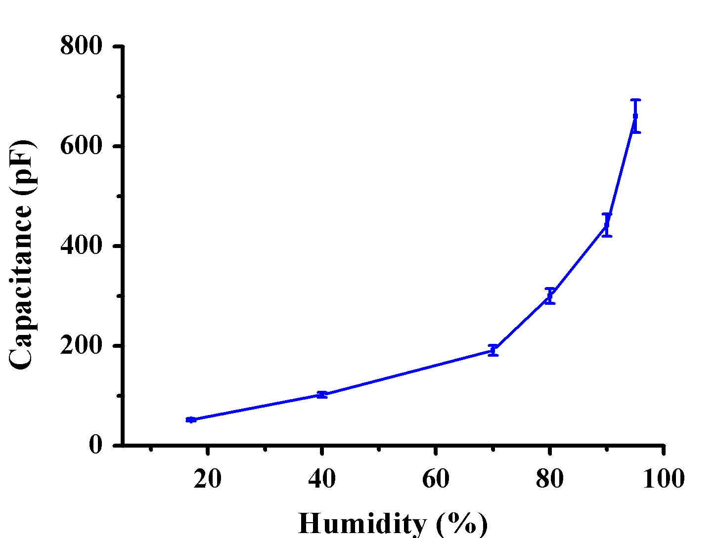

Figure 4 – Dependence of capacity on humidity

The electrical resistance versus humidity is presented in Figure 5. This image shows that the electrical resistance of the sensor decreases from 11,5 to 6,3 Log (R, Ohm) with increasing humidity at the range of 5-100 %.

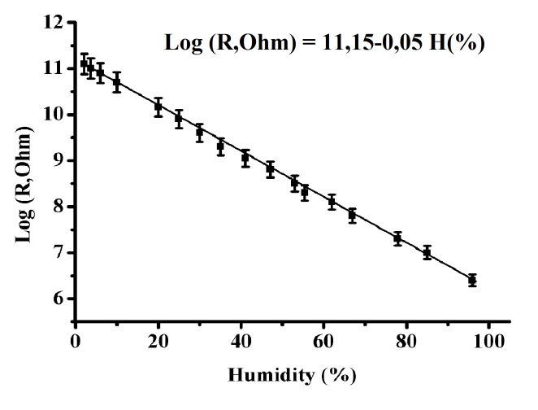

Figure 5 – Dependence of the electrical resistance on humidity
In the process of raising the humidity in the chamber, a drastic decrease in electrical resistance is observed, this would indicate a large amount of water vapor penetrated into the interplanar distance and is also adsorbed on the surface of the sample altering the resistance.

The recovery and response time of the sensor
We also studied the recovery and response of the humidity sensor. The recovery and response time of the sensor was tested at the range from 5 to 100 % humidity. Response dynamics and recovery were measured in the same way as we measured the stability of the electrical resistance.
The dynamics of the response of the humidity sensor as a function of time was studied using the sealed chamber with handmade humidifier. According to Figure 50, a decrease in electrical resistance is observed in entire range of relative humidity. This is because a large number of water molecules are adsorbed on the FFLGN surface, which significantly increases its conductivity due to proton-electron exchange between FFLGN and the adsorbed molecules. There is also the similar mechanism of changes in electrical conductivity, due to the influence of a water molecule as a result of which proton-electronic changes occur [23-26]. Figure 6 shows the dynamics of the humidity sensor response.

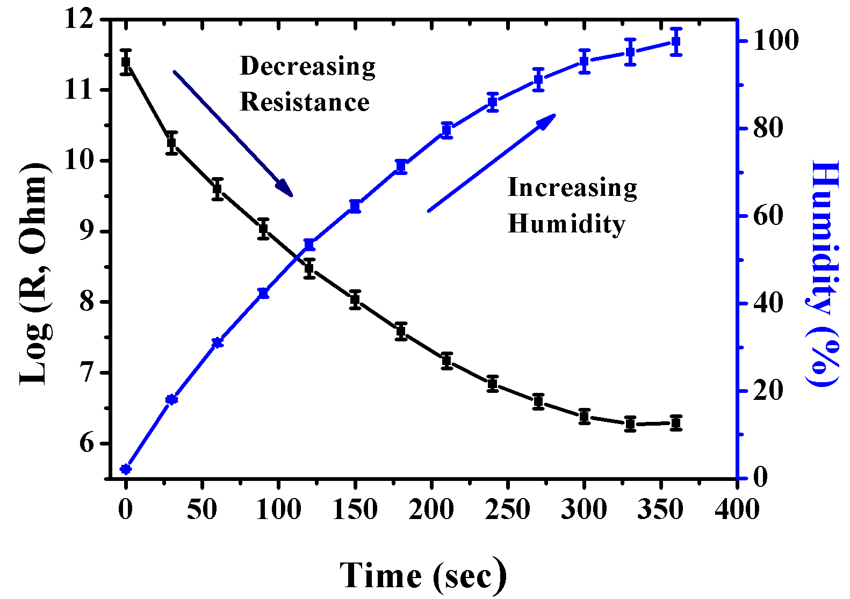

Figure 6 – Dynamics of the response

Recovery time of the sensor can be seen in Fig. 7. Increasing electrical resistance of the structure was recorded as a function of time using the Keithley 6517A source meter.

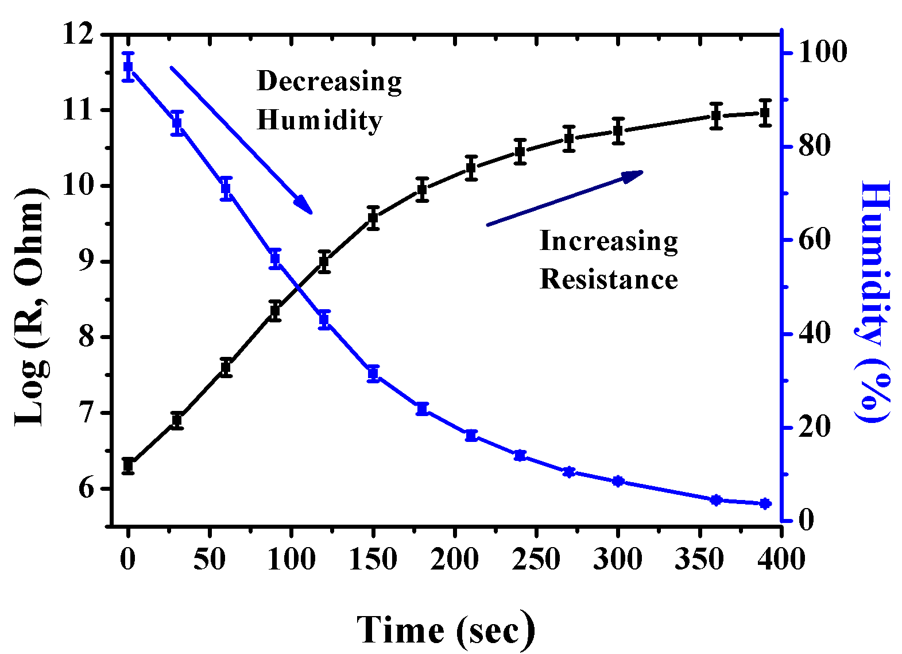

Figure 7 – Recovery dynamics

Figure 8 shows the response and recovery dynamics of the humidity sensor.
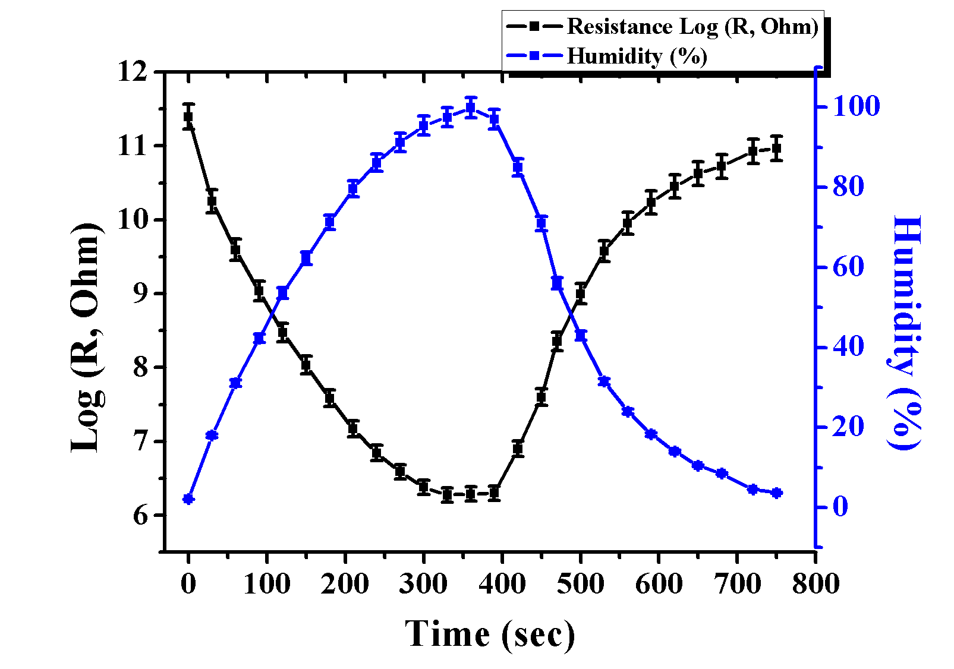
Figure 8 – Dynamics of response and recovery

The changing in the electrical resistance of the sample mainly depends on the adsorption of the water molecule on the surface of FFLGN membrane, therefore the electrical conductivity depends on water molecule on the surface. When the humidity level decreases from 100 to 5 % (RH), adsorbed water molecules are removed, this leads to increased resistance. Significantly increases in the electrical resistance of the sample observed at the humidity level from 100 to 20 % and resistance changes from 6,4 up to 10 Log (R, Ohm).
In section 1.11 (Table 2) we made a comparison of the performance of humidity sensors based on FFLGN with similar types of humidity sensors according to the following characteristics: dynamics of response and recovery, humidity detection range. According to the table 2, in comparison with sensors our device [206] has an advantage in response and recovery time, which has the same time of 360 s, as well as a wide range of relative humidity from 5-100%.
Thereby in this thesis we created humidity sensor based on FFLGN membrane, which FFLGN membrane was obtained from FFLGN aqueous dispersion. The FFLGN aqueous dispersion was synthesized via a modified Hummers method by using a pure natural graphite with various acids, then from this FFLGN aqueous via vacuum filtration, FFLGN membrane was produced. The created humidity sensor was tested in a wide range of humidity level from 5 to 100 % (RH) for studying electro-physical characteristics. The humidity sensor was tested for the stability of the electrical resistance at next multiple humidity levels: 5 %, 25 %, 50 %, 75 %, 100 % for 10 hours at room temperature and obtained measurement results show the stability of the sensor (±2 %) in the entire humidity range. Based on obtained results significant changes in the values of electrical resistance were observed, which are associated with the absorption of a water molecule on the surface and penetration into the interplanar distance of FFLGN membrane. According to the obtained electro-physical characteristics, we can say that the sensor is able to work stably at a wide range of humidity and respond rapidly to changes in humidity, which allows it to be useful as a precise and sensitive device.

Questions
- Application of a humidity sensor based on graphene
- Physicomechanical and important electronic properties of graphene and graphene-like materials
- Characteristics of humidity sensors
- Creation a humidity sensor based on an FFLGN membrane
- Dependence of capacity on humidity
- The recovery and response time of the sensor

References
- 135 Farahani H., Wagiran R. and Hamidon M.N.. Review Humidity Sensors Principle, Mechanism, and Fabrication Technologies // A Comprehensive Review Sensors. – 2014. – Vol. 14. – Р.7881 – 7939;
- 136 Chia Y.L. and Gwo B.L. Humidity Sensors: A Review // SENSOR LETTERS. – 2005. – Vol. 3. – Р. 1 – 14.
- 137 Naik G., Krishnaswamy S. Room-Temperature Humidity Sensing Using Graphene Oxide Thin Films // Graphene. – 2016. – Vol. 5. – Р. 1 – 13.
- 138 Lee, C. & Lee, G. Humidity sensors: A Review // Sens. Lett. – 2005. – Vol. 3. – Р. 1 – 15.
- 139 Hengchang B, Kuibo Y, Xiao X, Jing J, Shu W, Litao S, Mauricio T & Mildred S.. Ultrahigh humidity sensitivity of graphene oxide // Scientific Reports. – 2013. – Vol. 3. – Р. 1 – 7.
- 140 Schedin F., Geim, A.K., Morozov S.V., Hill E.W., Blake P., Katsnelson M.I. and Novoselov K.S. Detection of Individual Gas Molecules Adsorbed on Graphene // Nature Materials. – 2007. – Vol. 6. – Р. 652 – 655.
- 141 Lu G., Ocola L.E. and Chen J. Reduced Graphene Oxide for Room-Temperature Gas Sensors // Nanotechnology. – 2009. – Vol. 20, № 44. – Р. 445 – 502.
- 142 Lu G., Ocola L.E. and Chen J. Gas Detection Using Low-Temperature Reduced Graphene Oxide Sheets // Applied Physics Letters. – 2009. – Vol. 94, № 8. – Р. 083 – 111.
- 143 Lange U., Hirsch T., Mirsky V.M. and Wolfbeis O.S. Hydrogen Sensor Based on a Graphene-Palladium Nanocomposite // Electrochimica Acta. – 2011. – Vol. 56. – Р. 3707 – 3712.
- 144 Nomani M., Shishir R., Qazi M., Diwan D., Shields V., Spencer M., Tompa G.S., Sbrockey N.M. and Koley G. Highly Sensitive and Selective Detection of NO₂ Using Epitaxial Graphene on 6H-SiC // Sensors and Actuators B: Chemical. – 2010. – Vol. 150. – Р. 301 – 307.
- 145 Jeong H.Y., et al. Flexible Room-Temperature NO₂ Gas Sensors Based on Carbon Nanotubes/Reduced Graphene Hybrid Films // Physics Letters. – 2010. – Vol. 96. – Р. 213105.
- 146 Gautam Naik, Sridhar Krishnaswamy. Room-Temperature Humidity Sensing Using Graphene Oxide Thin Films // Graphene. – 2016. – Vol. 5, № 1. – Р. 1 – 13.
- 147 Meng-Chu Chen, et al. Fabrication of Humidity Sensor Based on Bilayer Graphene // Ieee electron device letters. – 2014. – Vol. 35, № 5. – Р. 590 – 592.
- 148 Weng H.L. et al. All-Optical Graphene Oxide Humidity Sensors // Sensors. – 2014. – Vol. 14, № 1. – Р. 24329 – 24337.
- 149 Sourav Gh, Ruma Gh, Prasanta K.G and Tarun K.B. Humidity Sensor Based on High Proton Conductivity of Graphene Oxide // IEEE Transactions on Nanotechnology. – 2015. – Vol. 14, № 5. – Р. 931 – 937.
- 150 Daniel H.R, Grissel R.R, Rodrigo M.M. and Ernesto S.G. A Capacitive Humidity Sensor Based on an Electrospun PVDF/Graphene Membrane // Sensors. – 2017. – Vol. 17, № 1009. – Р. 1 – 11.
- 151 Anderson D. Smith etc., Resistive graphene humidity sensors with rapid and direct electrical readout // Nanoscale. – 2015. – Vol. 7, № 45. – P. 19099 – 19109.
- 152 Anderson D. Smith etc., Graphene-based CO₂ sensing and its cross sensitivity with humidity // The Royal Society of Chemistry Advances. – 2017. – Vol. 7. – P. 22329 – 22339.
- 153 Massera E., Ferrara, V.L.A., Miglietta M., Polichetti, T., Nasti I. and Francia G.D.I. Gas Sensors Based on Graphene // Chemistry Today. – 2011. – Vol. 29. – P. 39 – 41.
- 154 Boudaden J, etc., Polyimide-Based Capacitive Humidity Sensor // Sensors. – 2018. – Vol. 18, № 5. – P. 1 – 15.
- 155 Ghosh A., Late D.J., Panchakarla L.S., Govindaraj A. & Rao C.N.R. NO₂ and humidity sensing characteristics of few-layer graphene // Journal of Experimental Nanoscience. – 2009. – Vol. 4, № 4. – P. 313 – 322.
- 156 Popov V.I. etc., Graphene based humidity sensors: The origin of alternating resistance change // Nanotechnology. – 2017. – Vol. 28, № 35. – P. 14.
- 157 Wang Y., Park S., Yeow J.T., Langner A., Müller F. A Capacitive humidity sensor based on ordered macroporous silicon with thin film surface coating. Sens. Actuators B Chem. – 2010. – Vol. 149, № 1. – P. 136 – 142.
- 204 Куанышбеков Т.К., Тулегенова М.А., Гусейнов Н.Р., Озюлмаз Б., Ильин А.М.. Изучение стабильности датчика влажности на основе оксида графена // ВЕСТНИК КазНИТУ им. К.Сатпаева. – 2017. – № 6(124). – С. 210 – 213.
- 205 Kuanyshbekov T.K., Ilyin A.M., Beall G.W., Guseinov N.R., and Tulegenova M.A. Sensitive humidity sensor based on functionalized graphene // Abstract. 4th International Conference on Sensors Engineering and Electronics Instrumentation Advances (SEIA' 2018). – Amsterdam, The Netherlands, 2018. – P. 45 – 46.
- 206 Kuanyshbekov T.K., Ilyin A.M., Beall G.W., Guseinov N.R. Creation of a Humidity Sensor Based on Functionalized Graphene Nanostructures // Sensors & Transducers. – 2019. – Vol. 229, – № 1. – P. 39 – 46.

