S. AMANZHOLOV EAST KAZAKHSTAN UNIVERSITY

Department of Chemistry

Subject: Nanotechnologies and Nanomaterials

Lecture No. 5: «Basics of computer simulation»

Lecturer: Kuanyshbekov Tilek Kuanyshbekuly, PhD

Oskemen 2024

 | LECTURER: PhD, Associate Professor  Kuanyshbekov Tilek Kuanyshbekuly  Lecture No. 5: «Basics of computer simulation»  Plan:  - Introduction  - Interchangeable terms  - Advantages of the computer simulation  - General limitations  - Computer Simulation of FSLGN  - 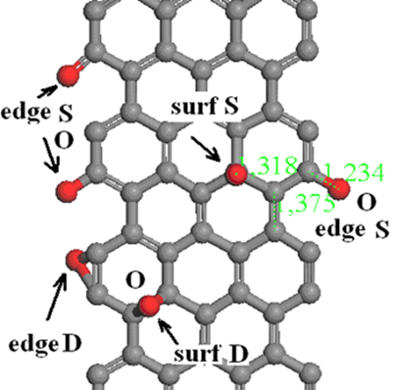

5. Basics of computer simulation
Computational science begins to play an important role in research and development. Nowadays modern scientific research initially based on experiment and its theoretical interpretation, which is become a triad of experiment, theory and computer simulation. So this is because the analysis of modeling complex systems can be a gate for the discovery of important, but still unnoticed, simplifications and patterns. Computing tools play an important role in the development and testing of new engineering products, also the simulation results are the basis for many decision policies [1].
At this time computer modeling has such interchangeable terms as computer modeling and simulations, which are successfully used in the following areas of science and technology: design, production management, business, science, technology, architecture, entertainment, government, military and logistics/transportation.
Computer modeling is used to reduce the risk associated with creating new systems or making changes to existing ones. More than ever, modern organizations want to be sure that investment will lead to expected results. For example, an assembly line may be required to produce a certain number of cars during an eight-hour shift. Complex, interacting factors affect the work, so powerful tools are needed to develop an accurate analysis.
Over the past few decades, computer modeling software, along with statistical analysis methods have evolved to provide developers with the tools that fit this task. Due to the development of technics and technology, each time the world becomes technical and therefore accuracy without errors is becoming increasingly important. When developing systems, business, industry, and government cannot afford to make reasonable assumptions and therefore computer modeling is more important than ever.
Compared to decision-making methods, using computer simulation for analysis has the following advantages [2]:
- allows to experiment without failures in existing systems, new ideas that are difficult, costly or impossible, as well as develop a model and compare it with the system to ensure that it accurately reflects current work. The advantages of the modeling process are that first you can make any desired modification to the model, the impact on the system under study, and then you can make a real system;
- using computer simulation it is possible to, check an advanced idea before setting, which allows identifying unexpected disadvantages in the construction and these disadvantages useful for improvement construct as instructions;
- the next advantage is the speed in the analysis in the simulation. The advantages of this process are that after developing a model, you can run a simulated system at speeds far exceeding those achievable in the real world. With many modeling languages, ​​you can conduct and run several experiments, which saves time.
To get results, the finished model can take from a few seconds to several hours, so this process is important for factory manufacturers to control the assembly process, for example, every morning before production starts, engineers enter the expected system input data into their model and predict how long it will take daily work. All of the above mention advantages of computer modeling have a common advantage, which is to reduce the risk, and also reduce uncertainty, therefore, increases confidence regarding the expected operation of the new system or the consequences in the existent construction.
In addition to the above advantages in computer modeling, there are general limitations as follows:
- one of the flaws is an expensive analysis method for creating a computer model, but, despite this drawback, low-cost modeling packages are available, and most of the large-scale modeling work is the main enclosure in training, software, hardware, analysis.
- the next disadvantage is laboriousness (labor intensity), which does not always give a quick answer to the questions, in most cases, data collection, model development, analysis and report generation take considerable time. Using two methods in the simulation process can be accelerated: reducing the specification (detailing, scaling) and the use of universal code libraries. So decline the level of detail, you can get answers to the questions of the general concept much faster, but in the process of using this approach, care should be taken when removal key details that may affect the accuracy of the model. Creating a universal simulation or code library is used during the performance of many similar simulations, this reusable resource preсlude re-invention for each simulation project, which is considered the basic idea.
- gives only approximate answers when modeling discrete events, which is based on the use of random number generators and in the process of modeling, the input has a random element, some uncertainty is also associated with the output.
- it is difficult to verify one of the limitations of computer modeling. Basically, the complexity of testing is reflected when the system does not yet exist, and it is important to know that the computer model accurately represents the system being studied. In such a case, the verification most often relies on the opinions of experts and intuition as a means of ensuring that the model works in the same way as the system, but whenever judgment and opinion are used, there is a possibility of error. It is often better to stick to a conservative point of view and make sure that the predicted performance of the system is no better than the expectations of the actual work. In addition, the human factor in a computer simulation can be very accurate for accurate capture and simulation [3].
Thus, the use of computer simulation is very important in research and development and allows to explore unforeseen physical or chemical properties of atoms and molecules.
Computer simulation of possible stable structures of graphene and few-layer graphene functionalized Ga
Computer modeling of molecular dynamics (MD) has become a very useful technique for studying many types of properties of layered nanomaterials, such as graphene, GO, few-layer graphene nanostructures, FFLGN, which have wide interest in various fields of science and technology, such as military technology, biotechnology, nanoscience, biomedicine, etc. In addition, research of its physical, chemical and electronic properties has paid considerable attention from researchers.
We present results of computer simulation and density functional theory (DFT) calculations of possible stable configurations of few-layer graphene, functionalized by Ga atoms [4]. As mentioned in the section 1.9 all calculations were performed by using local density approximation and very effective method of energy optimization, with periodic boundary conditions and, convergence tolerance on energy 0.001 eV.
Figure 1 presents possible adsorption sites for Ga atoms with high symmetry: namely: A, H, and B respectively. H site of adsorption (over the center of the hexagon) has the largest adsorption energy, therefore, it is the favored site for Ga atom adsorption.
Figure 2 shows a possible stable atomic complex of Ga- vacancy which was formed after using the procedure of energy optimization. In such a case, the Ga atom takes place outside the graphene sheet with forming a 3D complex defect.

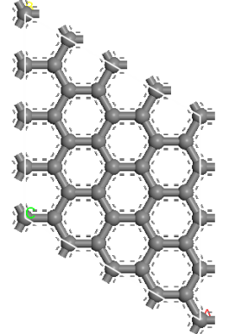  a) | 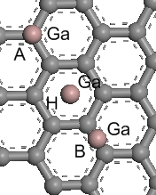  b)

Figure 1 – a) The unit cell for the graphene sheet within periodic boundary conditions calculations adopted a 4x4 structure; b) Some of calculated adsorption sites on graphene surface with a high symmetry: A) over the C atom; H) over the center of a hexagon; B) over the center of the C-C-bond. In all positions binding energy of Ga rather low: H – 0.73 eV, A – 0.57 eV, B – 0.40 eV. The distance between the Ga atom and graphene plane is 0.22 nm.

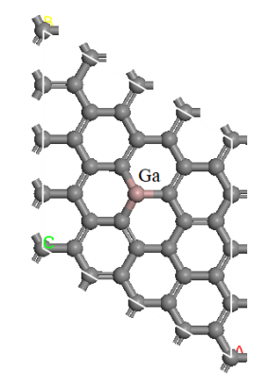  a) | 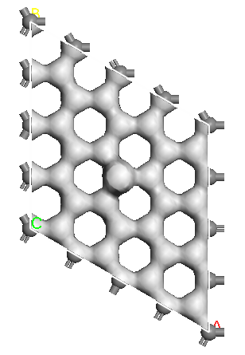  b)

Figure 2 – Computer models of atomic configurations Ga- graphene. a) an atomic configuration of Ga-atom bonded with a vacancy. The binding energy of Ga atom = 1.92 eV, the distance of Ga atom from graphene sheet equals 1.53 Å; b ) The map of electron charge distribution for density 200 el /nm³. In this case, gallium shows valence equal to three

Figure 3 illustrates a stable complex atomic configuration with the binding energy of Ga 1.71 eV and the distance from the graphene plane equals 0.8 Å. In this defect configuration, Ga demonstrates two-valence state.

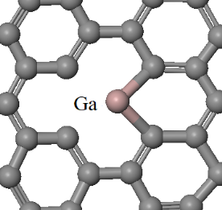  a) | 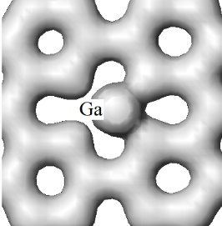  b)

Figure 3 – A possible structure of Ga-atom - vacancy: a) atomic configuration; b) a map of the distribution of the electron charge for density 410 el / nm³.

Complex defect configuration – a bridge-like defect [121, 123, 124] based on a gallium atom is shown in figure 4.

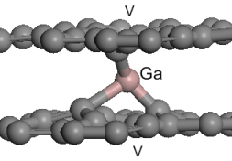  a) | 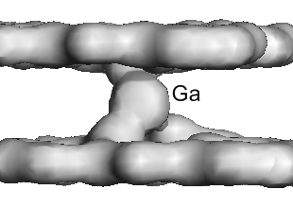  b)

Figure 4 – A bridge-like defect, based on Ga-atom, which connects two graphene sheets by fast covalent bond (E_{bind}= 3.28 eV): a) atomic structure of the complex defect based on a Ga- atom captured between two vacancies V in the graphene sheets; b) The map of the electron charge distribution for density 900 el/nm³. This configuration shows three valence state of Ga.

Results of simulation and calculations have shown that the stability of Ga-graphene composition is much higher when the Ga atom is linked with a structural defect. It should be noted, that maps of the electron charge distribution (figures 2-4) show, that the electron transfer between Ga and C, in general, is in a good agreement with well-known electronegativity data for carbon and gallium (by Pauling Scale).
In this way, computer simulations and DFT calculations of structural and energetic characteristics of some possible stable configurations of Ga-graphene nanostructures were performed. Similar atomic structures in graphene and few-layer graphene can be experimentally produced by low-energy irradiation with Ga⁺ ions in the SEM devices. Results of the work can be useful for production close to 2D-Ga-graphene nanostructures, for applications in nanoelectronic devices as well as for storing Ga in graphene nanostructures in atomic form.
In addition, one of the most important processes of FFLGN study is the functionalization of graphene with strong acids, as a result of which graphene becomes functionalized with hydroxyl and epoxy groups on their main plane and at the edges of the carbonyl and carboxyl groups [199-202], which was discussed in the section 1.4, and the FFLGN computer simulation and quantum-mechanical calculations will be presented in detail in the next section 3.1.2.

Computer Simulation of FSLGN
In this section, we have created a computer simulation of possible stable structures of FSLGN using the molecular dynamics method by the Chem Office Materials Studio software tools, which can be used to better understanding the unforeseen physical and chemical properties of FSLGN. FSLGN has significant relevance in various areas because of its unique structural and dynamic properties. In the process of performing computer simulation of complex polyatomic systems, calculations were performed using the density functional theory and molecular dynamics methods, as well as energy optimization procedures were used to obtain the most correct complete nanostructures. Many calculations on the characteristics of nanostructures were performed using one of the reliable functional in the DMol3 computational environment. During the calculation, the accuracy of the energy characteristics of nanostructures was up to 0.02 eV [7-12, 16].
Fragments of the computer model of FSLGN are shown in Fig. 5, which demonstrate FSLGN configurations with different atomic positions created by using density functional theory (DFT). According to the image, after oxidation reactions, one can see single and double configurations on the surface and edge configurations (Figure 5, a, b).

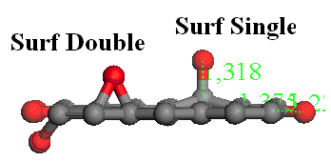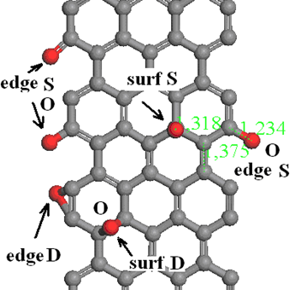

а) b)

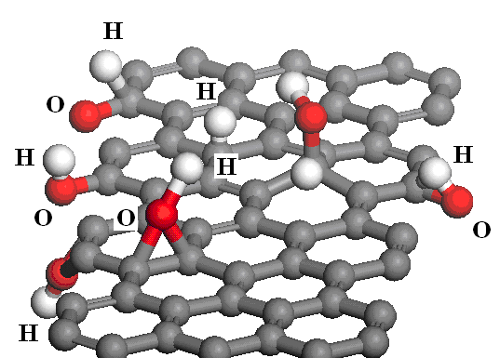

c)

a) side view after oxidation reactions; b) possible stable configurations of graphene compositions with oxygen; c) graphene + O-H groups after the combined action of oxidation

Figure 5 – Fragments of computer models of FSLGN

Figure 5 (c) shows the behavior of the FSLGN system after additional exposure to hydrogen, which reflects possible stable configurations of graphene compositions with hydrogen and oxygen. According to the figure, it can be observed that the vacancy serves as a higher concentration of hydrogen atoms, as a result of which configurations of the O–H radical type appear, and these radicals can be desorbed from the surface of functionalized graphene.
To calculate the changes in electronic properties under conditions of an increase in the level of oxidation, we created computer models of functionalized graphene, which are shown in Figure 6 (a, b, c).

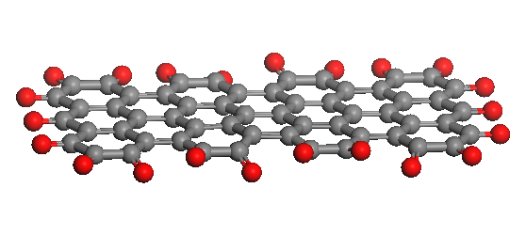

a) H-L = 0.2
graphene -O bond length = 1.2 A
Possible configurations with O

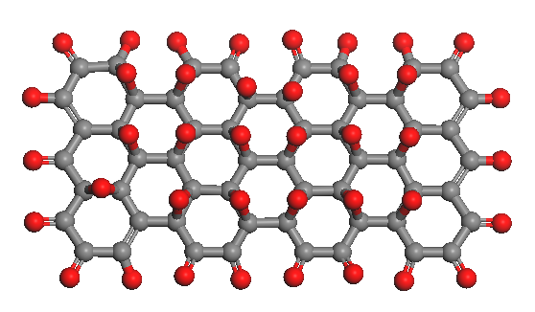

b) 0.6 eV, O/C = 40/ 56

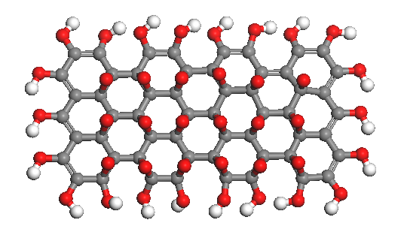

c) H-L =0.6 eV

Figure 6 – FSLGN computer model for calculating the changes in electronic properties under conditions of increasing HOMO-LUMO oxidation level

Figure 7 shows possible computer models of FSLGN. According to Figure 7, one can see configurations of the OH-H radical type, which cover the ends, as well as possible configurations of 2-sided oxygen H – L = 0.8 eV

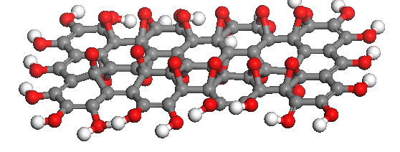

Figure 7 – 2-sided oxygen H-L = 0.8 eV, the ends are covered with O-H radicals
Questions
- Advantages in computer modeling
- Computer modeling of molecular dynamics (MD)
- Computer simulation of possible stable structures of graphene and few-layer graphene functionalized Ga
- A possible structure of Ga-atom
- Computer Simulation of FSLGN

References

- 123 Web-Resource, Leo P. Kadanoff. Excellence in computer simulation https://www3.nd.edu 16.11.2018
- 124 Web-Resource, Roger McHaney. Understanding Computer Simulation. https://library.ku.ac.ke 17.11.2018
- 125 Web-Resource, Molecular dynamics simulations https://afire.asnet 17.11.2018
- 126 Web-Resource, Markus J. Buehler. Introduction to classical molecular dynamics Lecture 2. https://ocw.mit.edu 18.11.2018
- 127 Web-Resource, Chapter 8 Monte Carlo Simulation. http://web.mst.edu 18.11.2018
- 128 Web-Resource, Dirk P. Kroese. Why the Monte Carlo Method is so important today. https://people.smp.uq.edu 18.11.2018
- 129 Ilyin A.M., Daineko E.A. & Beall G.W. Computer Simulation and Study of Radiation Defects in Graphene // Physica E. – 2009. – Vol. 42, №. 21. – P. 67 – 69.
- 130 Ilyin A., Guseinov N., Nikitin A. and Tsyganov I. Characterization of thin graphite layers and graphene with energy dispersive X-ray analysis // Physica E. – 2010. – Vol. 42, №. 8. – P. 2078 - 2080.
- 131 Ilyin A.M., Nemkaeva R.R., Kudryashov V.V. Computational study of graphene and few –layer graphene –metal composites, induced by radiation // J.Mater. Sci& Engineering, B3. – 2013. – Vol. 3. – P. 161 – 166.
- 132 Ilyin A.M., Guseinov N.R., Nemkaeva R.R., Asanova S.B., Kudryashov V.V. Bridge-like radiation defects in few-layer graphene // Nucl.Instrum & Methods in Phys.Res., B. – 2013. – Vol. 315. – P. 192 - 196.
- 133 Ilyin A.M., Kudryashov V.V., Guseinov N.R. Computer Simulation of Few-Layer Graphene Intercalated by Lithium for Power Sources // Journal of Electrochemical Society. – 2015. – Vol.162, №. 8. – P. A1544 – A1546.
- 134 Guseinov N., Baigarinova G., Ilyin A. Structural damaging in few-layer graphene due to the low energy electron irradiation // Advances in Nano Research. – 2016. – Vol. 4, №. 1. – P. 45 – 50.
- 135 Farahani H., Wagiran R. and Hamidon M.N.. Review Humidity Sensors Principle, Mechanism, and Fabrication Technologies // A Comprehensive Review Sensors. – 2014. – Vol. 14. – Р.7881 – 7939;
- 136 Chia Y.L. and Gwo B.L. Humidity Sensors: A Review // SENSOR LETTERS. – 2005. – Vol. 3. – Р. 1 – 14.
- 137 Naik G., Krishnaswamy S. Room-Temperature Humidity Sensing Using Graphene Oxide Thin Films // Graphene. – 2016. – Vol. 5. – Р. 1 – 13.
- 138 Lee, C. & Lee, G. Humidity sensors: A Review // Sens. Lett. – 2005. – Vol. 3. – Р. 1 – 15.
- 139 Hengchang B, Kuibo Y, Xiao X, Jing J, Shu W, Litao S, Mauricio T & Mildred S.. Ultrahigh humidity sensitivity of graphene oxide // Scientific Reports. – 2013. – Vol. 3. – Р. 1 – 7.
- 140 Schedin F., Geim, A.K., Morozov S.V., Hill E.W., Blake P., Katsnelson M.I. and Novoselov K.S. Detection of Individual Gas Molecules Adsorbed on Graphene // Nature Materials. – 2007. – Vol. 6. – Р. 652 – 655.

