S. AMANZHOLOV EAST KAZAKHSTAN UNIVERSITY

Department of Chemistry

Subject: Nanotechnologies and Nanomaterials

Lecture No. 6: «Basics of humidity and types of humidity sensitive elements»

Lecturer: Kuanyshbekov Tilek Kuanyshbekuly, PhD

Oskemen 2024

 | LECTURER: PhD, Associate Professor  Kuanyshbekov Tilek Kuanyshbekuly  Lecture No. 6: «Basics of humidity and types of humidity sensitive elements»  Plan:  - Introduction  - Important role of Humidity sensor  - The basic units of humidity measurement  - Creation of a Humidity Sensor  - Electrophysical Characteristics of the Humidity Sensor Based on GO and GO/CMC (0.03 g; 0.06 g; 0.15 g)  - 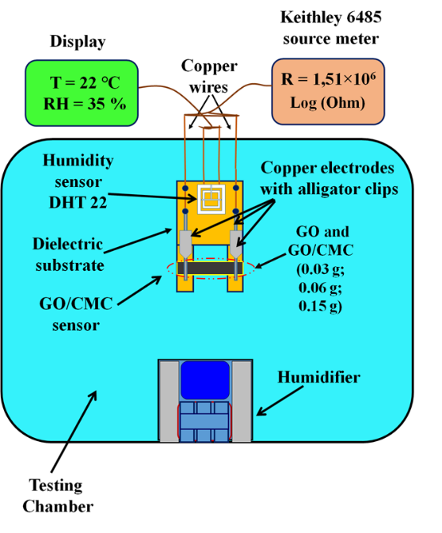

6. Basics of humidity and types of humidity sensitive elements
At present, the creation and application of a humidity sensor plays an important role in industrial and domestic applications for human convenience, as a result of which, depending on the operating conditions, there are different types of humidity sensitive elements based on operating principles, on a unit of measurement, and also on various types of sensitive materials.
The basic units of humidity measurement are relative humidity and absolute humidity and based on these measurement parameters, the sensors are divided into the following main types: sensors of relative humidity and absolute humidity. The unit of absolute humidity has another concept as vapor density and is determined by the ratio of the mass of water vapor in the air to the volume of air and is expressed by the following formula (4) [1, 2]:

AB = m_{w}/v

(here AB – the absolute humidity (g/m³),m_{w} - a mass of water (grams),v –volume of air (m³)).
The next unit of measurement is relative humidity, which is determined by the ratio of the moisture content of air to a saturated (maximum) humidity level. In this case, the relative humidity depends on the temperature and is therefore called relative measurement and is expressed by the following formula (5):

RH% = P_{V}/P_{S}*100

(here RH – relative humidity, P_{V}– the actual partial pressure of moisture that is contained in the air, P_{S}– the saturated pressure of humid air)
Also the most important is the determination of moisture saturation, which depends on temperature and presents the ratio of the mass of water vapor at saturation to the volume of air and is expressed by the following formula (6):

SH = m_{ws}/v

(here SH – moisture saturation (g/m³), m_{ws} – the mass of water vapor at saturation (g) и v the volume of air (m³)) [135].
According to the unit of measurement relative compared to absolute humidity, relative humidity is most widely used because of its simplicity and low cost.
As mentioned above, the classification of humidity sensors can be subdivided on the next basis: types of sensitive materials, principles of operation, and also the type of conductivity into resistive, capacitive, ionic, electronic (charge carriers) and the sensitivity mechanism into electronic, proton and electrolytic.
Currently, humidity sensors according to the types of sensitive materials are classified into: ceramic, organic polymers, semiconductor, organic/inorganic (polymer/ceramics) [1, 2].
Thus, to create humidity sensors and its application in industrial and domestic applications for human convenience, the most important is the choice of a suitable sensor type and the choice of material that will affect the sensitivity, stability of the device.

Creation of a Humidity Sensor Based on GO and GO/CMC
The design of the humidity sensor is shown in Figure 1. The GO and GO/CMC (0.03 g; 0.06 g; 0.15 g) membranes were mounted on a dielectric substrate and connected with opposite ends of copper wire (0.15 mm in diameter) as electrodes to the samples. These electrodes were attached with stable fixtures to ensure good electrical contact. Four legs of the dielectric substrate were installed. As can be seen from Figure 1, the sensor substrate had the following dimensions: 10.5 × 5.7 cm; the thickness of the membranes was about 20 microns; the length was 3.5 cm; and the width was 1 cm. The surface of the GO and GO/CMC membranes was open on both sides, making it sensitive to the relative humidity of the environment. As can be seen from the diagram in Figure 1, a humidity sensor based on GO and GO/CMC (0.03 g; 0.06 g; 0.15 g) and an exemplary DHT 22 sensor on the Arduino platform were mounted together on a dielectric substrate and placed together in the test chamber (Figure 2) that was used to control the humidity.The DHT 22 sensor is designed to measure humidity levels in the range from 0 to 100% and the measurement accuracy is in the range of2–5%.
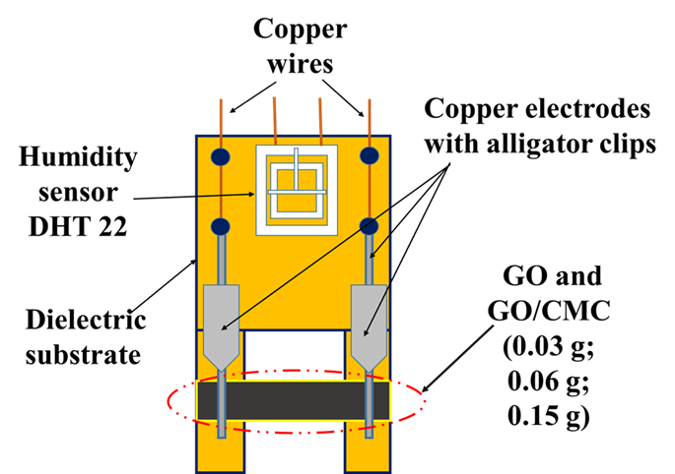
Figure 1. Structure of the humidity sensor.

A schematic representation of the installation for investigating the sensitivity of the sensor to humidity is shown in Figure 4. The humidity sensor test chamber has a main box and a humidity controller from 1% to 99% with a temperature sensor. A Keithley Picoammeter (Picoammeter 6485× Model) was used to measure the electrophysical characteristics of the humidity sensor. The Keithley 6485 meter was attached to the copper electrodes with alligator clips. The error bars were limited by an instrument error of no more than 0.5%.
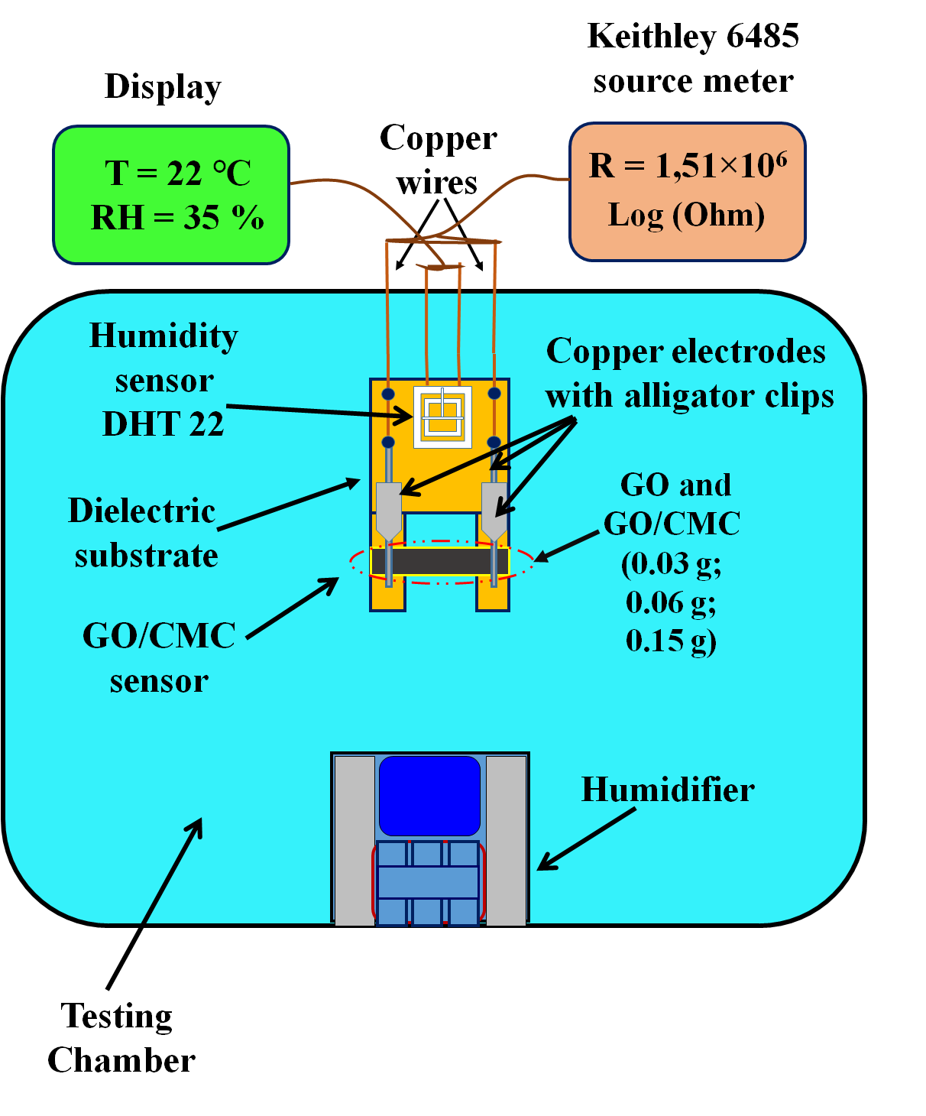
Figure 2. Schematic view of the installation.

Electrophysical Characteristics of the Humidity Sensor Based on GO and GO/CMC (0.03 g; 0.06 g; 0.15 g)
The electrical parameters of the humidity sensor based on the GO and GO/CMC membranes (0.03 g; 0.06 g; 0.15 g) were studied as a function of humidity to determine the performance of the device. The response and recovery of the humidity sensor were tested using a Keithley (Model 6485) meter attached to copper electrodes with alligator clips. The results of the sensor response and recovery tests as a function of time are shown in Figure 3. The response and recovery time of the humidity sensor was tested in a sealed chamber with a controlled humidity level in the range from 20% to 90% (RH) with an interval of 5% (RH) for 84 min (Figure 10). The results of the study showed that with an increase in the relative humidity, the electrical resistance of the humidity sensor decreased. According to the obtained results, it is obvious that in all samples with an increase in humidity from 20% to 90% (RH), a significant decrease in electrical resistance was observed of almost two to four orders of magnitude depending on the addition of CMC (0.03 g; 0.06 g; 0.15 g) to GO. In addition, a symmetrical change in the values of electrical resistance wasobserved when the humidity decreased from 90% to 20%. On the initial GO, with an increase in humidity from 20% to 90% (RH), the electrical resistance decreased by three orders of magnitude from 3.4 × 10⁷ to 2.6 × 10⁴ Log (R, Ohm). Then, after adding CMC (0.03 g; 0.06 g; 0.15 g) to the samples (1, 2, 3), the electrical resistance decreased as follows: (1)—from 1 × 10⁸ to 7.8 × 10⁴; (2)—from 2.9 × 10⁸ to 4.1 × 10⁴; (3)—from 6.4 × 10⁹ to 6.2 × 10⁴ Log (R, Ohm). In the dynamics of recovery, with a decrease in humidity from 90% to 20%, the electrical resistance of the GO and GO/CMC samples (0.03 g; 0.06 g; 0.15 g) increased in the following order: (0)—from 2.6 × 10⁴ to 1, 7 × 10⁷; (1)—from 7.8 × 10⁴ to 5 × 10⁷; (2)—from 4.1 × 10⁴ to 1.2 × 10⁸; (3)—from 6.2 × 10⁴ to 1.1 × 10⁹ Log (R, Ohm). In the results of the dynamics of sensor recovery at 20% humidity, the values of the electrical resistance of the samples were not significantly lower than the resistance at the response at the same level of 20% humidity, which is explained by the saturation of the membranes with water molecules, and indicates the successful recovery of the samples from moisture. In addition, with an increase in humidity compared to the initial GO after the addition of CMC (0.03 g; 0.06 g; 0.15 g), a significant increase in the electrical resistance was observed with an increase in the masses of the added CMC particles in the GO. This change is explained by the presence of hydrogen bonds between GO and CMC [3, 4–7] and an ether bond, C=O, which is confirmed by the IR spectrum and electrical characteristics in Figure 11 as well as by the interfacial polarization that occurs at the CMC–GO boundary [8, 9]. In general, during the response of the sensor, the process of reducing the electrical resistance with increasing humidity is due to the fact that a large number of water molecules are adsorbed on the surface of GO and CMC, which significantly increases its conductivity due to the proton–electron exchange between GO/CMC and adsorbed molecules [10–13]. Accordingly, during the dynamics of recovery, adsorbed water molecules are removed, which leads to an increase in resistance. Thus, according to the results of the dynamics of response and recovery of the humidity sensor, a decrease and increase in the electrical resistance values is observed in the entire range of relative humidity, which confirms the sensitivity of GO and GO/CMC (0.03 g; 0.06 g; 0.15 g) membranes to moisture.
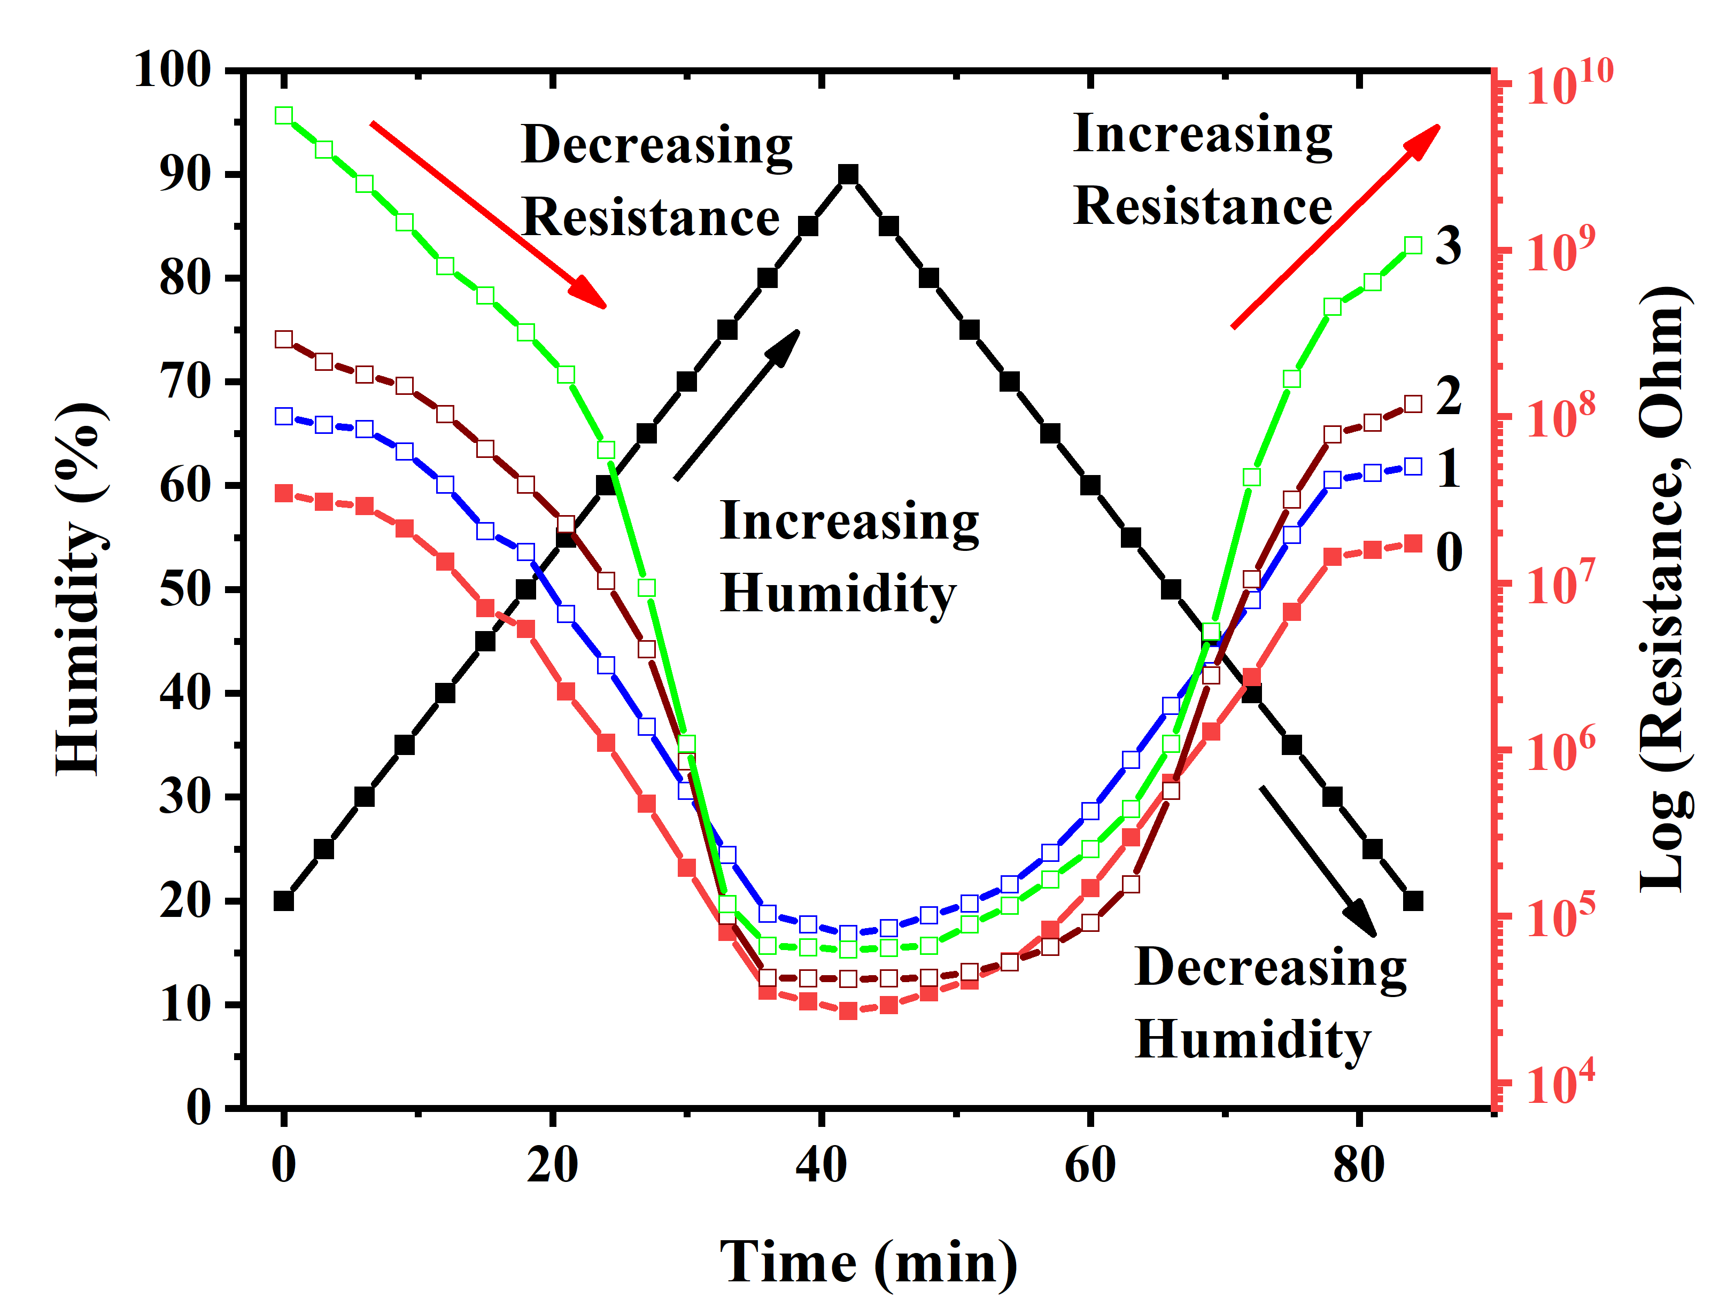
Figure 3. Dynamics of response and recovery of GO and GO/CMC samples: (0) initial GO; (1) GO/CMC 0.03 g; (2) GO/CMC 0.06 g; (3) GO/CMC 0.15 g.
Questions
            - Important role of creation and application of a humidity sensor
            - Basic units of humidity measurement are relative humidity and absolute humidity and based on these measurement parameters
            - Creation of a Humidity Sensor Based on GO and GO/CMC
            - Electrophysical Characteristics of the Humidity Sensor Based on GO and GO/CMC (0.03 g; 0.06 g; 0.15 g)

References
            - Farahani H., Wagiran R. and Hamidon M.N.. Review Humidity Sensors Principle, Mechanism, and Fabrication Technologies // A Comprehensive Review Sensors. – 2014. – Vol. 14. – Р.7881 – 7939;
            - Chia Y.L. and Gwo B.L. Humidity Sensors: A Review // SENSOR LETTERS. – 2005. – Vol. 3. – Р. 1 – 14.
            - Zhang, H.; Zhai, D.; He, Y. Graphene oxide/polyacrylamide/carboxymethylcellulose sodium nanocomposite hydrogel with enhanced mechanical strength: Preparation, characterization and the swelling behavior. J. RSC Adv.2014, 4, 44600–44609.
            - Lim, D.J.; Marks, N.A.; Rowles, M.R. Universal Scherrer equation for graphene fragments. Carbon2020, 162, 475–480. https://doi.org/10.1016/j.carbon.2020.02.064.
            - Hen, J.; Li, H.; Zhang, L.; Du, C.; Fang, T.; Hu, J. Direct Reduction of Graphene Oxide/Nanofbrillated Cellulose Composite Film and its Electrical Conductivity Research. J. Sci. Rep.2020, 10, 124.
            - Zhao, M.; Zhang, S.; Fang, G.; Huang, C.; Wu, T. Directionally-GrownCarboxymethyl Cellulose/Reduced Graphene Oxide Aerogel with Excellent Structure Stability and Adsorption Capacity. J. Polym. 2020, 12, 2219.
            - Ciolacu, D.E.; Suflet, D.M. Cellulose-Based Hydrogels for Medical/Pharmaceutical Applications in Biomass as Renewable Raw Material to Obtain Bioproducts of High-Tech Value; Elsevier: Amsterdam, The Netherlands, 2018
            - Mariano, M.; El Kissi, N.; Dufresne, A. Cellulose nanocrystals and related nanocomposites: Review of some properties and challenges. J. Polym.Sci.Part B Polym.Phys. 2014, 52, 791–806.
            - He, S.; Wang, G.S.; Lu, C.; Luo, X.; Wen, B.; Guo, L.; Cao, M.S. Enhanced wave absorption of nanocomposites based on the syn-thesized complex symmetrical CuS nanostructure and poly (vinylidene fluoride). J. Mater Chem. A2013, 1, 4685–4692.
            - Lim, W.H.; Yap, Y.K.; Chong, W.Y.; Ahmad, H. All-Optical Graphene Oxide Humidity Sensors. Sensors 2014, 14, 24329–24337. https://doi.org/10.3390/s141224329.
            - Ghosh, S.; Ghosh, R.; Guha, P.K.; Bhattacharyya, T.K. Humidity Sensor Based on High Proton Conductivity of Graphene Oxide. IEEE Trans. Nanotechnol. 2015, 14, 931–937. https://doi.org/10.1109/TNANO.2015.2465859.
            - Hernández-Rivera, D.; Rodríguez-Roldán, G.; Mora-Martínez, R.; Suaste-Gómez, E. A Capacitive Humidity Sensor Based on an Electrospun PVDF/Graphene Membrane. Sensors2017, 17, 1009. https://doi.org/10.3390/s17051009.
            - Anderson, J.H.; Parks, G.A. Electrical conductivity of silica gel in the presence of adsorbed water. J. Phys. Chem.1968, 72, 3662–3668. https://doi.org/10.1021/j100856a051.

