S. AMANZHOLOV EAST KAZAKHSTAN UNIVERSITY

Department of Chemistry

Subject: Nanotechnologies and Nanomaterials

Lecture No. 7: «Classification of computer simulation methods»

Lecturer: Kuanyshbekov Tilek Kuanyshbekuly, PhD

Oskemen 2024

 | LECTURER: PhD, Associate Professor  Kuanyshbekov Tilek Kuanyshbekuly  Lecture No. 7: «Classification of computer simulation methods»  Plan:  - Approaches of computer modeling are molecular dynamics (MD) and Monte Carlo (MC)  - Computer simulation of Monte Carlo  - Computer Simulation of FSLGN  - 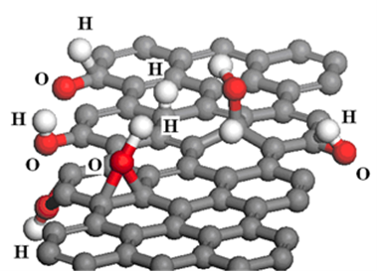

7. Classification of computer simulation methods
Today wide spread approaches of computer modeling are molecular dynamics (MD) and Monte Carlo (MC), and also there are hybrid techniques that combine the features of both.
MD allows to anticipate an elasticity, plasticity or destruction, without any changes in the procedure. In addition MD has another name as atomistic modeling which allows simulate materials of nanometers size, analyze and understand the motion of each atom in the material, understand how a material exposed deformation, phase changes, also extracting information from atomistic dynamics. Sometimes MD is called the “first principles approach” to understanding the behavior of atoms and determining interatomic potentials (how atoms interact) all properties of materials (infinite possibilities and problems) [125, 126].
The next most important type of computer simulation is Monte Carlo, which was named after the city. Monte-Carlo, like MD, will be used to solve some problems, unforeseen risks, in science, technology, in finance, etc. In comparison with the MD method in this method the process is modeled by generating random processes, objects, quantities, which in turn is repeated several times and on the basis of the obtained random data, the probabilistic characteristics of the process being studied or the problem being solved are calculated. During the modeling, these random objects can be “natural”, which is part of the simulation of the real system or are introduced “artificially”. Often, in many cases of simulation, random objects are introduced “artificially”. Also, the Monte Carlo method is actually used for modeling physical processes, for solving quantitative problems of science, technology, and also in materials related science, where they are used to develop and analyze new materials and structures. In addition, the Monte Carlo method is applied to the design of virtual materials, which in turn allows you to get more data than physical experiments [127, 128].
Thus, MD and Monte-Carlo are widespread approaches of computer modeling, which in turn allows to study the properties of materials, analyze and understand the motion of each atom in the material, determine the interatomic potentials (how atoms interact), and also apply when studying random structures and graphs arising in statistical physics, probability theory.
Figure 1 (a, b, c) shows the computer models of the FSLGN after optimization, which resulted in the formation of structural defects, hole-like defects are especially obvious, and the oxide is bonded on both sides according to the image.

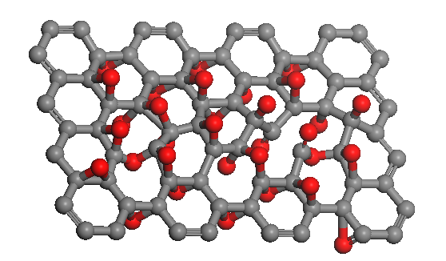
а)
.
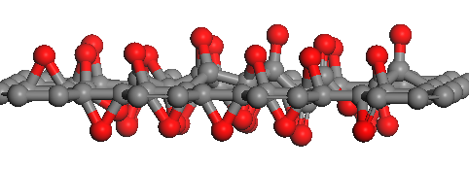
b)

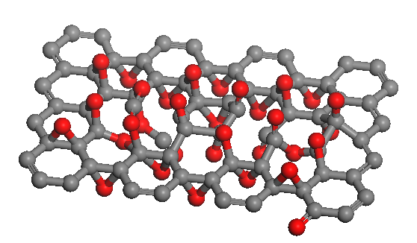
c)

Figure 1 – Computer simulation of two-sided bonds of oxide with graphene: a) view from the surface, b) from the side, c) hole-like defects

The charge map shows the covalent bond of oxygen with graphene, in addition, the electron charge density was calculated, which is = 0.02 e/A³ (Figure 2).

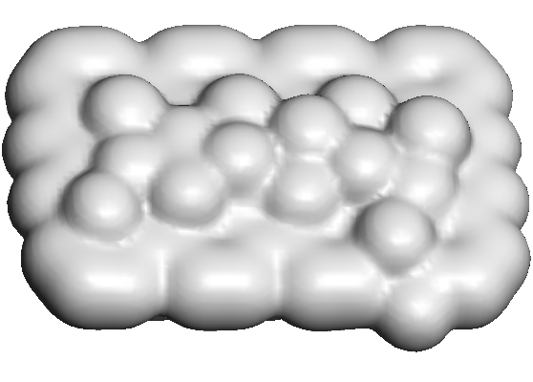

Figure 2 – Electron charge density

Figure 3 – Shows a model of a possible FSLGN reduce process with various connections: functionalizing graphene -O and graphene -O-H groups

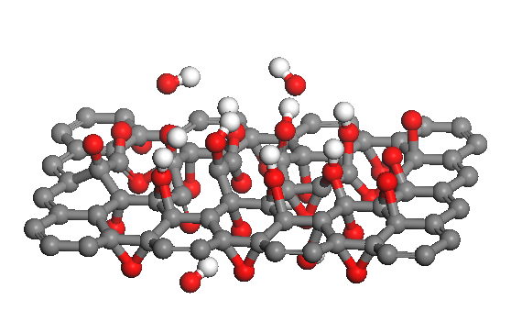

Figure 4 – Computer model of the FSLGN reduction process

Thus, the application of the density functional theory (DFT) using the molecular dynamics method with Chem Office Materials Studio software tools allows exploring unforeseen physical or chemical properties FSLGN. In this section, computer models of typical configurations of FSLGN were presented, also the length and binding energies of C–O, and O–H radicals were calculated. In addition, computer models of various atomic arrangements, types of oxygen with graphene, a model of the possible reduction process of FSLGN were created, and the binding energies of the graphene -O and graphene -O-H functionalizing groups were calculated.

Questions
- Advantages in computer modeling
- Computer modeling of molecular dynamics (MD)
- Computer simulation of possible stable structures of graphene and few-layer graphene functionalized Ga
- A possible structure of Ga-atom
- Computer Simulation of FSLGN

References

- 123 Web-Resource, Leo P. Kadanoff. Excellence in computer simulation https://www3.nd.edu 16.11.2018
- 124 Web-Resource, Roger McHaney. Understanding Computer Simulation. https://library.ku.ac.ke 17.11.2018
- 125 Web-Resource, Molecular dynamics simulations https://afire.asnet 17.11.2018
- 126 Web-Resource, Markus J. Buehler. Introduction to classical molecular dynamics Lecture 2. https://ocw.mit.edu 18.11.2018
- 127 Web-Resource, Chapter 8 Monte Carlo Simulation. http://web.mst.edu 18.11.2018
- 128 Web-Resource, Dirk P. Kroese. Why the Monte Carlo Method is so important today. https://people.smp.uq.edu 18.11.2018
- 129 Ilyin A.M., Daineko E.A. & Beall G.W. Computer Simulation and Study of Radiation Defects in Graphene // Physica E. – 2009. – Vol. 42, №. 21. – P. 67 – 69.
- 130 Ilyin A., Guseinov N., Nikitin A. and Tsyganov I. Characterization of thin graphite layers and graphene with energy dispersive X-ray analysis // Physica E. – 2010. – Vol. 42, №. 8. – P. 2078 - 2080.
- 131 Ilyin A.M., Nemkaeva R.R., Kudryashov V.V. Computational study of graphene and few –layer graphene –metal composites, induced by radiation // J.Mater. Sci& Engineering, B3. – 2013. – Vol. 3. – P. 161 – 166.
- 132 Ilyin A.M., Guseinov N.R., Nemkaeva R.R., Asanova S.B., Kudryashov V.V. Bridge-like radiation defects in few-layer graphene // Nucl.Instrum & Methods in Phys.Res., B. – 2013. – Vol. 315. – P. 192 - 196.
- 133 Ilyin A.M., Kudryashov V.V., Guseinov N.R. Computer Simulation of Few-Layer Graphene Intercalated by Lithium for Power Sources // Journal of Electrochemical Society. – 2015. – Vol.162, №. 8. – P. A1544 – A1546.
- 134 Guseinov N., Baigarinova G., Ilyin A. Structural damaging in few-layer graphene due to the low energy electron irradiation // Advances in Nano Research. – 2016. – Vol. 4, №. 1. – P. 45 – 50.
- 135 Farahani H., Wagiran R. and Hamidon M.N.. Review Humidity Sensors Principle, Mechanism, and Fabrication Technologies // A Comprehensive Review Sensors. – 2014. – Vol. 14. – Р.7881 – 7939;
- 136 Chia Y.L. and Gwo B.L. Humidity Sensors: A Review // SENSOR LETTERS. – 2005. – Vol. 3. – Р. 1 – 14.
- 137 Naik G., Krishnaswamy S. Room-Temperature Humidity Sensing Using Graphene Oxide Thin Films // Graphene. – 2016. – Vol. 5. – Р. 1 – 13.
- 138 Lee, C. & Lee, G. Humidity sensors: A Review // Sens. Lett. – 2005. – Vol. 3. – Р. 1 – 15.
- 139 Hengchang B, Kuibo Y, Xiao X, Jing J, Shu W, Litao S, Mauricio T & Mildred S.. Ultrahigh humidity sensitivity of graphene oxide // Scientific Reports. – 2013. – Vol. 3. – Р. 1 – 7.
- 140 Schedin F., Geim, A.K., Morozov S.V., Hill E.W., Blake P., Katsnelson M.I. and Novoselov K.S. Detection of Individual Gas Molecules Adsorbed on Graphene // Nature Materials. – 2007. – Vol. 6. – Р. 652 – 655.

