S. AMANZHOLOV EAST KAZAKHSTAN UNIVERSITY

Department of Chemistry

Subject: Nanotechnologies and Nanomaterials
Lecture No. 8: «Computer simulation of FFLGN, Ga-doped graphene»

Lecturer: Kuanyshbekov Tilek Kuanyshbekuly, PhD

Oskemen 2024

 | LECTURER: PhD, Associate Professor  Kuanyshbekov Tilek Kuanyshbekuly  Lecture No. 8: «Computer simulation of FFLGN, Ga-doped graphene»  Plan:  - Approaches of computer modeling are molecular dynamics (MD) and Monte Carlo (MC)  - Computer simulation of Monte Carlo  - Computer Simulation of FSLGN  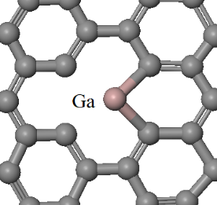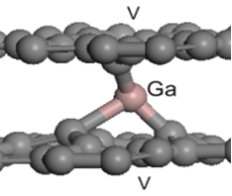

8. Computer simulation of FFLGN, Ga-doped graphene
It is very well known that graphene [1] and FFLGN are considered as exceptionally promising materials which are in many applications of more interest than graphene itself [2, 3, 4].
One more interesting material – FFLGN (GO) [5-6] that is graphene, functionalized with oxygen-containing chemical groups. This material is promising as an intermediate product for producing graphene in large scales. Additionally, it can be used for producing new materials for electronics, materials science. In the last few years, there has been an increase of attention to functionalization of graphene with radiation techniques, for example, forming radiation defects and doping them by atoms of different elements [7, 9-13]. This conception represents a new way of producing graphene-based 2D nanostructures functionalized with elements like Ga, As, N, B, S. Such materials are promising for prospective applications in nanoelectronics, supersensitive sensors, electrical power sources, flexible electronic and power devices. But it is not yet well understood about stable atomic configurations of graphene, functionalized with individual atoms of different elements in which way they can be produced in graphene nanostructures and how to obtain characteristics needed. It is in some cases rather difficult problem for experimental research and proper interpretation of data. In this situation, computational simulation and study of functionalized graphene-based nanostructures become a very effective research tool for better understanding the physical and chemical properties of such materials [9, 11-13] and predicting their characteristics. In section 3.1.1, we demonstrate results of computer simulations of some possible stable structures of Ga-doped graphene and few-layer graphene and first-principles study of their energetic and structural characteristics [13]. It is known that Ga in its common state is a metal with a very low melting point (≈ 30 ºC), but when Ga atoms are arranged separately in a two-dimensional graphene’s structure, all basic properties can change very essentially.
Further, in sections 3.1.1, 3.1.2. we present results of computer simulation and density functional theory (DFT) calculations within Dmol3 software-package [12-14] of possible stable configurations of FSLGN, few-layer graphene, graphene functionalized by Ga atoms. All calculations were performed using local density approximation and very effective method of energy optimization [13, 15], with using periodic boundary conditions, with convergence tolerance on energy 0.001 eV.
Computer simulation of possible stable structures of graphene and few-layer graphene functionalized Ga
Computer modeling of molecular dynamics (MD) has become a very useful technique for studying many types of properties of layered nanomaterials, such as graphene, GO, few-layer graphene nanostructures, FFLGN, which have wide interest in various fields of science and technology, such as military technology, biotechnology, nanoscience, biomedicine, etc. In addition, research of its physical, chemical and electronic properties has paid considerable attention from researchers.
We present results of computer simulation and density functional theory (DFT) calculations of possible stable configurations of few-layer graphene, functionalized by Ga atoms [18]. As mentioned in the section 1.9 all calculations were performed by using local density approximation and very effective method of energy optimization, with periodic boundary conditions and, convergence tolerance on energy 0.001 eV.
Figure 14 presents possible adsorption sites for Ga atoms with high symmetry: namely: A, H, and B respectively. H site of adsorption (over the center of the hexagon) has the largest adsorption energy, therefore, it is the favored site for Ga atom adsorption.
Figure 15 shows a possible stable atomic complex of Ga- vacancy which was formed after using the procedure of energy optimization. In such a case, the Ga atom takes place outside the graphene sheet with forming a 3D complex defect.

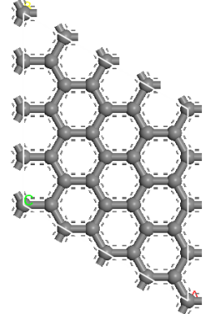  a) | 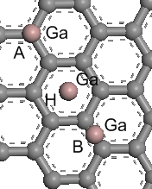  b)

Figure 1 – a) The unit cell for the graphene sheet within periodic boundary conditions calculations adopted a 4x4 structure; b) Some of calculated adsorption sites on graphene surface with a high symmetry: A) over the C atom; H) over the center of a hexagon; B) over the center of the C-C-bond. In all positions binding energy of Ga rather low: H – 0.73 eV, A – 0.57 eV, B – 0.40 eV. The distance between the Ga atom and graphene plane is 0.22 nm.

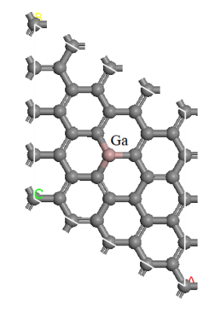  a) | 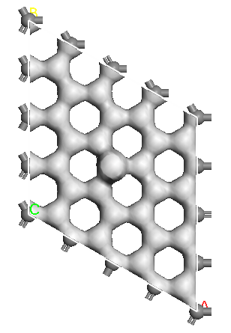  b)

Figure 2 – Computer models of atomic configurations Ga- graphene. a) an atomic configuration of Ga-atom bonded with a vacancy. The binding energy of Ga atom = 1.92 eV, the distance of Ga atom from graphene sheet equals 1.53 Å; b ) The map of electron charge distribution for density 200 el /nm³. In this case, gallium shows valence equal to three

Figure 3 illustrates a stable complex atomic configuration with the binding energy of Ga 1.71 eV and the distance from the graphene plane equals 0.8 Å. In this defect configuration, Ga demonstrates two-valence state.

a) | 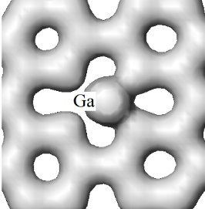  b)

Figure 3 – A possible structure of Ga-atom - vacancy: a) atomic configuration; b) a map of the distribution of the electron charge for density 410 el / nm³.

Complex defect configuration – a bridge-like defect [11, 12, 14] based on a gallium atom is shown in figure 4.

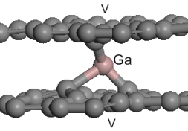  a) | 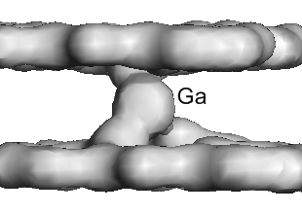  b)

Figure 4 – A bridge-like defect, based on Ga-atom, which connects two graphene sheets by fast covalent bond (E_{bind}= 3.28 eV): a) atomic structure of the complex defect based on a Ga- atom captured between two vacancies V in the graphene sheets; b) The map of the electron charge distribution for density 900 el/nm³. This configuration shows three valence state of Ga.

Results of simulation and calculations have shown that the stability of Ga-graphene composition is much higher when the Ga atom is linked with a structural defect. It should be noted, that maps of the electron charge distribution (figures 2-4) show, that the electron transfer between Ga and C, in general, is in a good agreement with well-known electronegativity data for carbon and gallium (by Pauling Scale).
In this way, computer simulations and DFT calculations of structural and energetic characteristics of some possible stable configurations of Ga-graphene nanostructures were performed. Similar atomic structures in graphene and few-layer graphene can be experimentally produced by low-energy irradiation with Ga⁺ ions in the SEM devices. Results of the work can be useful for production close to 2D-Ga-graphene nanostructures, for applications in nanoelectronic devices as well as for storing Ga in graphene nanostructures in atomic form.
In addition, one of the most important processes of FFLGN study is the functionalization of graphene with strong acids, as a result of which graphene becomes functionalized with hydroxyl and epoxy groups on their main plane and at the edges of the carbonyl and carboxyl groups [12-14], which was discussed in the section 1.4, and the FFLGN computer simulation and quantum-mechanical calculations will be presented in detail in the next section 3.1.2.
Questions
- Advantages in computer modeling
- Computer modeling of molecular dynamics (MD)
- Computer simulation of possible stable structures of graphene and few-layer graphene functionalized Ga
- A possible structure of Ga-atom
- Computer Simulation of FSLGN

References

- 123 Web-Resource, Leo P. Kadanoff. Excellence in computer simulation https://www3.nd.edu 16.11.2018
- 124 Web-Resource, Roger McHaney. Understanding Computer Simulation. https://library.ku.ac.ke 17.11.2018
- 125 Web-Resource, Molecular dynamics simulations https://afire.asnet 17.11.2018
- 126 Web-Resource, Markus J. Buehler. Introduction to classical molecular dynamics Lecture 2. https://ocw.mit.edu 18.11.2018
- 127 Web-Resource, Chapter 8 Monte Carlo Simulation. http://web.mst.edu 18.11.2018
- 128 Web-Resource, Dirk P. Kroese. Why the Monte Carlo Method is so important today. https://people.smp.uq.edu 18.11.2018
- 129 Ilyin A.M., Daineko E.A. & Beall G.W. Computer Simulation and Study of Radiation Defects in Graphene // Physica E. – 2009. – Vol. 42, №. 21. – P. 67 – 69.
- 130 Ilyin A., Guseinov N., Nikitin A. and Tsyganov I. Characterization of thin graphite layers and graphene with energy dispersive X-ray analysis // Physica E. – 2010. – Vol. 42, №. 8. – P. 2078 - 2080.
- 131 Ilyin A.M., Nemkaeva R.R., Kudryashov V.V. Computational study of graphene and few –layer graphene –metal composites, induced by radiation // J.Mater. Sci& Engineering, B3. – 2013. – Vol. 3. – P. 161 – 166.
- 132 Ilyin A.M., Guseinov N.R., Nemkaeva R.R., Asanova S.B., Kudryashov V.V. Bridge-like radiation defects in few-layer graphene // Nucl.Instrum & Methods in Phys.Res., B. – 2013. – Vol. 315. – P. 192 - 196.
- 133 Ilyin A.M., Kudryashov V.V., Guseinov N.R. Computer Simulation of Few-Layer Graphene Intercalated by Lithium for Power Sources // Journal of Electrochemical Society. – 2015. – Vol.162, №. 8. – P. A1544 – A1546.
- 134 Guseinov N., Baigarinova G., Ilyin A. Structural damaging in few-layer graphene due to the low energy electron irradiation // Advances in Nano Research. – 2016. – Vol. 4, №. 1. – P. 45 – 50.
- 135 Farahani H., Wagiran R. and Hamidon M.N.. Review Humidity Sensors Principle, Mechanism, and Fabrication Technologies // A Comprehensive Review Sensors. – 2014. – Vol. 14. – Р.7881 – 7939;
- 136 Chia Y.L. and Gwo B.L. Humidity Sensors: A Review // SENSOR LETTERS. – 2005. – Vol. 3. – Р. 1 – 14.
- 137 Naik G., Krishnaswamy S. Room-Temperature Humidity Sensing Using Graphene Oxide Thin Films // Graphene. – 2016. – Vol. 5. – Р. 1 – 13.
- 138 Lee, C. & Lee, G. Humidity sensors: A Review // Sens. Lett. – 2005. – Vol. 3. – Р. 1 – 15.
- 139 Hengchang B, Kuibo Y, Xiao X, Jing J, Shu W, Litao S, Mauricio T & Mildred S.. Ultrahigh humidity sensitivity of graphene oxide // Scientific Reports. – 2013. – Vol. 3. – Р. 1 – 7.
- 140 Schedin F., Geim, A.K., Morozov S.V., Hill E.W., Blake P., Katsnelson M.I. and Novoselov K.S. Detection of Individual Gas Molecules Adsorbed on Graphene // Nature Materials. – 2007. – Vol. 6. – Р. 652 – 655.

