S. AMANZHOLOV EAST KAZAKHSTAN UNIVERSITY

Department of Chemistry

Subject: Nanotechnologies and Nanomaterials

Lecture No. 9: «Graphene»

Lecturer: Kuanyshbekov Tilek Kuanyshbekuly, PhD

Oskemen 2024

 | LECTURER: PhD, Associate Professor  Kuanyshbekov Tilek Kuanyshbekuly  Lecture No. 9: «Graphene»  Plan:  - Graphene  - Structure of graphene  - Electronic properties of graphene  - Graphene Transparency 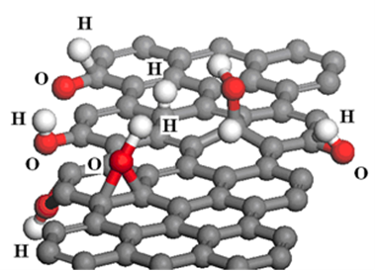

9. Graphene
For the first time in 2004, Geim and Novoselov, using the method of mechanical exfoliation, separated one sheet of graphene from graphite. Since then, graphene has unique physic-mechanical properties (mechanical, thermal, optical and electrical), so based on the above properties it’s attracted more attention in many fields of science and technology. Graphene is a flat layer of the monatomic structure of sp² bound carbon atoms, which is tightly packed in a hexagonal structure [1, 2].
Graphene is a one-layer sheet of carbon, which is a flat monolayer of
sp²-hybridization carbon atoms located in a honeycomb lattice and having a carbon-carbon bond distance of 0.142 nm [3], and the height of one layer is 0.33 nm (Figure 1 ( a, b)).

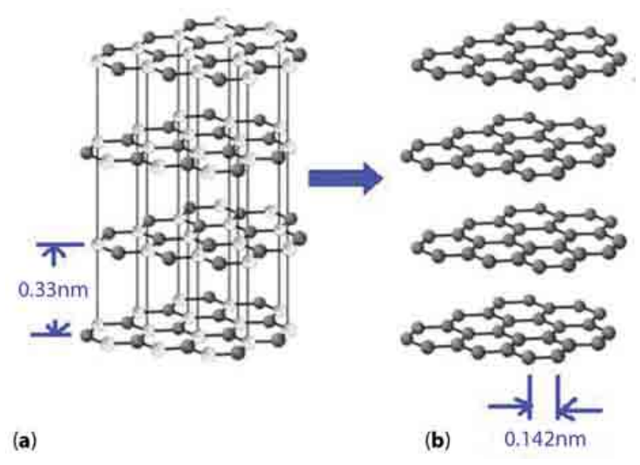

Figure 1 – Schematic diagram of (a) graphite and (b) four layers of graphene from graphite [21, p. 3]

Structure of graphene has a stable hexagonal form due to densely packed carbon atoms and sp² bonds in each lattice, and this -bond consists of combinations as s, p_{x}, and p_{y} orbitals [4]. The final p_{z}-electron is a π-bond located vertically to the plane of the lattice on which the electrical conductivity of graphene depends and the hybridization of this π -bonds contribute to the formation of the -zone and π* -zone (bands).
And also the electronic properties of graphene depend on these zones, with the help of which electrons can freely move through the half-filled bands [5]. Thus, the graphene structure consists of a densely packed one layer of carbon atoms associated with the surrounding atoms of carbon by sp² hybridization in the shape of a benzene ring in which each atom donates an unpaired electron for -bonds and in this case electrons can move freely with little interference at room temperature, which leads to high conductivity [2, 6].
Graphene is semimetal and lower energy of electrons can pass from the valence to the conduction bands through a small overlap, and this transition occurs without external heat exposure. Also, a certain amount of electrons can be in the conduction band and in the valence band there is a certain number of holes [7]. Figure 2 shows the conduction bands in the form of a cone-shaped structure, in that the valence band and conduction band intercept the Dirac point, also the manifestation of the anomalous quantum Hall effect and the characteristics of relativistic particles [3, 8], which occur in the process of electron transfer [9, 10].
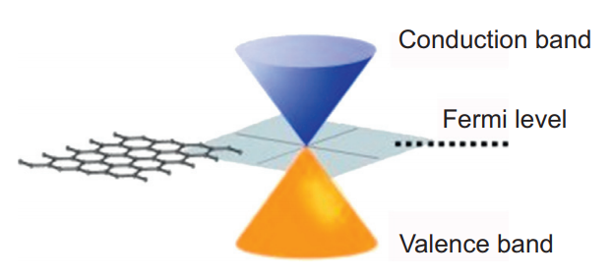

Figure 2 – Conduction zones in the form of a cone-shaped structure [3, p. 10]

Compared to other carbon materials, graphene has optical, electrical and mechanical properties. The optical property is distinguished by the fact that, regardless of the wavelength in the optical zone, graphene absorbs 2.3% of the light intensity.
Also, the transparency of graphene depends on the number of layers, that is, single-layer graphene absorbs 2.3% of visible light and has a very high transparency of 97.7% and the transparency of two-layer graphene is less than single-layer and the difference between them is 2.3% [3, 7], which is shown in Figure 3 [3, p. 8].
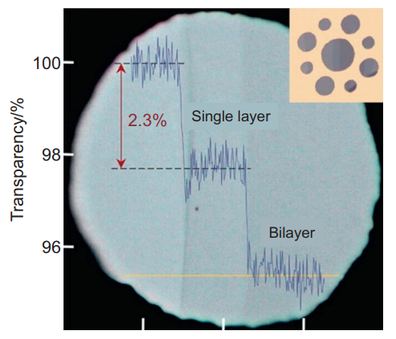

Figure 3 – Graphene Transparency [3, p. 8]

Graphene with different layers has the ability to show different colors and contrasts, also graphene layers can be distinguished using the refraction and interference light [3, 8]. And also, depending on the different thickness of graphene, you can control the unique optical properties of this material.
Another interesting property of graphene is the mobility of electrons. In this case, the electrical conductivity of a sheet of 2D material is given by the expression and the mobility of a 2D sheet is theoretically limited to = 200,000 cm²V⁻¹s⁻¹ by acoustic phonons at carrier density n = 10¹² cm⁻² and 140 times mobile than silicon, and the resistivity per square is 31 Ohms. Compared with copper, the electrical conductivity of graphene with a thickness of one layer is much higher, that is, the volumetric conductivity of graphene is 0.96 × 10⁶ Ohm⁻¹ cm ⁻¹, and copper has 0.60 × 10⁶ Ohm⁻¹ cm⁻¹ [5].
Thus, graphene can potentially become competitive and replace indium and fluorine doped tin oxide and other traditional membranes [3] due to its optical and high conductivity properties.
The next property of graphene is the mechanical strength, which has the most rigid crystal structure among all known materials and the tensile strength and modulus of elasticity of graphene are 125 GPa and 1.1 TPa [9], respectively, its tensile strength reaches 42 N/m. If we compare the strength of steel and graphene with the same size and thickness, then graphene is approximately 100 times stronger, for example, 1 m² of graphene can withstand 4 kg of weight [3, 30].
Steel has a tensile strength in the range of 250-1200 MPa = 0.25-1.2 × 109 N/m². For example, if it is hypothetical to take a steel film with a thickness of 3.35Å = 3.35 × 10⁻¹⁰ m and as the thickness of a single graphene layer in graphite, then a two-dimensional tensile strength of steel will give 0.084-0.40 N/m, and for graphene 42 N/m, and these data show that graphene is more than 100 times stronger.
Also one of the important properties of graphene is thermal conductivity. The thermal conductivity is 10 times better than copper, which is, at room temperature, copper has 401 W m⁻¹K⁻¹, and graphene is approximately 5000 W m⁻¹K⁻¹ [5]. In addition, graphene has a high surface area of 2630 m²/g [3, 11] and this property allows it to be used in microsensors for gas molecules by observing sharp changes in electrical resistance in the process of adsorption and desorption of gas molecules.
Questions
- Mechanical exfoliation of grpahene
- Structure of graphene
- Electronic properties of graphene
- Conduction zones in the form of a cone-shaped structure
- Graphene Transparency

References
- Hiremath N., Mays J., Bhat G., Recent developments in carbon fibers and carbon nanotube-based fibers: a review // Polymer Reviews. – 2017. – Vol. 57, № 2. – P. 339 – 368.
- Arbuzov A.A., Muradyan V.E., and Tarasov B.P. Synthesis of few-layer graphene sheets via chemical and thermal reduction of graphite oxide // Proceedings of the International Conference Nanomaterials: Applications and Properties. – 2012. – Vol. 1, №. 1. – P. 4.
- Singh V., Joung D., Zhai L., Das S., Khondaker S.I., and Seal S. Graphene based materials: past, present and future // Progress in Materials Science. – 2011. –Vol. 56, №.8. – P. 1178 – 1271.
- Web-Resource, Sharon M., et al. Graphene: An Introduction to the Fundamentals and Industrial Applications. – USA: John Wiley & Sons, 2015. – P. 294.
- Novoselov K.S., Geim A.K., Morozov S.V., et al. Two-dimensional gas of massless dirac fermions in graphene // Nature. – 2005. – Vol. 438. (7065) – P. 197 – 200.
- Zhang Y.B., Tan Y.W., Stormer H.L., et al. Experimental observation of the quantum hall effect and berry's phase in graphene // Nature. – 2005. – Vol. 438. (7065) – P. 201 – 204
- Berger C., Song Z.M., Li T.B., et al. Ultrathin epitaxial graphite: 2D electron gas properties and a route toward graphene-based nanoelectronics // J. Phys. Chem. B. – 2004. – Vol. 108, № 52. – P. 19912 – 19916.
- Son Y.W., Cohen M.L., Louie S.G. Half-metallic graphene nanoribbons // Nature. – 2006. – Vol.444, № 7117. – P. 347 – 349.
- Avouris P., Chen Z., Perebeinos V.. Carbon-based electronics // Nat. Nanotechnol. – 2007. – Vol. 2, № 10. – P. 605 – 613.
- Nair R.R., Blake P., Grigorenko A.N., et al. Fine structure constant defines visual transparency of graphene // Science. – 2008. – Vol.320, № 5881. – P. 1308.
- Ni Z.H., Wang H.M., Kasim J., et al. Graphene thickness determination using reflection and contrast spectroscopy // Nano Lett. – 2007. – Vol. 7, № 9. – P. 2758 – 2763.
- 29 Lee C., Wei X., Kysar J.W., et al., Measurement of the elastic properties and intrinsic strength of monolayer graphene // Science. – 2008. – Vol. 321, № 5887. – P. 385 – 388.
- Stankovich S., Dikin D.A., Dommett G.H.B., et al. Graphene-based composite materials // Nature. – 2006. – Vol. 442, № 7100. – P. 282 – 286.
- Stoller M.D., Park S., Zhu Y., et al. Graphene-based ultracapacitors // Nano Lett. – 2008. – Vol. 8, № 10. – P. 3498 – 3502.

