S. AMANZHOLOV EAST KAZAKHSTAN UNIVERSITY

Department of Chemistry

Subject: Nanotechnologies and Nanomaterials

Lecture No. 10: «Methods for the synthesis of graphene»

Lecturer: Kuanyshbekov Tilek Kuanyshbekuly, PhD

Oskemen 2024

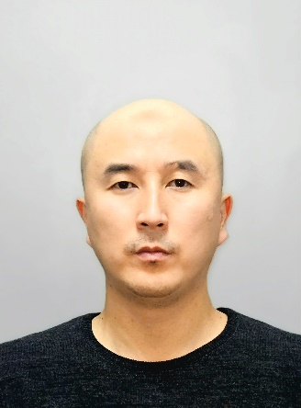 | LECTURER: PhD, Associate Professor  Kuanyshbekov Tilek Kuanyshbekuly  Lecture No. 10: «Methods for the synthesis of graphene»  Plan:  - Synthesis of graphene  - Various methods for the synthesis of graphene  - Synthesis of graphene in the CVD  - Electrochemical exfoliation of graphite  - 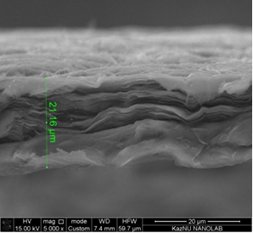

10. Methods for the synthesis of graphene
To date graphene has attracted widespread attention, and also represents a huge potential for various scientific and practical applications, due to its physic-mechanical properties. Graphene is characterized as a 2D sheet of sp²-hybridized carbon atoms located in a hexagonal lattice [1].
One of the important processes is the synthesis of graphene. By synthesis of graphene, is meant to obtain graphene of the desired size, purity, crystallinity using various methods [2]. In this case, the most commonly used methods for the synthesis of graphene are mechanical splitting [2]; epitaxial growth; chemical vapor deposition (CVD); electrochemical peeling [1, 2, 3, 4]. Figure 1 shows the different methods for the synthesis of graphene.

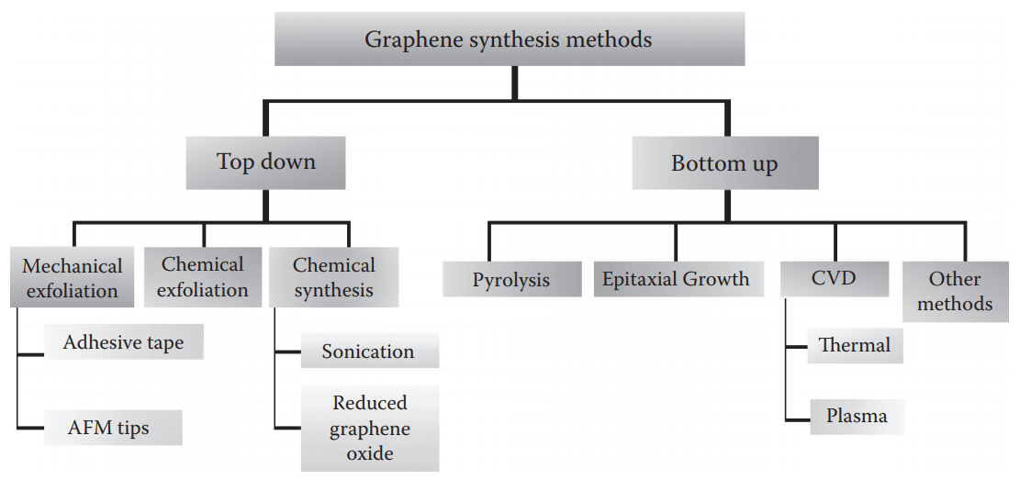

Figure 1 – Various methods for the synthesis of graphene [3, p. 29]

To obtain graphene by the method of mechanical splitting, thin layers of HOPG are placed between adhesive tapes and the graphite film is cleaved off time after time until a thin layer is obtained [2].
The next important method is epitaxial growth of graphene, where graphene is grown on monocrystalline silicon carbide (SiC) [3]. In this method, silicon carbide (SiC) is heated under a temperature of about 1200 °С under vacuum, resulting in the sublimation of Si atoms, forming carbon layers on SiC, which can be double-layered, multi-layered, or monolayer [1].
Synthesis of graphene in the CVD method carried out directly on next transition metal substrates, such as Ni, Cu, Co, Au, and Ru. Also, the process of saturating carbon carried out under the influence of the next various gaseous hydrocarbons: methane, ethylene, acetylene, and benzene at high temperature [4].
There are differences between CVD processes with hot and cold walls, that substrate in the hot wall is heated by radiation from the heated chamber walls and temperature is relatively constant everywhere because the chamber is heated by an external source of energy. In the cold wall reactor, the sample is heated using the following ways: passing current through the sample, using a heater of the substrate, using induction, and the chamber walls have room temperature [6].
The next method of obtaining graphene is electrochemical exfoliation of graphite. Choice the electrodes and electrolyte one of the important processes in the electrochemical exfoliation, which affects the increasing in charge transfer and functionalization of obtaining graphene sheets. Many different electrodes and electrolytes are used for this method and most commonly used electrodes are: HOPG, graphite, Cu, Pt., and the next electrolytes: HBr, HCl, HNO_{3,} and H₂SO₄, as well as acid electrolytes and alkaline electrolyte KOH, diluted with distilled water, which is ideal for exfoliating graphite [7-9].
In this process, two graphite electrodes or other types are first inserted into the solution. Then about 10 V is applied to the electrodes and the intercalating ion of the solution penetrates between the graphite layers and exfoliates into FLG sheets. After separating graphite particles from the graphene, the solution is exposed to centrifugation or ultrasound to improve the exfoliations. At the finish of the process, the solution is dried [10, 11].
Thus, until today, the synthesis of graphene and graphene-like materials is relevant due to the unique physic-mechanical properties, therefore, many works are aimed at finding ways to obtain graphene under such conditions as low cost, a fairly simple synthesis method, scalability and capabilities turn it into graphene. One of the most appropriate methods for the synthesis of graphene, given the above conditions, is to obtain FFLGN, which will be discussed in subsequent sections of this work.

Questions
- Mechanical exfoliation of grpahene
- Various methods for the synthesis of graphene
- Synthesis of graphene in the CVD
- Electrochemical exfoliation of graphite

References
- 24 Berger C., Song Z.M., Li T.B., et al. Ultrathin epitaxial graphite: 2D electron gas properties and a route toward graphene-based nanoelectronics // J. Phys. Chem. B. – 2004. – Vol. 108, № 52. – P. 19912 – 19916.
- 32 Novoselov, K.S., Geim, A.K., Morozov, S.V., Jiang, D., Zhang, Y., Dubonos, S.V., Grigorieva, I.V., and Firsov, A.A. Electric field effect in atomically thin carbon films // Science. – 2004. – Vol. 306. – P. 666 – 669.
- 33 Shivaraman, Sh., Barton R.A., Yu X., Alden J., Herman, L. Chandrashekhar M., Park J., McEuen P.L., Parpia J.M., Craighead H.G. and Spencer M.G. Free-Standing Epitaxial Graphene // Journal of nano Letter. – 2009. – Vol. 9. – P. 3100 – 3105.
- 34 Reina, A., Jia, X.T., Ho, J., Nezich, D., Son, H., Bulovic, V., Mildred Dresselhaus, S., Kong, J. Large area, few-layer graphene films on arbitrary substrates by chemical vapor deposition // Nano Lett. – 2009. – Vol. 9, № 1. – P. 30 – 35.
- 35 Wonbong Choi, Jo-won Lee. Graphene Synthesis and Applications. – USA New York: Taylor & Francis Group, 2016. – P. 394.
- 36 Keun Soo Kim, Yue Zhao, Houk Jang, Sang Yoon Lee, Jong Min Kim, Kwang S. Kim, Jong-Hyun Ahn, Philip Kim, Jae-Young Choi, and Byung Hee Hong. Large-scale pattern growth of graphene ﬁlms for stretchable transparent electrodes. // Nature. – 2009. – Vol. 457, № 7230. – P. 706 – 710.
- 37 Parvez K., Li R., Puniredd S.R., Hernandez Y., Hinkel F., Wang S., Feng X., Mu¨ llen K. Electrochemically exfoliated graphene as solution-processable, highly conductive electrodes for organic electronics // ACS Nano. – 2013. – Vol. 7, № 7. – P. 3598 – 3606.
- 38 Su C.Y., Lu A.Y., Xu Y., Chen F.R., Khlobystov A.N., Li L.J. High-quality thin graphene films from fast electrochemical exfoliation // ACS Nano. – 2011. – Vol. 5, № 7. – P. 2332 – 2339.
- 39 Liu N., Luo F., Wu H., Liu Y., Zhang C., Chen J. One-Step Ionic-Liquid-Assisted Electrochemical Synthesis of Ionic-Liquid-Functionalized Graphene Sheets Directly from Graphite // Advanced Functional Materials. – 2008. – Vol. 18. – P. 1518 – 1525.
- 40 Singh V.V et al. Greener Electrochemical Synthesis of High Quality Graphene Nanosheets Directly from Pencil and its SPR Sensing Application // Advanced Functional Materials. – 2012. – Vol. 22, № 11. – P. 2352 – 2362.
- 41 Ching-Yuan Su et al. High-quality thin graphene films from fast electrochemical exfoliation // ACS Nano. – 2011. – Vol. 5, № 3. – P. 2332 – 2339.
- 42 Sergey D, Scott G et al. A One-step, solvothermal reduction method for producing reduced graphene oxide dispersions in organic solvents // ACS Nano. – 2010. – Vol. 4, № 7. – P. 3845 – 3852.

