S. AMANZHOLOV EAST KAZAKHSTAN UNIVERSITY

Department of Chemistry

Subject: Nanotechnologies and Nanomaterials

Lecture No. 11: «Various forms of carbon»

Lecturer: Kuanyshbekov Tilek Kuanyshbekuly, PhD

Oskemen 2024

 | LECTURER: PhD, Associate Professor  Kuanyshbekov Tilek Kuanyshbekuly  Lecture No. 11: «Various forms of carbon»  Plan:  - C 60 fullerene molecules, carbon nanotubes and graphite  - Graphite-like carbon nanomaterials  - The timeline of individual events in the history of graphene  - Fullerenes  - Carbon nanotubes  - 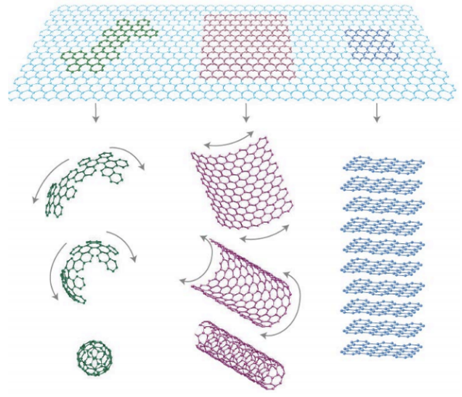

11. Various forms of carbon
One of the enthralling elements in material science and nanotechnology is carbon, which can introduce in the following molecular types: graphite, fullerenes, and nanotubes. Figure 1 shows the molecules of fullerene C60, carbon nanotubes and graphite, which can be considered in the form of graphene sheets arranged in a hexagonal lattice.

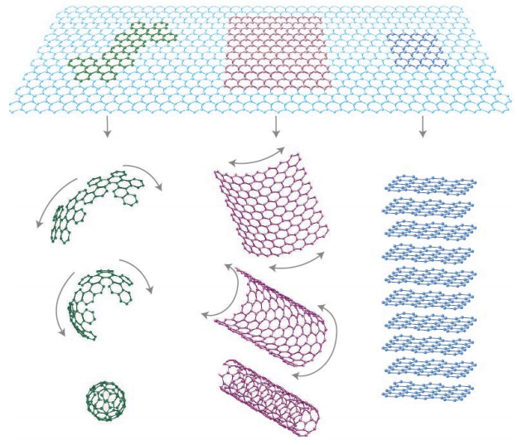

Figure 1 – C 60 fullerene molecules, carbon nanotubes and graphite [2, p. 4]

Among these carbon forms, the well-known is graphite, consisting of single layers of carbon atoms, which are stacked with hexagonal carbon sheets on above of each other. Single sheet representing the hexagonal structure was obtained in an exfoliated form in 2004 by K. Novoselov and A. Geim. Also shown that one of these single sheets, the so-called graphene, can be transferred to another substrate and the electrical characteristics can be measured [1, 2].
Graphite-like carbon nanomaterials consist of sp² – hybridized carbon atoms located in a hexagonal lattice, their difference in different sizes and shapes and only some common properties are similar [3].
In the history of graphene-like materials, they have been known and studied since the 1940s, but obtaining single isolated graphene and measuring its electrical characteristics was experimentally difficult and was considered almost impossible [2, 4, 5].
A detailed report was made in [6] and the history of the obtaining and characterization of graphene was shown in Table 1 [6]. From the history, we note Boehm, who invented the name of graphene in 1986 [4, 7, 8], in his work in 1962, demonstrated the existence of single graphene. In 1962, Boehm exfoliated RGO with heteroatomic contamination, where the electrical conductivity was significantly lower compared to pure graphene, which was obtained using the “scotch tape method” [8–11].
On the basis of this historical time scale for the synthesis and characterization of graphene, it should be noted that all works except Boehm were observational and did not describe the distinctive properties of graphene. Thus, according to the historical scale in 2005, Novoselov and Geim made the first report on obtaining a single layer of graphene using the “scotch tape method” without heteroatomic contamination and which describes its distinctive unique properties [6, 12].

Table 1 – The timeline of individual events in the history of graphene for its preparation, synthesis, and characterization [13, p. 3]

№ | Years | Events in the history of graphene
 | 1840-1958 | Graphite oxide synthesis (Schafhaeutl, Brodie, Staudenmaier, Hummers)
 | 1962 | Obtain RGO, GO by chemical and thermal reduction of graphite oxide (Boehm, colleagues)
 | 1968 | Obtain LEED patterns formed by absorbing a small molecule on Pt (100) (Morgan and Somorjai)
 | 1969 | interpretation of Morgan and Somorjai data on the presence of a monolayer of graphite on the Pt surface
 | 1970 | Obtain monolayer graphite by segregating carbon on the surface of Ni (100) (Blakely and his colleagues)
 | 1975 | Prepare monolayer graphite by sublimation of silicon from silicon carbide (Van Bommel and his colleagues)
 | 1986 | Using the term "graphene" to describe mono layers of graphite-like carbon recommended by Boehm and his colleagues.
 | 1997 | IUPAC formalizes the definition of graphene: “The term graphene should be used only when reactions, structural relations, or other properties of multiple layers of graphene are discussed.”
 | 1999 | Micromechanically exfoliate graphite into thin lamellae comprised of several layers of graphene (Ruoff, colleagues).
 | 2004 | Obtain graphene by micromechanical exfoliation (Geim, colleagues).

We all know that ordinary pencil contains graphite, and when this pencil is moved on paper, the graphite is exfoliate into several thin single layers of graphite, the so-called graphene sheets. That is, fairly simple use of a pencil, which contributes to the splitting of graphite, shows that the complexity is not the manufacture of graphene structures, but simply isolation on large individual sheets in order to investigate its unique two-dimensional (2D) properties that Geim, Novoselov and their employees succeeded in.
Fullerenes were discovered by chemists in 1996 and represent a new form of molecular carbon C60 that contains 60 carbon atoms assembled in a circle shape, resembling a soccer ball, which consists of 20 hexagons and 12 pentagons that allow surfaces to form a sphere [14].
Another form of carbon structures, known since 1993, are nanotubes [15], which represent a bound quasi-one-dimensional shape and are formed from twisted graphene sheets in the form of tubes. Carbon nanotubes, like fullerenes, have hemispherical ends, and the electronic and mechanical properties of single-walled nanotubes are almost similar to graphene [5, 16–18].
Carbon nanotubes depending its layers of the walls have the following sizes: the diameters of single have 0.8-2 nm, the diameters of multi have 5-20 nm and may to 100 nm. Also, a conductance or semi conductance walls of nanotube depends on lattice orientation relative to the axis, which has the name chirality [3].

Questions
- C 60 fullerene molecules, carbon nanotubes and graphite
- Graphite-like carbon nanomaterials
- The timeline of individual events in the history of graphene
- Fullerenes
- Carbon nanotubes

REFERENCES

1 Novoselov K.S., Jiang D., Schedin F., Booth T.J., Khotkevich V.V., Morozov S.V. and Geim A.K. Two-Dimensional Atomic Crystals // Proceedings of the National Academy of Sciences of the USA. – 2005. – Vol. 102, № 30. – P. 10451– 10453.
2 Web-Resource, Scientifc Background on the Nobel Prize in Physics 2010. Graphene. http://www.nobelprize.
3 Hongwei Zhu., Zhiping Xu., Dan Xie.,Ying Fang. Graphene Fabrication, Characterizations, Properties and Applications. – United Kingdom: Academic Press. Elsevier Inc, 2018. – P. 272.
4 Boehm H.P., Clauss A., Hofmann U., and Fischer G.O. Thin Carbon Leaves // Zeitschrift Für Naturforschung. – 1962. – Vol. 17. – P. 150 – 153.
5 Oshima C., Itoh A., Rokuta E., and Tanaka T.. A hetero-epitaxial-double-atomic-layer system of monolayer graphene/monolayer h-BN on Ni (111) // Solid State Communications. – 2000. – Vol. 116, № 1. – P. 37 – 40.
6 Dreyer D.R., Ruoff R.S., Bielawski C.W. From conception to realization: an historical account of graphene and some perspectives for its future // Angew Chem. Int. Ed. – 2010. – Vol. 49. – P. 9336 – 9344.
7 Boehm H.-P. Setton R., Stumpp E. Nomenclature and terminology of graphite intercalation compounds // Carbon. – 1986. – Vol. 24. – P. 241 – 245.
8 Boehm H.-P. Graphene-how a laboratory curiosity suddenly became extremely interesting // Angew. Chem. Int. Ed. – 2010. – Vol. 49. – P. 9332 – 9335.
9 Park S., Ruoff R.S. Chemical methods for the production of graphenes // Nature Nanotechnology. – 2009. – Vol. 4. – P. 217 – 224.
10 Stankovich S., Piner R.D., Chen X., Wu N., Nguyen S.T., Ruoff R.S. Stable aqueous dispersions of graphitic nanoplatelets via the reduction of exfoliated graphite oxide in the presence of poly(sodium 4-styrenesulfonate) // Journal of Material Chemistre. – 2006. – Vol. 16. – P. 155 – 158.
11 Shin H.-J., Kim K.K., Benayad A., et al. Efficient Reduction of Graphite Oxide by Sodium Borohydride and Its Effect on Electrical Conductance // Advanced functional materials. – 2009. – Vol. 19. – P. 1987 – 1992.
12 Geim A.K. Graphene prehistory // Physica Scripta. – 2012. – Vol. 2012, T 146. – P. 4.
13 Web-Resource, Dale A. C. Brownson, Craig E. Banks. The Handbook of Graphene Electrochemistry // Springer-Verlag London Ltd. P. 330. – 2014.
14 Kroto H.W., Heath J.R., Obrien S.C., Curl R.F., and Smalley R.E. C60: Buckminster fullerene // Nature. – 1985. – Vol. 318. – P. 162 – 163.
15 Oberlin A., Endo M., and Koyama T.. Filamentous growth of carbon through benzene decomposition // Journal of Crystal Growth. – 1976. – Vol. 32. – P. 335 – 349.
16 Iijima S., and Ichihashi T. Single-shell carbon nanotubes of 1-nm diameter // Nature. – 1993. – Vol. 363. – P. 603 – 605.
17 Bethune D.S., Kiang C.H., Devries M.S., Gorman G., Savoy R., Vazquez J., and Beyers R. Cobalt-catalysed growth of carbon nanotubes with single-atomic-layer walls // Nature. – 1993. – Vol. 363. – P. 605 – 607.
18 Hiremath N., Mays J., Bhat G., Recent developments in carbon fibers and carbon nanotube-based fibers: a review // Polymer Reviews. – 2017. – Vol. 57, № 2. – P. 339 – 368.

