Laboratoty work #13. Operation with services on the website of theelectronic government http://egov.kz/cms/ru/government-services/for_citizen:registration of requests, obtaining counterparts of documents, etc.

Purpose: to study the basics of work in the electronic government of theRepublic of Kazakhstan.

Methodological guide.

What does electronic government mean and its purposes?
Just try to imagе a society close in your perspective to the ideal one. Sound, with good job, good level of life, favorable living environment – the list can be continued endlessly and according to personal priorities be completed with necessary additional aspects.
But essential part of that society is the state itself. State takes care of the citizens. State provides opportunities for the best way of fulfillment of each citizen. State that guarantees integrity and compliance with law. State oriented to needs and demands of citizens. State with easy, apprehensible and available interaction – a state for people.
Development of information communicational technologies in Kazakhstan may guarantee the implementation of as minimum two last statements. The concept of “electronic government” has been developed for comfort, clear without obstacles communication between the state and the people.
“Electronic government” was created for more effective, transparent and accessible work of government agencies.
Formerly each state agency had been acting separately and had weak contacts with the rest and at the same time citizens had to rush different instances to obtain necessary certificates and references, verifications and other loads of documents. All this made the process of obtainment of only one service unbearable with endless visits to numerous agencies. Today it is all over owing to the projects of the “electronic government”.
Electronic government is the integrated mechanism of interaction between the state and citizens, state agencies with each other, ensuring consistency with the help of informational technologies. This mechanism reduced queues to state agencies and simplified acceptance of certificates, references, permits and many other documents and services.
In other words “electronic government” it is when for obtainment of license you need only Individual identification number (IIN) (other necessary data is taken by automatic requests), it is when you can pay for utility services and fines online, it is when for getting a certificate at «State-owned corporation «Government for citizens» NJSC you may only need your ID card, it is when you may independently register your business and get the certificate at the “electronic government” web-portal within 10-15 minutes, it is whet you may get info about the turn of your kid the waiting list to the kindergarten at any time of the day and night, or get statement of residence on cell phone and hundreds more of such “when”.

Development of the electronic government in the Republic of Kazakhstan

The idea of creation of the electronic government belongs to the President of the country and was announced almost 9 years ago. During this period passed four global stages of establishment and development of the electronic government. Each stage assisted in interaction processes between each Kazakhstani citizen with the state.
The first stage – informational. At that particular time was launched electronic government web-portal filled with information. It provided information about state agencies, their work and services which they deliver to citizens. In addition regulatory legal acts were also posted for information.
At this stage each Kazakhstani citizen could get necessary information – the list of necessary documents, the sizes of state duties, contact information of state agency. Starting from the first state reduced necessity in visits to different institutions owing to provided information in full volume.
The second stage is interactive. It was marked with the start of electronic services provision. The users of the web-portal had got an opportunity to send requests to different state agencies just staying at home without any losses of time. Introduction of interactive services at the electronic government web-portal seriously saved time for the paperwork. At this stage were launched informational systems, state data bases, electronic licensing and gateway of the electronic government.
The third stage of the electronic government development is a transactional one. At this stage citizens got an opportunity to pay for state taxes and fees, fines and utility services. If earlier citizens needed to go to banks not the services can be paid and obtained online.
For entrepreneurs transactional stage presented a truly valuable gift – Government procurement. The benefits are obvious - increased transparency and openness of competitions, tenders.
The fourth stage of the electronic government is transformational, it is the current stage of the development. The main aim now is provision of services to citizens with maximum efficiency. For the achievement of this target interactive and transaction services were combined within complex services which are demanded by the citizens of Kazakhstan. From the beginning of the year citizens may register legal entity within just 15 minutes, accept ID card, passport or driver’s license. Significance of socially important services will be highlighted, that is why all of them have been transformed into electronic format.

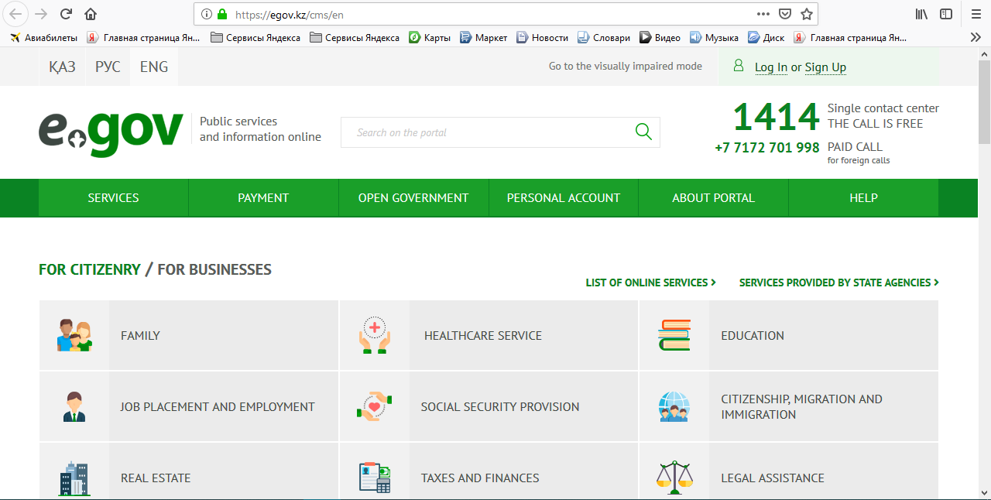

Figure 1. Homepage of the site egov.kz

Task
- Open a browser and go to the site http://egov.kz/. Familiarize yourself with the site services http://egov.kz/.
- Apply for an electronic digital signature.
- Analyze the algorithm for obtaining one of the types of certificates on obtaining “Issuance of real estate technical certificate” portal provided by the e-government service.

INSTRUCTION
on obtaining “Issuance of real estate technical certificate” service as related to selection of application type via e-Gov portal

Note: service recipient should be registered on e-Gov portal and have DS (digital signature).
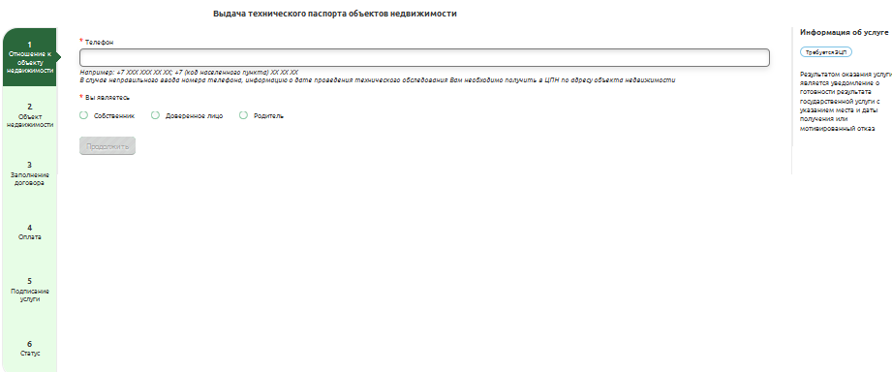
Picture 1. 1st step.
- Indicate phone number to which the date of technical inspection will be sent (Picture 1).
- Indicate relation to real estate unit (Owner/Owner`s trustee/Owner`s parent).

In case if an applicant is an owner`s trustee, s/he should fill in information (picture 2) and enclose scanned copy of power of attorney or birth certificate, if real estate`s owner is a child. Click “Continue” to proceed.
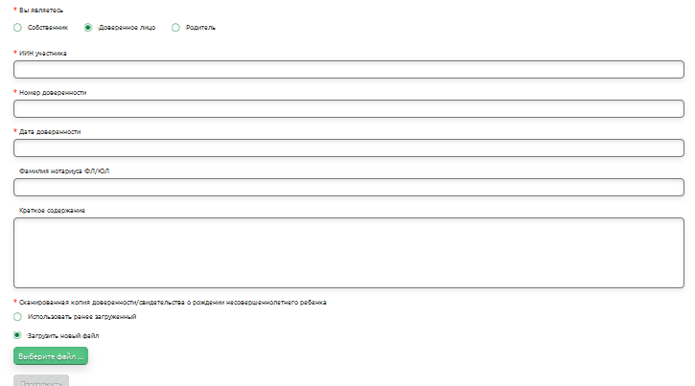
Picture 2. Page to be filled in by owner`s trustee

- In “Application type” section indicate the type of technical inspection (Picture 3). Afterwards indicate address data, choose “Real estate type” and click “Continue”.

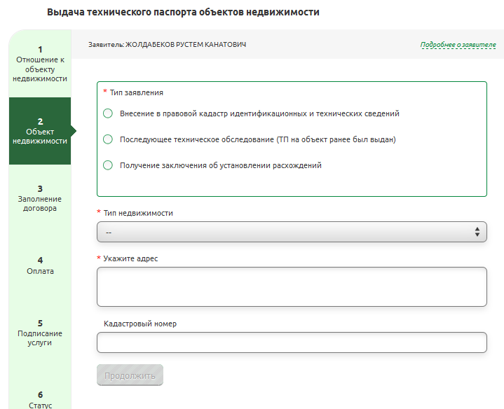
Picture 3. Fields to be filled in on real estate`s address data.

- The 3rd step is “Contract fill-in” (Picture 4). Scanned copy of title certificate should be enclosed here. Choose the payment sum in “Prepayment” pop-up list (it depends on real estate`s area). According to the chosen real estate type, the field “Period as per tariff (per day)” is filled in automatically.
Confirm filled in data; click “I bear the legal responsibility for the accuracy of indicated information” indicator and click “Continue”.

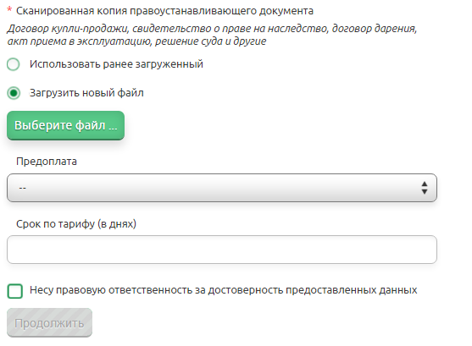
Picture 4. Contract fill-in
- Pay for technical inspection using one of the methods below(Picture 5):
- Online: pay using payment card (Picture 6). Press “Next” and fill in payment card details (Picture 7). After the payment is made, a page with receipt will appear. Click “Go to Personal Cabinet” (Picture 8).
- Enclose receipt if payment has been done earlier (Picture 9).

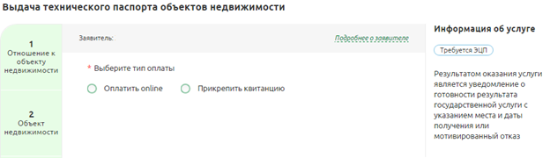
Picture 5. Selecting payment method

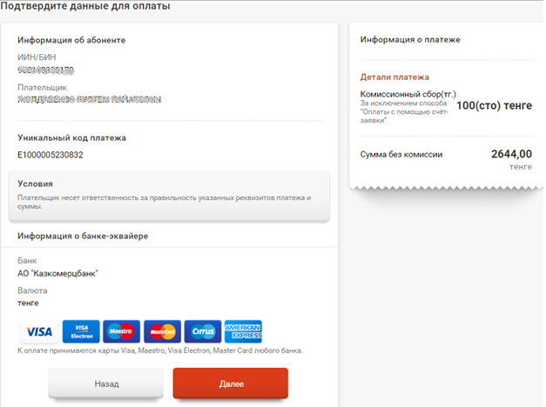
Picture 6. Online payment
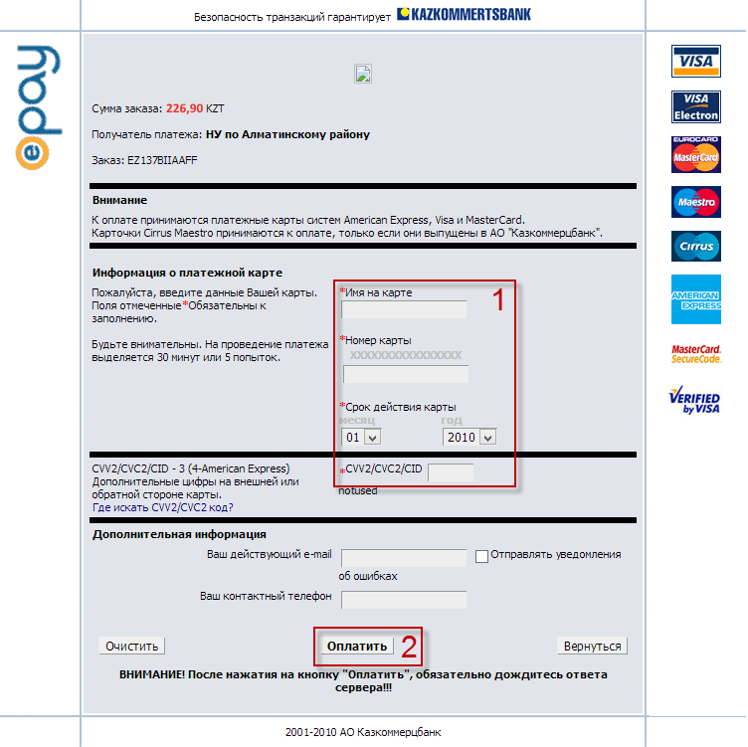
Picture 7. Filling in payment card data.
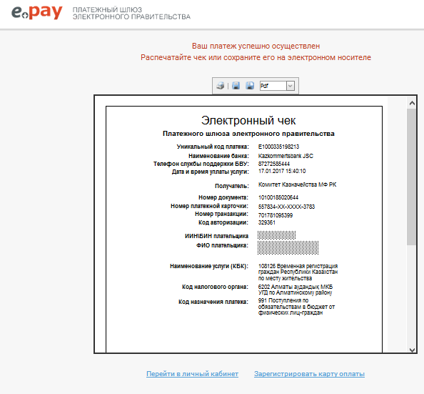
Picture 8. Transfer to Personal Cabinet
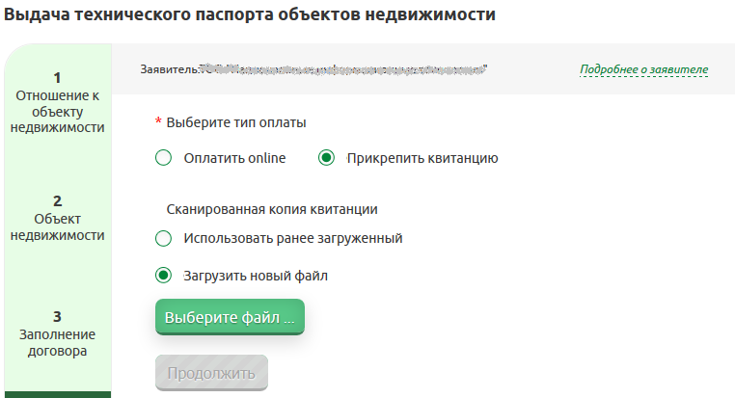
Picture 9. Receipt enclosure
- Status page appears (Picture 10). Click “Continue” to proceed to signing.

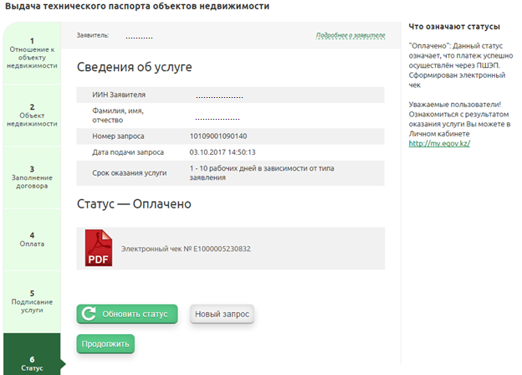
Picture 10. Information about a service

- Choose signing method and sign a request (Picture 11).
- Sign using SMS password (password will be sent to an applicant`s phone number);
- Sign using DS (DS might be recorded to a national ID, computer media or USB flash drive);
- Sign using mobile DS (DS recorded to SIM card).
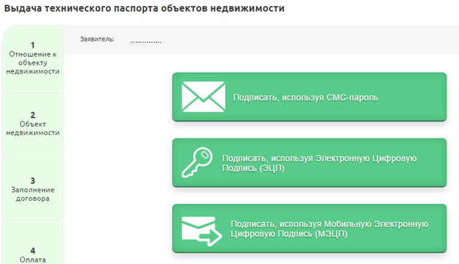
Picture 11. Selecting signing method
- After signing, status page will appear. Click “Renew Status”. Current status of a request will be displayed.
- “Paid” status means that the payment via e-Gov gateway was successful. In this case, electronic receipt is generated (Picture 10);
- “Request is processing” status means that a request is processing (Picture 12);
- “Request received by a government agency” means that a government agency received a request (Picture 13);
- “Waiting for payment” status means that payment for technical inspection should be done (Picture 14). Click “Pay” button and pay using payment card (clause.5, pictures 6, 7, 8);
- “Request is successfully processed” status means that government agency has processed a request. The result of service delivery is positive (Picture 15);
- “A request rejected by a government agency” means that a government agency received a request and it was rejected by one of the reasons (Picture 16).

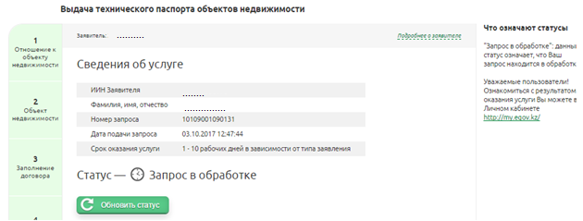
Picture12. Request is processing

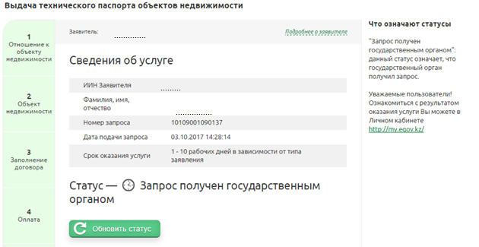
Picture 13. Request received by a government agency
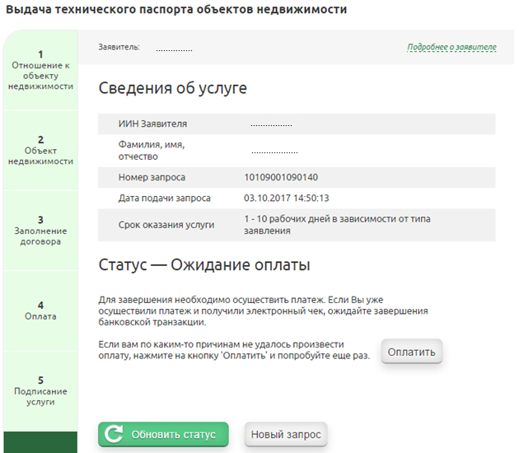
Picture 14. Waiting for payment for technical inspection

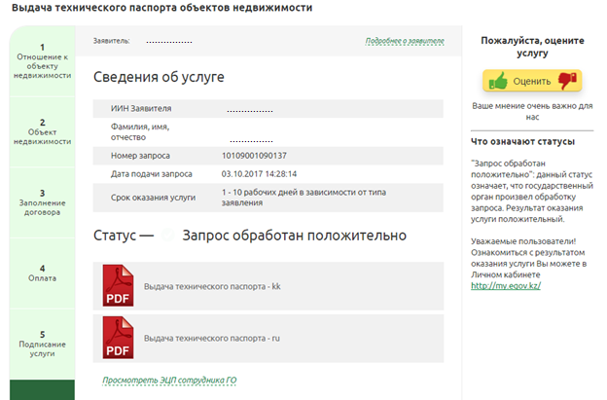
Picture 15. Request is successfully processed
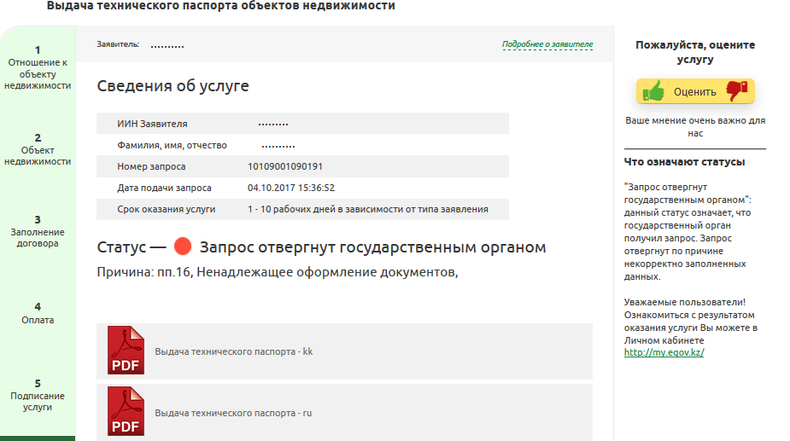
Picture 16. Justified refusal to deliver a service specifying the reasons

