Laboratoty work #14. Introducing Moodle Platform.

Purpose: Development of structure and the maintenance of a lesson in the environment of remote learning: Moodle.

Methodological guide.

General Features of the Moodle Platform

The Moodle platform has three levels of use, with features of differential use and access. So is the concept of trustee or administrator (the manager of the platform), teacher (who may also have other designations, for example, trainer, facilitator, promoter) and the student (learner, participant, among others). These roles and their features are represented in the following table.

Table 1. Roles and functions in Moodle Platform
Role | Function
Administrator | Manages the whole environment
Teacher | Generate events, courses or subjects according to the thematic areas defined Generate training or events which are designated
Student | Accesses and interacts with a specific event and participates in the subjects they are subscribed

Moodle is composed of a simple interface that looks more like a portal of information; layout of this environment can be seen in Figure 1. In general, the pages of the courses are divided into three columns that can be customized by the teacher or the course, adding elements such as: calendar, online users, list of activities, among others. These elements are arranged in columns to the right and left of the screen the user can be moved from one place to another teacher. In the center column, we find a set of options that may be the result of the class through a list of topics numbered or dated weekly or, areas to group content or similar activities. In the center column of thecourses that use Moodle as a virtual environment, there are generally living areas, for the record of course-related news, discussion forums, content areas to enter text, images and presentations on the theme, activities areas, to direct the tasks to be performed or delivered to the teacher or the central column, is the place where resources and activities are available.

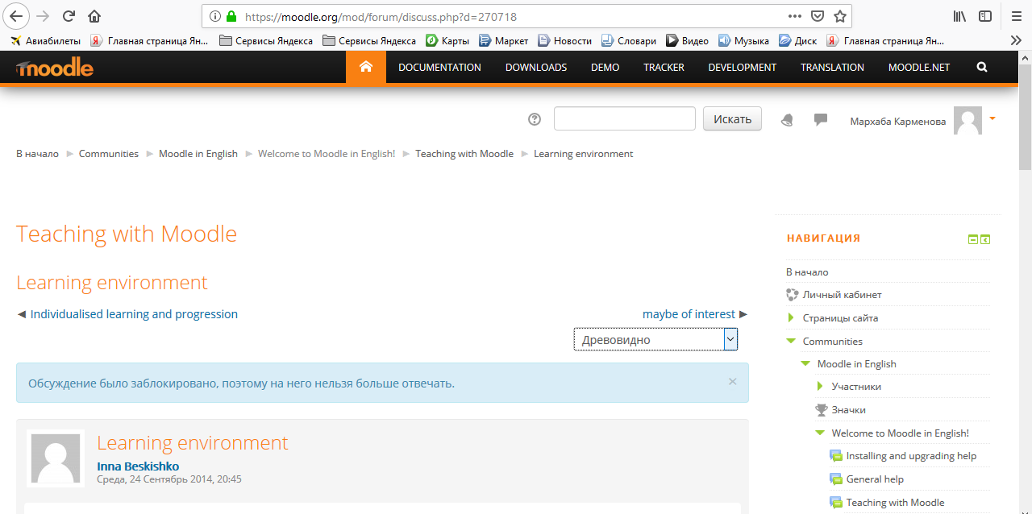

Figure 1. Layout of a page in Moodle

Through this environment, we can create various activities and use a set of tools that can be used according to each educational objective. We can see in the Figure 2 some activities in the Moodle platform.

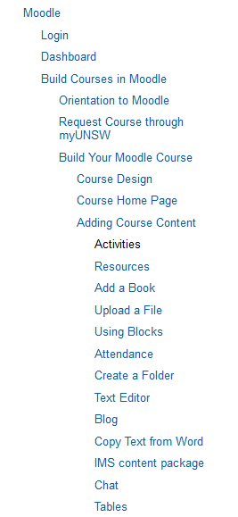

Figure 2. Activities in Moodle

Let’s see what activities are available in Moodle:

– CHAT

The Chat module allows participants to have a real-time synchronous discussion.This is a useful way to get a different understanding of each other and the topic being discussed – the mode of using a chat room is quite different from typical internet forums. Chat contains a number of features for managing and reviewing chat discussions.

– DATABASE

The Database module allows the lecturer and/or students to build, display and search a bank of record entries about a topic. The format and structure of these entries can include images, files, URLs, numbers and text amongst other things.Although the database currently has issues exporting data for different modules, it is sometimes convenient to store and share data with all the participants. Database consists of multiple fields, which you need to create. You also set each database to decide how many entries each participant must write in order to view other entries, minimum and maximum entries one is allowed, and so on.

– FORUMS

Forums are used for asynchronous online discussion. By subscribing to a forum, participants receive copies of each new post by email. Teachers can impose subscription on everyone if they want to, and in this way can use a forum to contact all students on a course.They allow students and teachers to post comments in a central place to simulate (and stimulate) discussion. All Moodle courses automatically come with a News forum which cannot be removed, and all course participants will receive email whenever anything is added to that particular forum. However, you can add new forums as well.

– GLOSSARY

The Glossary activity allows participants to create and maintain a list of terms and definitions, as in a dictionary. It can be used to build an annotated list of useful websites or FAQs. The definitions can be searched or browsed in many different formats, and can be linked from other places on the site.

– QUESTIONNAIRE

The questionnaire module in Moodle allows you to create a survey or questionnaire for students to fill out, for instance a course evaluation or a reading response survey. You may choose whether or not the responses are anonymous.

– SCHEDULER

Scheduler is a Moodle Activity that allows the course instructor to post available meeting times and then has the students sign up for the slot that best suits them. This is useful for required meetings between student and professor, such as advising days, or simply for optional office hours.

– LESSON

A Lesson allows a lecturer to create conditional pathways through material. It consists of a number of pages, each page normally ending with a question and a number of possible answers. Depending on the student's choice of answer they either progress to the next page or are taken back to a previous page. When students answer a question, they are redirected to whatever page you'd like them to see next based on their answer. It can be a helpful tool for practicing material, studying, and testing.

– HOT POTATOES

The Hot Potatoes module, allows teachers to administer Hot Potatoes quizzes via Moodle.

– ASSIGNMENTS

Assignments allow students to submit work online, including uploading any file type (Word document, Powerpoint, video clip etc.). Lecturers can grade and give feedback.

Advanced Uploading of Files

This option should be used when you want your students to be submitting multiple files, or particularly big files. In this sub-module, you will be able to set a maximum file size as well as a maximum number of files submitted per student, and you can decide if you want students to work in groups, if students can delete files after they are uploaded, if students can write notes to you online, and when the assignment is due. You can also decide whether you would like to receive an email every time a student submits a file. This assignment has a further feature of allowing teachers to submit feedback in the form of a file, so an electronically corrected document may be returned. For detailed documentation on this, see the Advanced Assignments PDF on the right side of this page.

Online Text

This option is for relatively short, text-based assignments. For example, if you wanted to ask students to submit their thoughts on a reading assignment, you might use this kind of assignment. Students will not be able to upload files from their computer; they will simply see a text editor box, approximately paragraph-sized, where they can type something up online and submit it to you. In the sub-module, you can set things like due dates, whether late assignments are acceptable, whether assignments can be resubmitted, and whether you would like to receive email alerts when a submission has been made. You can also make the submissions easier to grade by turning on the "Comment inline" option, which will allow you to edit the original text, or comment using a different color. Furthermore, you can split students into groups, but this is generally a solitary kind of assignment.

Upload Single File

If you would like to have your students upload files, but you only want each student to upload one file and the files aren't particularly big (Word documents, Excel spreadsheets, etc.), then you can use the much simpler "Upload a single file" option, which works almost exactly like "Advanced uploading of files", except for the number limit on each student. As a professor, you can set a grade scale, due date, late submission policy, and resubmission policy, as well as a maximum size of file. You can also split students into groups and have each group submit one assignment, and decide whether you would like email alerts when files are submitted.

Offline Activity

This is the easiest option to use. There is no online submission of any kind; the assignment mostly exists as a reminder to students that they have a certain assignment due on a certain day. Mostly, this is used for assignments from the textbook, or offline worksheets. You can set a grading scale, a due date, and a late submission policy, but again, this is all for the students' benefit, since they won't be submitting anything online, anyway.

– QUIZ

The Quiz module allows the lecturer to design and set quiz tests, and includes a range of question types and reporting options. Moodle Quizzes are a great resource for every professor. Electronic quizzes can do many things that paper quizzes just can't. You can create different question types, randomly generate quizzes from pools of questions, allow students to retake quizzes multiple times, and have the computer score it all. These features open up a world of possibilities that just aren't practical with paper-based testing.

Moodle quizzes have two components: the quiz body and the question pools. The body is the final quiz that a student will see, after all the randomizing and question-picking--it is the "container" for the various questions pulled from the question pools. You can define rules for how the body pulls from the pools: for example, you might create three question pools, one for each chapter that you are testing, and tell the quiz body to pull five questions from the first chapter, two questions from the second chapter, and three from the third chapter. Pools can be reused, shared between classes, and moved between systems.

– WIKI

A Wiki enables documents to be authored collectively. A history of all contributions and changes is stored and the wiki can be rolled back to a previous version at any time. Wikis can be formatted with Wiki Markup or with HTML if the wiki has been given that option.

– WORKSHOP

A Workshop is a peer assessment activity. It allows participants to assess each other's projects, as well as exemplar projects, in a number of ways. The key to the Workshop is the scoring guide, which is a set of specific criteria for making judgments about the quality of a given work. This helps to provide a framework for both instructor and peer feedback on open-ended assignments, such as essays and research papers.

– SCORM

Moodle has an embedded module for both SCORM or AICC formats that allows you to easily create, reuse, and transfer your (or someone else’s) custom training content to and from other course management systems (and from some text book resources).

– SURVEY

Moodle’s surveys can give feedback on how useful certain aspects of coursework are. There are currently only five pre-designed surveys to choose from; you cannot write your own survey at present.

Task 1

Create a Lesson in Moodle
- On the course homeage, click Turn editing on .
- In the relevant week or topic, click Add an activity or resource, then in the pop-up generated, select Lesson and click Add.
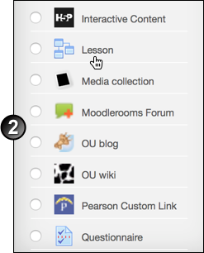
- On the Adding a new Lesson page, click Expand all at the upper right to display all the available page sections.
- In the General section, enter a Name and an optional Description.
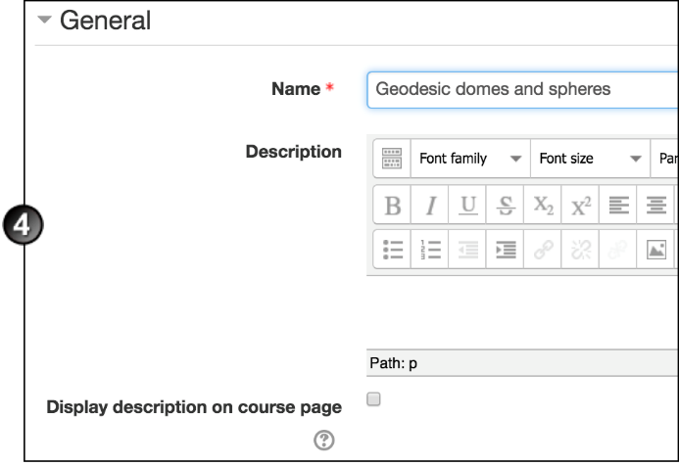
- Under Appearance:
  - If desired, attach the appropriate file to display as a File pop-up at the start of a lesson. Every page of the lesson can include a link to re-open this pop-up if you want.
  - Select whether you want to display a Progress bar at the bottom of the lesson pages, showing the percentage of the course that the user has completed.
  - Select whether you want each page to Display ongoing score, that is, the user's points earned thus far.
  - Select whether you want to Display left menu containing a list of lesson pages.
  - If you wish, set a Minimum grade to display menu. You might want students to go through the entire lesson the first time, then on achieving the desired grade the left menu becomes available to them to use for reviewing.
  - Select whether the lesson is to display as a Slideshow, with a fixed width and height.
  - The Maximum number of answers only affects what the teacher sees; use it to specify the maximum number of answer options that can be used in a lesson. For example, if you are only using True/False questions, you can set this to 2.
  - Select whether you want to Use default feedback, i.e. "That's the correct answer/That's the wrong answer", for any questions asked.
  - If you want to present, at the end of the lesson, a Link to next activity, select that activity from the drop-down list.
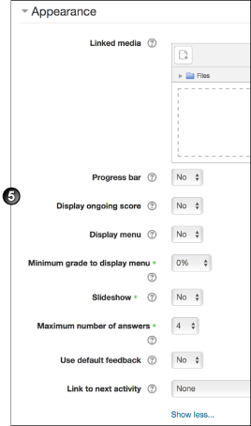
- Under Availability:
  - Enable and complete the Available from and Deadline fields.
  - Enable and set a Time limit (minutes) if required.
  - If you wish, make this a Password protected lesson by selecing Yes and entering a Password.
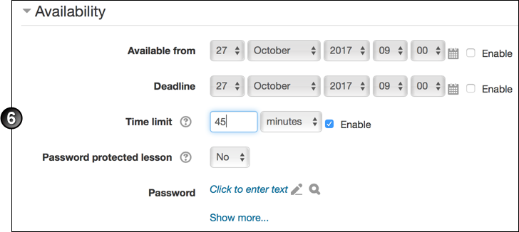
- Under Flow control:
  - Select whether to Allow student review, i.e. students can go back through the lesson before exiting.
  - Select whether you want to Provide option to try a question again with no point credit, if a student answers a questions wrongly.
  - Set the Maximum number of attempts at each question. When this maximum is reached, the next lesson page will display.
  - Select the Action after correct answer. The options are as follows:
    - Normal = the next page in the lesson is shown
    - Show an unseen page = pages display in random order; no page displays twice
    - Show an unanswered page = pages containing unanswered questions display again, in random order
  - If you selected anything other than Normal in the previous field, set the Number of pages to show in the course of a lesson. If you set this to 0, all pages are shown.
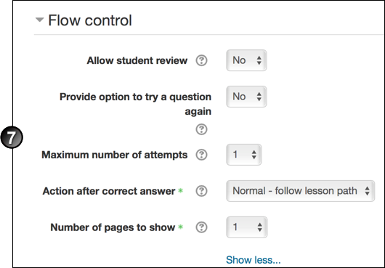
- Under Grade:
  - Select the maximum Grade that can be attained in the lesson.
  - Select the Grade category.
  - Select whether you want this to be a Practice lesson, i.e. not to display in the Gradebook.
  - If you enable Custom scoring, you can give each answer an individual numerical point value, positive or negative.
  - With Re-takes allowed, students can attempt the lesson more than once.
  - If you selected Yes for Re-takes, select whether you want the mark for the lesson to be the main mark or the maximum of the student's attempts.
  - If you wish, set the Minimum number of questions to be used to calculate a mark. If the lesson contains one or more content pages, leave this setting as 0. If you set it to another number, add the following text to the lesson's opening page: "In this lesson you are expected to attempt at least [chosen number of] questions. You can attempt more if you wish; however, if you attempt fewer than [chosen number], your grade will be calculated as though you attempted [chosen number]."
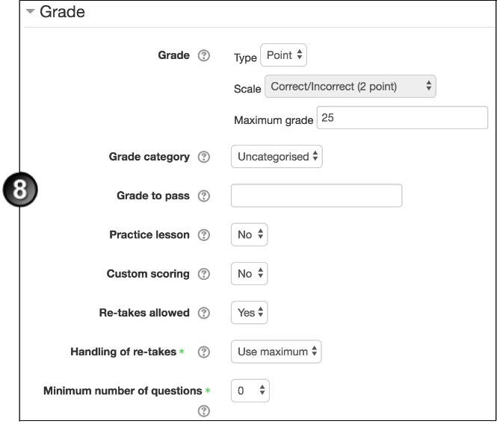
- Complete the remaining sections as necessary.
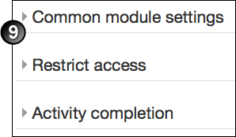
- Click Save and display, and go to the Build a lesson instructions to build the lesson within the shell you have just created.
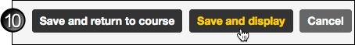

Build a Lesson
If you have just completed the instructions above, the Edit screen for the lesson will be displaying. If you are using an existing lesson shell and starting on the course home page, click the Update icon for the lesson, then in the Updating screen, in the Settings block, under Lesson administration, click Edit (not Edit settings).
- In the Edit screen, a choice of actions displays. (All of these are self-explanatory, except for Add a cluster. A cluster is a group of question pages that are offered randomly to students as they progress through the lesson. You need to have created the question pages before you can add them as a cluster. This MoodleDocs page about clusters tells you all about this advanced lesson feature.) Select the action you want to perform.
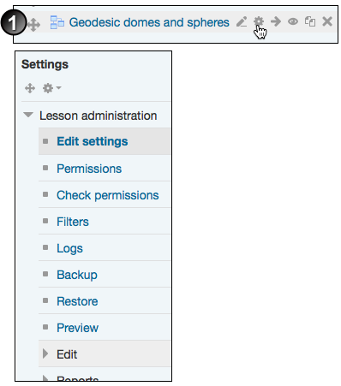
- For further instructions and assistance building your lesson, consult this MoodleDocs page, Building Lesson. The page takes you through all five actions, showing you how to add content and questions, how to move students through the lesson (using jumps, explained further on this page), and how to bring the lesson to a satisfactory close.
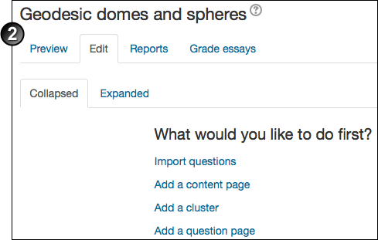

View lesson reports
To access reports relating to a lesson:
- On the course home page, click the lesson's link.
- In the Settings block, click Lesson administration > Reports.
- Select one of the 2 types of reports available: Overview or Detailed statistics.
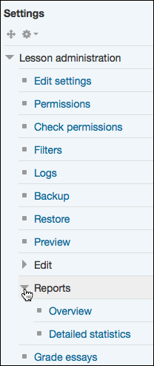

Overview
The Overview report contains all student names, their lesson attempts (displayed as a percentage of completion, with last access and total time spent on the lesson) and the highest score from any attempt. Clicking See all course grades at the upper right takes you to the Grader Report in the Gradebook.

Detailed statistics
The Detailed statistics report delivers data on individual questions.The question/content slide displays, followed by the available answer options or jump actions. For questions (for example multiple choice) all options display, along with (under Class Statistics) the cohort percentage of participants who selected each available option. Just as with the Overview report, instructors can click See all course grades to move to the Grader Report in the Gradebook.

Further information
For more information about generating course logs and statistics, go to the Generate reports in Moodle page.

