SOFTWARE. OPERATING SYSTEMS
Introduction
- Program:
Set of sequence instruction that tell the computer what to do.
- Software:
A collection of programs, data, and information.
- Programmer:
The person who makes the program.

Computer software
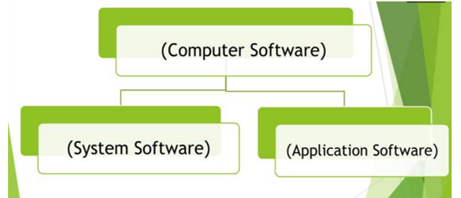

Application Software
System Software

System Software
- It is the software which is used by the computer or operates a computer system.
- Built inside the computer or in a CD must be bought.

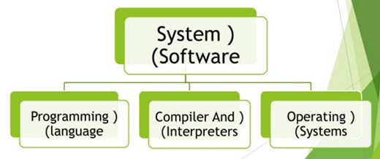
Programming language
- Programs are developed by the programming languages.
- It is a set of words, rules, syntax.
- There are many programming languages each to solve specific kinds of problems.
- Ex. ( C, Java, Pascal, Basic, …etc).

Generations of Programming language

- Machine Language.
- Assembly Language.
- High Level Language.
- Application Generation.
- Object Oriented Languages.

Compiler And Interpreters
Compilers and Interpreters: Program that translate the source code into object code.
- Compilers: translate a whole program once and execute it.
- Interpreters: translate and execute one instruction at a time. Its slower and use more space than the compiler.
Operating Systems
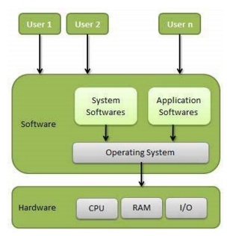
An operating system is a program that acts as an interface between the user and the computer hardware and controls the execution of all kinds of programs.

Operating Systems

Following are some of important functions of an operating System.
- Memory Management
- Processor Management
- Device Management
- File Management
- Security
- Control over system performance
- Job accounting
- Error detecting aids
- Coordination between other software and users

Memory Management
- Keeps tracks of primary memory, i.e., what part of it are in use by whom, what part are not in use.
- In multiprogramming, the OS decides which process will get memory when and how much.
- Allocates the memory when a process requests it to do so.
- De-allocates the memory when a process no longer needs it or has been terminated.

Processor Management
Keeps tracks of processor and status of process. The program responsible for this task is known as traffic controller.
- Allocates the processor (CPU) to a process.
- De-allocates processor when a process is no longer required.

Device Management
- Keeps tracks of all devices. Program responsible for this task is known as the I/O controller.
- Decides which process gets the device when and for how much time.
- Allocates the device in the efficient way.
- De-allocates devices.
File Management
- Keeps track of information, location, uses, status etc. The collective facilities are often known as file system.
- Decides who gets the resources.
- Allocates the resources.
- De-allocates the resources.

Other Important Activities
- Security − By means of password and similar other techniques, it prevents unauthorized access to programs and data.
- Control over system performance − Recording delays between request for a service and response from the system.
- Job accounting − Keeping track of time and resources used by various jobs and users.
- Error detecting aids − Production of dumps, traces, error messages, and other debugging and error detecting aids.
- Coordination between other software and users − Coordination and assignment of compilers, interpreters, assemblers and other software to the various users of the computer systems.

Types of Operating Systems
Real-Time Operating System
Real-time Operating System also known as RTOS; are used for managing the control machinery, scientific instruments and industrial systems.
There are two types of real-time operating systems.

Hard Real-Time Systems- the system guarantee the completion of the critical task on time.
Soft Real-Time Systems- these are less restrictive and hence these give the first priority to the critical tasks than the other tasks.

Types of Operating Systems
Single-User, Single Task Operating Systems
work on single task and single user at a time. Here, a single tasks or operation can be carried out efficiently and thoroughly by a single user.

Types of Operating Systems
Single-User, Multi-Task Operating System
These operating systems works on more than one task and process them concurrently at a time. Here, the processors switch rapidly between the processes.

Multiuser Operating System
In these OS, multiple users are allowed to access the same data or information at a time via a network. The users can also interact among each-other.

Multiprocessing Operating System:
Here, a single process runs on two or more processors. All the processing and their management takes place in a parallel way, hence this OS are also called as Parallel Processing.

Embedded Operating System
These are embedded in a device, which is located in ROM. These are applicable and developed only for the needed resources and accordingly developed. These OS are less resource intensive. Mainly, applicable in appliances like microwaves, washing machines, traffic control systems etc.

Distributed Operating System
In these OS, the computers work in co-operation with each other. As this OS manages a group of independent computers and makes them appear to be a single computer is known as a distributed operating system

Along with these OS, the other developed OS are Mobile Operating Systems, which are now famous in all types of latest and developed mobiles; among them the most renowned and famous are the Android OS with all multitasking and application features. In Batch Processing and Interactive Systems, the execution of programs takes place in batches. The Online and Offline Processing Systems offers the processing of data in online mode.

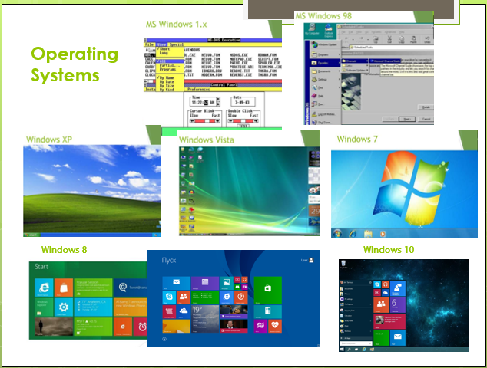

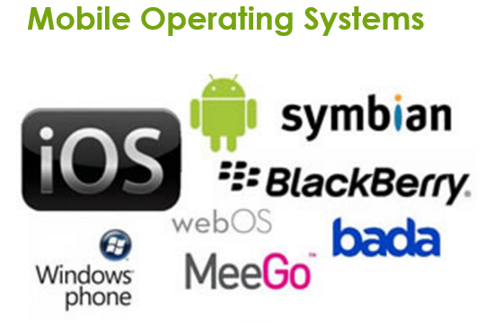

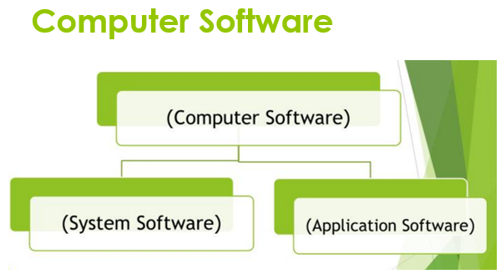
Application Software
is a software tool that functions with the purpose of supporting or improving the user’s work

Basic Applications
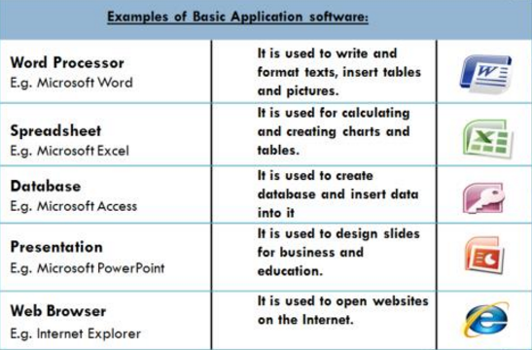

Specialized applications
Focus on specific disciplines and occupations
Examples:

- Graphics Programs
- Audio and Video Editing Software
- Multimedia Creation Programs
- Web Designing Programs

Interfaces
Interface: It’s the way that the user use to deal (communicate) with the computer
Types:
Command Line Interface
- Commands must be typed on the keyboard
- It’s slow process
- Require a high degree of computer knowledge

Graphical User Interface
- Use pictures, windows, menus, icons to represent object and operation
- User can select any object by pointing the mouse at it an click on it
- Ease, enjoyable

