LABORATORY WORK #6

CREATING MULTIMEDIA PRESENTATION

Multimedia presentation
A multimedia presentation differs from a normal presentation in that it contains some form of animation or media. Typically a multimedia presentation contains at least one of the following elements:
- Video or movie clip
- Animation
- Sound (this could be a voice-over, background music or sound clips)
- Navigation structure

Choice of multimedia presentation technology
The first – and hardest – part is to choose the technology for your presentation. The choice comes down to two main contenders, Adobe Flash or Microsoft PowerPoint.


Microsoft PowerPoint
The easiest way to create a multimedia presentation is in Microsoft PowerPoint. You can add in video, a soundtrack and also a reasonable degree of animation.

By far the biggest advantage of making multimedia presentations in PowerPoint is that it is easy for anyone to be able to edit the presentation.

An example of how you can introduce multimedia effects in a presentation is shown in the taxi sequence on the right. It starts with a line drawing being made on the screen and is then followed up with a taxi fading in.

The sequence is part of one of our PowerPoint templates. You can see the effect in action by downloading the taxi animated template from the download page. Make sure that you view the sequence in PowerPoint show mode.

How to embed videos in your PowerPoint presentation

Как вставлять видео в презентацию PowerPoint
2010 has come of age when it comes to embedding videos. In just a few simple steps you can select a video clip from your PC or a website (don’t forget the all-important copyright issues, though) and embed it in your presentation.

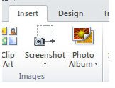
A couple of pointers regarding video formats
Несколько указателей на видеоформаты

When it comes to which file format is best to use in a presentation we can guess there are as many opinions as there are file formats. Suffice it to say that when it comes down to it you will probably find that either one of these will work perfectly satisfactorily on almost all computers.

- AVI (Audio Video Interleave) – A long-established format that will work fine as long as you bear in mind that it is a bit heavy on file size. Figure on about 5mb for a 1 hour video. Admittedly, an hour-long video clip in a presentation is somewhat extreme but it always pays to keep files as small and compact as possible. Quality of these files is excellent.

- WMV (Windows Media Video) – This is a compressed video format and therefore a smaller file size. My choice would be this format as it provides the best compromise between quality and size.
- MPEG – (Moving Pictures Experts Group) – This format is also perfectly suitable for presentations as these files are also much smaller and are of high quality.

- SWF – (Shock Wave Flash) – A format used mainly for web-based applications and animations. It has a small file size and audio capability.

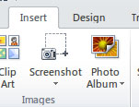
Fig 2. Ribbon – insert

For more in-depth discussion on video formats a quick Google will provide a wealth of information. Any one of the above will be more than satisfactory for your presentation, though.

Embedding your video clip

Make sure you have selected ‘Insert’ on your ribbon. By the way, a quick way to do this is to use the mouse wheel to choose between ‘File’, ‘Home’, ‘Insert’, etc. The scroll wheel jumps from tab to tab as you scroll the wheel. Or simply click the tab to select.

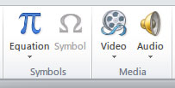
Fig 3. Video selection icon

On the right is the ‘Video’ insert menu/ribbon selection icon and on clicking you are offered three further choices. We will deal with them from top to bottom.

Video from File / Видео из файла
Selecting this option will open a dialog box so that you can navigate to where your video clip is filed on your PC.
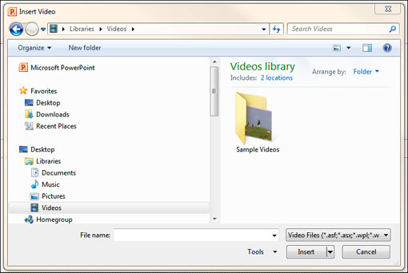
Fig 4. Video dialog box

Once you have found your clip and selected it, click the insert button and the clip is embedded into your slide, as you can see here.
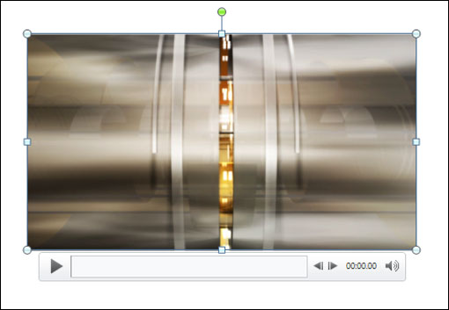
Fig 5. Inserted video clip

The image below shows the formatting dialog box for the video player inserted into your slide.

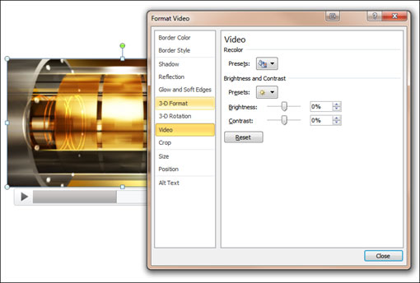
Fig 6. Formatting options

Customising the video player is straightforward and provides a good range of options, such as border colour and style. Also available are adjustments for the video itself. Selecting the ‘Video’ option offers brightness and contrast options of the video output.
Power Point 2010 offers video editing functionality as well. No more do you have to spend ages editing in complicated software to get the length of the video clip correct.
Notice the ‘Trim Video’ option on the left. Selecting this option opens a simple window where you can tweak your video clip to the exact length you require.
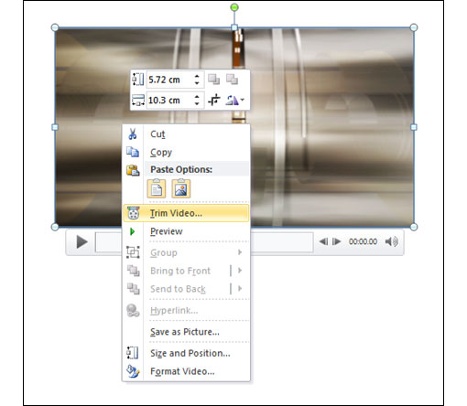
Fig 7. Video editing options
Below the thumbnail of the video on the right in Fig. 8 you can see a green and a red marker.
Click and drag the green marker to your starting point. Note how the thumbnail adjusts to show you the starting point.
The red marker works in the same way. Just drag it to your end point. The Start and End time fields show the corresponding times and top right you can see the duration of your video clip.
Before I move onto the next choice of video embedding, take a look at the ‘Size’ option. You can see this in the Formatting options image in Fig. 6 above. With this option you can change the video display to suit your slide.
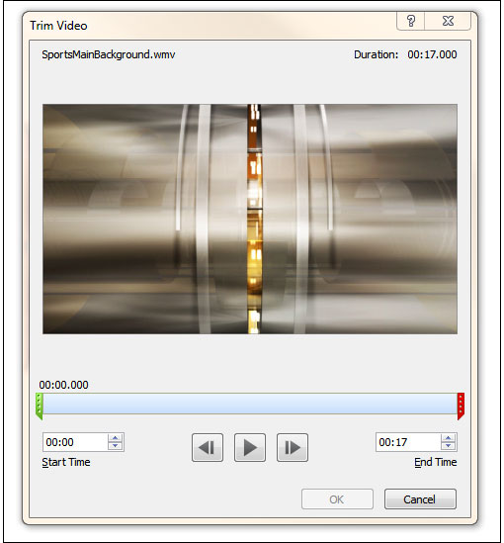
Fig 8. Editing dialog

Video from Website / Видео с сайта

On the right is the dialog box that opens when you choose to add a video from a website.
Let’s suppose you have a number of video clips on YouTube, or perhaps your website has a video you would like to add to the presentation.
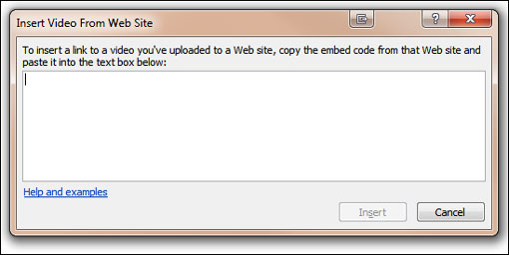
Fig 9. Video embedding dialog from websites

The last option allows you to add Clip Art to a presentation
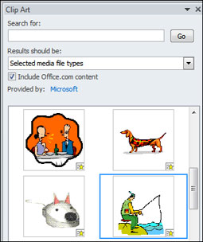
Fig 14. Clip art dialog

On the right is a snip from the Clip Art pane that opens when you choose the Clip Art option under Insert/Video in the ribbon. I chose the man fishing and once clicked it is dropped into the slide. Unlike the other two video options, you will not be able to preview this. To see the clip animate you must run the show (F5). Once again, don’t forget to experiment with the ‘Picture Tools’ – ‘Format’ options in the ribbon.
It might make the difference between an ‘okay’ presentation and a ‘knock out’ one.

Adding music to PowerPoint presentation

Step 1. Choose your music format – MP3 or WAV.
- MP3 – Smaller file size, but cannot be embedded
- WAV – Larger file size, but can be embedded

Step 2. Insert the music in your PowerPoint presentation.
From the main menu Insert > Movies and Sounds > Sound from file

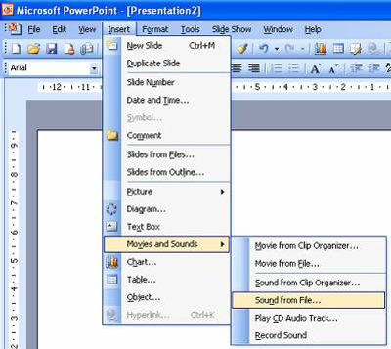
Then from the Files of Type drop down box select mp3 format.
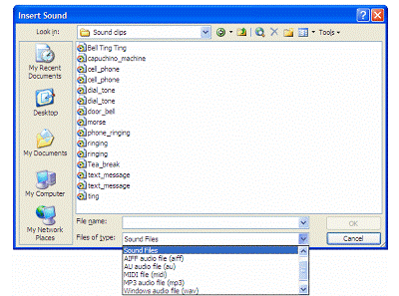
You will then get a message about how you want the music to start


Step 3. Setting the music to play across multiple slides
Select your music file then Right click (not the usual left click) and select Custom Animation. You can do this by selecting Slide Show > Custom Animation
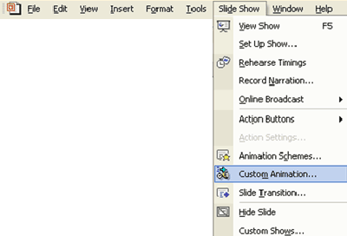

Step 4. How to embed music in your presentation
The last gotcha in the process is that the music may not be embedded in your PowerPoint presentation. This means that if you save your presentation onto a CD or you are to email it, then the music may not automatically go across. It all depends upon the file size of the music.
If you want the music to be embedded in the presentation you will need to follow a couple of steps.
- Make sure your music is in WAV format (mp3 files can only be linked and not embedded)
- Increase the value in the Link sounds with file size greater than box to a value greater than the file size of the MP3 file. For example if the file size is 4.5MB then you will need to include a value higher than 4500. A good general purpose size that should incorporate most song files is 6000 as most mp3 files are less than 6MB. Be careful as some classical music tracks could be longer than this.

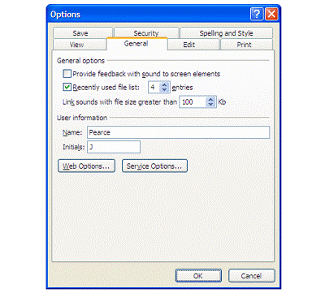
The only downside is that the file size of the final file could be quite large.
There is a 50 Mb limit for embedding WAV files. For eample if you had two WAV files of 34 MB the you will be able to embed them, but it would make your file size over 68MB.
You will also need to make sure that you have all of the copyright permissions and performing rights clearances to be able to store the music in your presentation.

How to animate your slides in PowerPoint
A short tutorial that describes how to animate your slides in PowerPoint.

To get your slides animated you have to start with custom animation.

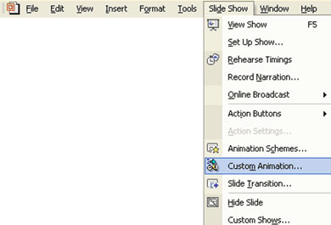
After you have selected Custom Animation you will be given a dialogue box like this.

