Smart City Technologies: work with SMART Notebook Software Lab

Objective(s):

- Explore and use the features of SMART Notebook Software.
- Development of an interactive didactic game.

Software:
To work with the application, you must install the program on your computer. Follow the link below to download the program:
https://smart-notebook-software.software.informer.com/download/.

Exercise 1:
Explore the basic features of the program using the SMART Notebook software tutorial.

Methodical guidance

Getting Started
Smart Board is an interactive whiteboard developed by SMART Technologies that combines the capabilities of a data projector and a white board. Use the SMART Board to create interactive presentations or during meetings to add notes or make changes to your document.

1. SMART Board Resources
The Smart Tech website has additional information and helpful resources available:
http://smarttech.com/us
The SMART Notebook Software also has built in tutorials. To access the tutorial:
1. Open SMART Notebook software
2. Select Help on the Toolbar
3. Click Tutorial
SMART Tech also offers free live online training sessions including a Getting Started and Advanced SMART Notebook Software sessions. Register for this free training on their site:
http://smarttech.com/HomePage/Resources/Training/LiveOnlineTraining

2. How to Use SMART Board as a Projector and Whiteboard
To use the SMART Board data projector and white board functionality, connect your laptop to the video and USB cables. The Smart Board will automatically power on when your laptop is turned on.
The light, located at the bottom right of the board, will turn green if everything is hooked up correctly.
The SMART Board will automatically power off once the laptop has been disconnected.
The SMART Board functions can be operated directly on the board with the special pen, your hand or from your laptop.

I. Smartboard Tool Bar
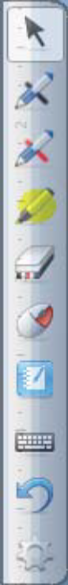
If you don’t have SMART Notebook installed on your laptop you can still use the Smartboard Tool Bar. The toolbar tab will appear on the left hand side of both the laptop screen and on the Smartboard once your laptop has been connected and powered on.
This tool bar offers basic Smartboard features such as:
- Use of either red or black colored pens
- Eraser
- Enable/Disable right click on screen
- On screen keyboard
- Undo

To use any of these features, click the double right arrows using the pen provided. The toolbar will now appear, select any of the options using the pen or your mouse.
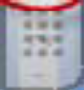

II. Saving your notes
SMART Board’s Ink Aware allows you to insert your notes and drawings into the current document.
Ink Aware programs include Microsoft Word, Excel and PowerPoint.

To save the document when using an Ink Aware program:

1. Select File
2. Select Save
3. Name your file and click Save

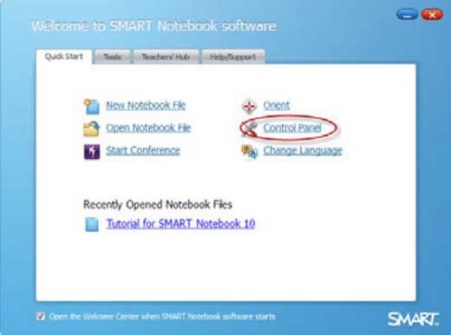
To view a list of Ink Aware programs

1. Open SMART Notebook
2. Select Control Panel
3. Select Configure SMART Tools.
4. Click Ink Aware Program Settings.
5. The Aware window appears.
6. You can enable or disable
Ink Aware for the programs.

If a check mar appears in the Aware Enabled column, the program is Ink Aware If a program is not Ink Aware, you are not able to directly save your notes or drawings. Instead a transparent layer appears over the current program allowing you to take a screen capture to insert into a new SMART Notebook file.

III. Convert handwriting to text
The Smartboard is able to convert your handwritten notes to text if you are using Ink Aware software.

To make notes:
1. Using the pen, select either the black or red ink pen from Tool bar
2. Write your message directly on the screen

To convert notes to text:
1. On the Aware Tools pop-up, Select the Insert as Text button
2. Your handwritten message will be converted to text

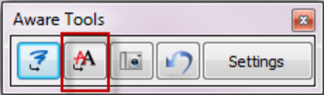

3. Using SMART Notebook:
To take advantage of all the SMART Board features, build your presentations or take notes in your meeting using SMART Notebook. Contact your administrator to have SMART Notebook installed on your laptop and for installation instructions and a product key.
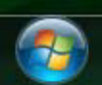
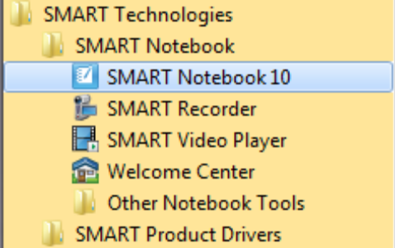
Open up Smart Notebook by:

1. Click on Windows Start Button
2. Choose All Programs
3. Click the SMART Technologies folder
4. Click the SMART Notebook folder
5. Choose SMART Notebook 10

I. Interface
Open a New Notebook File to get started. The Notebook software has elements similar to both Microsoft Word and Microsoft PowerPoint. A formatting toolbar is located at the top of the page and there are expandable tabs down the right hand side. The middle of the document is the work area.

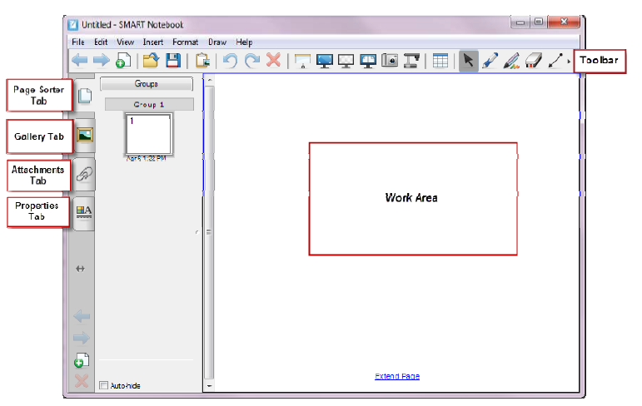

II. Formatting Toolbar
The formatting toolbar is located at the top of the SMART Notebook screen. The toolbar has the following icons:
 The arrows are used to move page to page (backward & forward)
- Add Page – Insert blank page
 Open File – Open an existing file
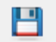 Save – Save page
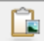 Paste – Paste copied object into file
- Undo – Undo the last action performed
 Redo – Redo the action performed
- Delete – Delete selected object
- Show/Hide Screen Shade – Enables you to cover the screen and reveal it slowly
 Full Screen – Displays the current page full screen
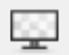 Transparent Background – View the desktop and other windows while still working with the SMART Notebook software
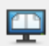 Dual/Single Page Display – Displays two pages side by side
- Screen Capture – Take a screen capture of any image and insert it onto a page in
.notebook file
- SMART Document Camera – Insert images from a SMART Documents Camera into a page
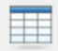 Insert Table – Inserts table on to the current page
- Select – Select object on page with mouse or finger
 Pens – Draw a freehand object on the current page
- Creative Pens – Draw a freehand object on the current page with creative pen
- Eraser – Erases objects on the current page (3 choices of erasers from small to large)
Lines – Draw lines (straight or arc) on the current page.
- Shapes – Draw a shape on the current page
 Shape Recognition Pen – Draw a freehand object on the current page that SMART Notebook recognizes and converts into a rectangle, ellipse, triangle or arc.
 Magic Pen – Create freehand objects that slowly fade, open a magnification window or open a spotlight window
 Fill – Fill selected objects
- Text – Select font for text object
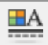 Properties – Display the Properties tab to change the selected objects properties
 Measurement Tools – Ruler, Protractor or compass
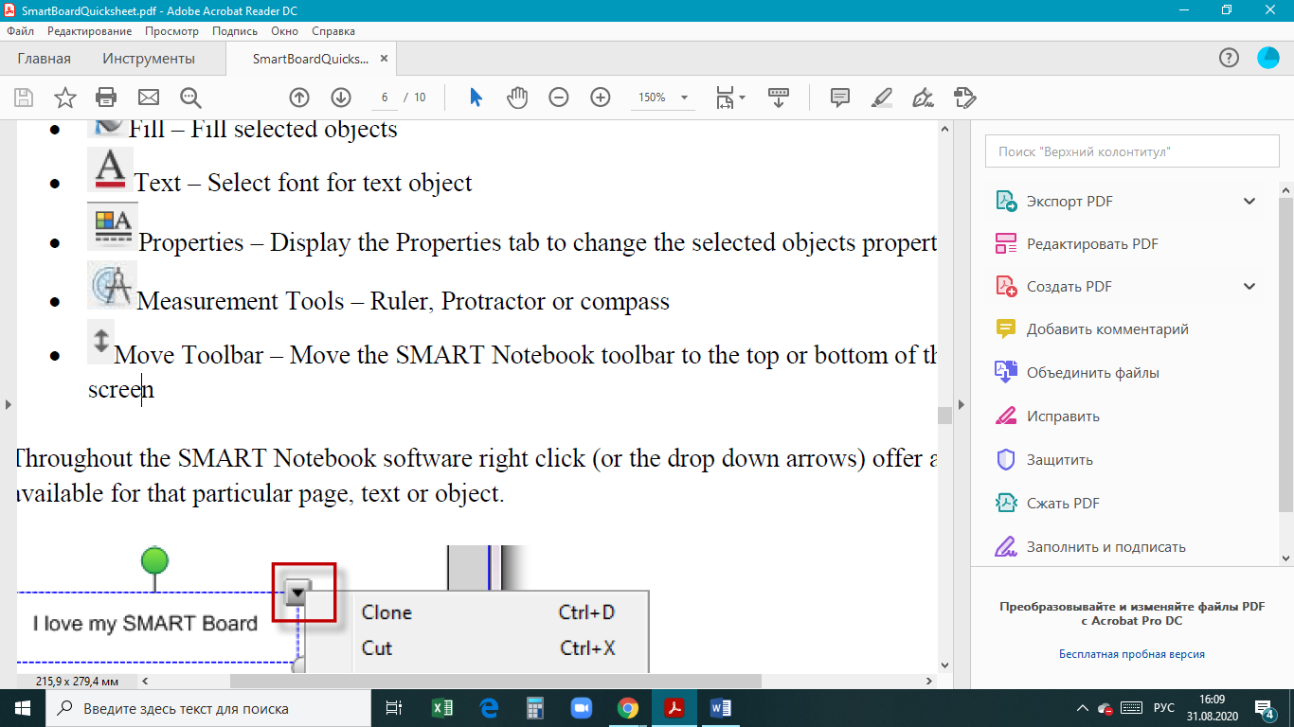 Move Toolbar – Move the SMART Notebook toolbar to the top or bottom of the interactive screen

Throughout the SMART Notebook software right click (or the drop down arrows) offer all the options available for that particular page, text or object.
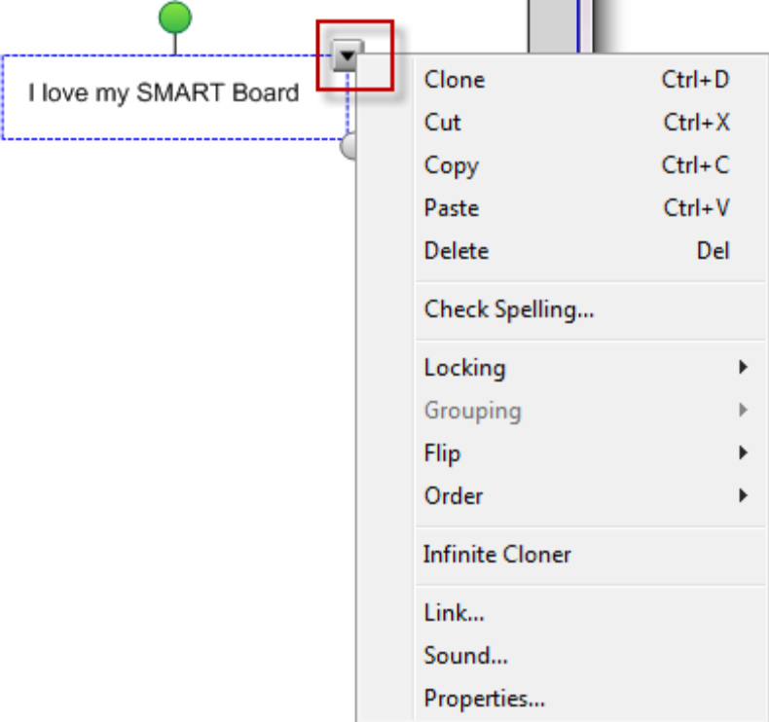
4. Work Area
The work area displays the current page. Use the pen or keyboard to make notes, draw or insert objects in this area.

I. Convert Handwriting to Text Using SMART Notebook
SMART Notebook is able to convert your handwritten notes to text.
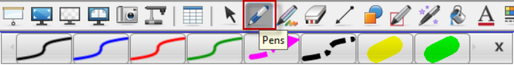
To make notes:
1. Using the pen, Select the Pen
button from the top tool bar
2. Choose the type of ink
3. Write your message directly on the screen

To convert notes to text:
1. Click on the Select button on the toolbar 
2. Select the text to be converted and a dropdown box will appear
3. Choose Recognize “ your word”
4. Your handwritten message will be converted to text
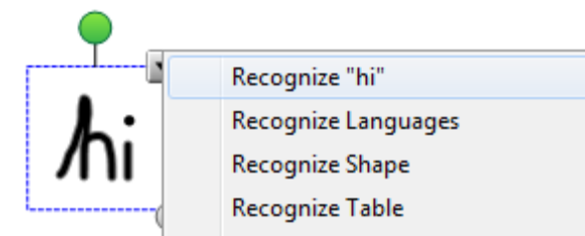

II. Convert Hand Drawn Shapes to Objects
The Shape Recognition Pen converts hand drawn shapes and lines into objects. This tool can be used to create diagrams.
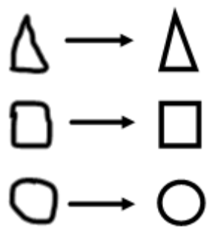
To convert hand drawn shapes to objects:

1. Draw shape using pen
2. Click the Select button on the toolbar and
select the shape to convert
3. Click the dropdown box and select Recognize Shape

5. Page Sorter Tab
When opening SMART Notebook, the Page Sorter Tab will open on default. Thumbnail views of the pages will appear on the left hand side of the page. The current page selected will appear in the work area. Note – If starting a new document, the work area will be blank and there will only be one blank page showing in the thumbnail view.

The current page will have a blue border and a drop down arrow in the top right hand corner in the thumbnail view. To move from page to page using the arrows in the tool bar or click on the thumbnail.

To add a new page:
1. Click Insert, Blank Page or 
2. Press the Insert Blank Page button

I. Right Click and Drop Down
Arrow
Right Click or use the drop down arrow to access more options such as deleting, clearing or cloning a page.
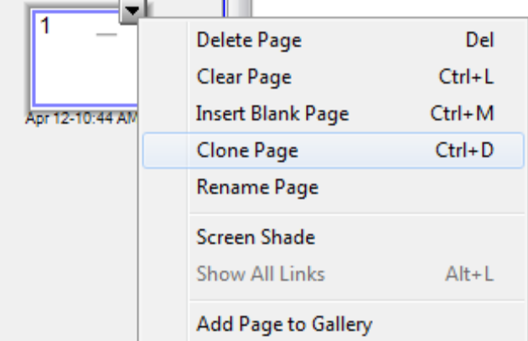

II. Creating a Group of Pages

SMART Notebook is able to group pages within the current file. This enables you to find a particular group quickly within the Page Sorter thumbnails and display its pages. This is useful when there are a large number of pages within a file.

To create or edit a group:
1. Select the Groups button in the Page Sorter
2. Click Edit Groups
3. Choose Add New Group button
4. Type the group name
5. To move a page into a group, drag and drop it into the group

Note – To change the order of the groups, click the group’s blue bar and drag and drop it in the appropriate place.

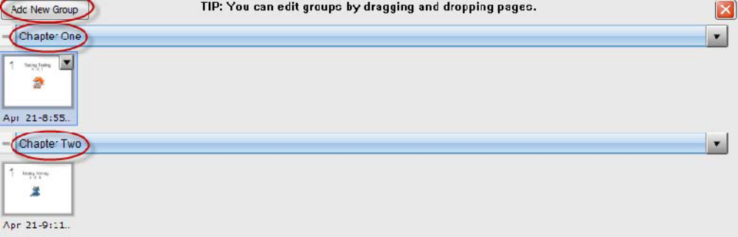

6. Gallery Tab
The Gallery Tab contains pictures, interactive and multimedia, notebook files and pages, backgrounds and themes.

To insert an object into the page:
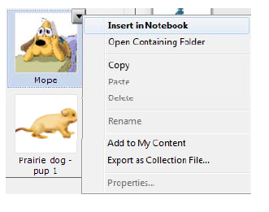
1. Using the search function at the top of the page, type
in the item you are looking for (eg. Dog)
2. A list of objects will appear. Once you have found
the appropriate object, click on it.
3. A drop down arrow will appear on the top right hand
side of the object
4. Choose Insert in Notebook from the list
5. The picture will now appear in the Work Area of the
selected page

I. Cloning Objects
To create duplicate object or create multiple copies on an object with Infinite Cloner command. It’s Copy/Paste function in one.

To clone an object:
1. Select the object
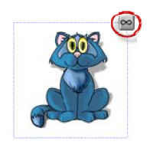
2. Click the down arrow and select Clone
3. A duplicate object appears

To clone an object using the Infinite Cloner:
1. Select the object
2. Click the down arrow and select Infinite Cloner
3. Select the object again. An infinity symbol appears
4. A duplicate object appears
5. Repeat step 3 to continue cloning

II. Layering Objects
Have the ability to layer objects and text and change the order of the objects on a page. In SMART Notebook, the item added last to the page will appear on top.

To change the layer order:
1. Select the image or text
2. Click the drop down menu
3. Select Order and Bring to Front
4. The item selected will now appear on top of the other objects

III. Grouping
Ability to make multiple objects into one object
To group objects:
1. Using cursor, select all items to be grouped (draw large box over items)
2. Click the drop down menu to select Grouping
3. The items will now appear as one large item

7. Attachments Tab
Add attachments from other software applications to your file.

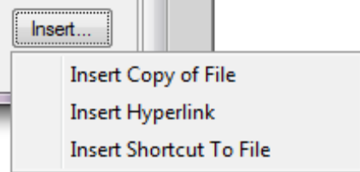
To insert an attachment:
1. Select the Attachments Tab
2. Click the Insert button
a. Insert Copy of File – Search for
the file and select Open
b. Insert Hyperlink – Fill in the website address and the name to display
c. Insert Shortcut to File – Search for the file and select Open
3. The items now appear in the Attachments Tab

8. Properties Tab
Format objects (including freehand objects), shapes, lines, text, and tables by using the Properties tab.
Depending on the object selected, it is possible to change:
- The color, thickness and style of lines
- Transparency and fill effects of an object
- Font type, size and style of text
- The animation of objects
The Properties tab will only display the options available for the selected object.
Provided by User Services, Information Technology

Exercise 2:
Develop an interactive game for the specifics of your educational program. Pick a specific topic. Expand the topic with an interactive challenge game.

